Ergonomic Equipment
***Please note that most, if not all of these items are available for purchase via the eBuy platform, allowing employees to benefit from UI contracted pricing. Additionally, the items featured are commonly recommended during ergonomic evaluations for cost effective solutions. However, this is not an exhaustive list. Please contact the UI Ergonomics Program if further consultation is applicable.

Fellowes Professional Series Back Support with Microban Protection
Item #: E68037601
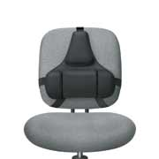
Mid spinal support with memory foam cushion promotes good posture
Lower lumbar support with three memory foam sections conforms comfortably to natural body curvature
Microban antimicrobial protection to keep product cleaner
Tri-Tachment system ensures stability and eliminates the need for readjustment
Memory foam responds to back weight and warmth for custom support
Made of soft, breathable fabric and contoured for a relaxed fit

3M In-Line Document Holder
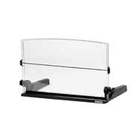
Item #: E6DH640
Good for document reference or transcribing from
documents at computer
Legs straddle monitor so it can work in very tight
space
Can be used as writing surface
Large enough for open folders or 11x17 in landscape

Safco Restease™ Adjustable Footrest

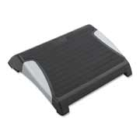
Item #: E62120BL
Provides support for feet when chair is elevated above seated knee height
Can reduce pressure on back of thighs
Wider and sturdier construction appropriate for larger stature users

Safco Ergo-Comfort® Adjustable Footrest

Item #: E62106

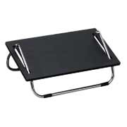
Provides support for feet when chair is elevated above seated knee height
Can reduce pressure on back of thighs

3M Adjustable Gel Wrist Rest Platform for Keyboard and Mice

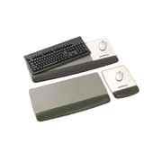
Item #: E6WR422LE
15% pre-consumer recycled content
Environmentally Preferable Products
Sleek design with tapered wrist rests and no hard edges
Angle-adjustable platform enables negative and positive tilt of keyboard for optimal ergonomics
Minimize contact pressure and to prevent the wrist from dropping
Fits keyboard and mouse

3M Extra-Long Gel Wrist Rest

Item #: E6WR340LE

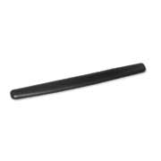
Applies to surface in front of keyboard to minimize contact pressure and to prevent the wrist from dropping
Fits keyboard and mouse
Width: 25.0"

Ergoguys EG-ErgoArm Ergonomic Adjustable Computer Arm Rest with Mouse Pad

Item #: K1EG-ERGOARM

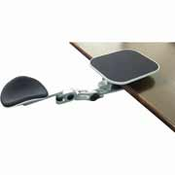

The Arm-Stand computer armrest is ergonomically designed to reduce aches and pains such as Carpal Tunnel Syndrome in the wrist, arm, shoulder and neck areas cause by long-term use of computer and other repetitive movements
Each of the Arm-Stand can support up to 11kgs(or 24lbs) of weight effectively relieving 90% of the weight undertaken by your wrists
With its unique design, you can now move freely, comfortably and effortlessly to perform your computer tasks.

Unitech Numeric USB K19 Keypad

Item #: Q3K19U

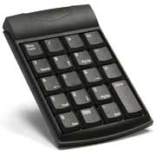
A must for anyone that needs to use the 10-key periodically
Large 10-key layout with good key activations can be a real improvement vs. conventional 10-key data entry work

Verbatim 97472 Mini Wireless Slim Keyboard and Mouse

Item #: C997472

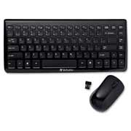
USB 2.0; Also compatible with USB 1.1 ports
Built with a laptop style keyboard configuration to allow for maximum desktop space saving
Quiet, Low Profile, soft touch keys
2.4 Ghz Wireless
Limited One Year Warranty
Media Console; Control your tunes from the Media Console

Microsoft Sculpt

Item #: S9L5V-00001

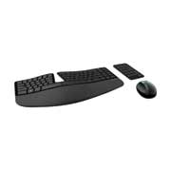
Sculpt Ergonomic Desktop is built on advanced ergonomic principles, with a split keyboard layout that keeps wrists and forearms in a relaxed position, and a cushioned palm rest to provide wrist support
The domed keyboard shape works to reduce and correct wrist pronation that can cause pain and limited mobility
Natural arc keyboard layout follows the curve of your fingertips for a more natural way of typing

Evoluent Vertical Mouse 4 Right

Item #: S9VM4R
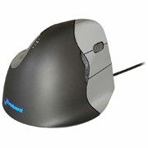
The Evoluent Vertical Mouse offers a unique, patented shape that supports your hand in a relaxed handshake position and eliminates forearm twisting that most mice cause
You will quickly become accustomed to the improved comfort; the grip is the same as an ordinary mouse, just turned sideways

Logitech Marble Mouse

Item #: S9910-000806

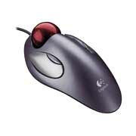
Good for person with side-side wrist deviation sensitivity or
sensitive to forearm movement
Good fit for small to medium hand size
Good application when adequate activation mouse space is
not available
Good for R/L alternating of mouse hand
Not ideal for click and drag or cut and paste functions

Logitech Wireless Trackball M570

Item #: S9910-001799

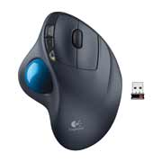
Good for person with side-side wrist deviation sensitivity or sensitive to forearm movement
Good fit for medium to large hand size
Not ideal for those with Thumb movement sensitivity

Fellows Office Suites Adjustable Height Riser for Laptops

Item # FEL8036701
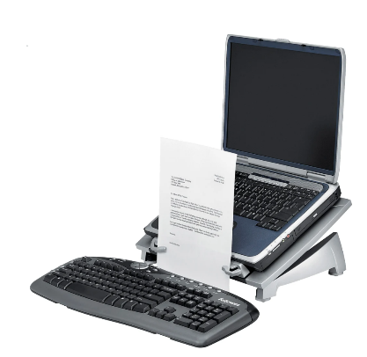
Raise your notebook screen to eye level. Riser lets you adjust the screen of your notebook computer to the height that's most comfortable for you to view.
Holds your notebook in place.
Ventilation helps keep your computer cool. Cooling vents help dissipate heat from your notebook computer.

