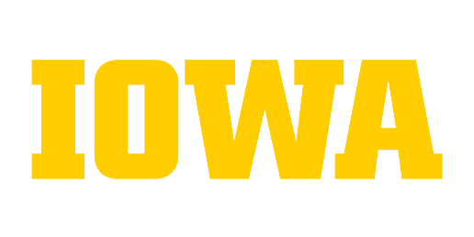
Sample Completed Documentation for Career Development
Career Advancement – Research Hawk – Research Assistant (PRK1)

Documentation of Career Development – Career Advancement

Complete Directions for Form available at: http://hr.uiowa.edu/career-development/form-instructions

Section 1 – Demographics (Employee and/or Supervisor)
Employee Name: Research Hawk Current Classification/Job Code: Research Assistant / PRK1
Department: Biology Supervisor: Ima Boss
Initiated by: Research Hawk Date Initiated: 11/1/2017

Section 2 - Scope/Responsibilities (Employee and/or Supervisor)
Please list the six most important activities that are performed. If the duty is entirely new since the last time the employee/position was classified, please indicate so. If an existing duty has changed, please describe the change. The new or expanded duties should be performed for an appropriate period of time that is sufficient enough to evaluate the employee’s performance and continuing success in the role. The period of time necessary for evaluation is at the discretion of the college/division. Examples of completed Documentation of Career Development Forms are found at http://hr.uiowa.edu/career-development/form-instructions.
Position Specific Duties | Is this a new duty? | Description of Change (i.e. new duties/skills, additional key areas of responsibility, expanded scope and/or advanced competency)
Contribute to the research projects by conducting literature searches, interpreting and adapting published research protocols to meet and expand lab research goals, (e.g. ________________________). |  | Expanded Scope - Previously assisted with conducting literature searches. I’m now focused on the interpretation of published research protocols to meet and expand lab research goals and represents.
Designed, made, and test a new model for the study (e.g. _____________________). Developed new protocol, (include example) that increases accuracy of experiments. Perform experiments in molecular biology on _____ based upon lab protocols, record results, and present findings. |  | Advanced Competency – As my knowledge has increased, my level of responsibility has led me to become more involved with experiment design and testing.
Manage lab animals by interacting with the Office of Animal Resources to assure the proper ordering and transfer in and out of facilities on and off campus. Develop systems and forms to manage breeding colony status. |  | New Duty – Responsibilities shifted from another employee in the department.
Maintain lab equipment and supplies; create new forms and procedures to organize lab resources; assure lab safety by reviewing and implementing safety procedures.
Record experiment findings by summarizing data and developing it into figures for reports and publications.
Provide guidance to undergraduate students on lab protocols and safety procedures. |  | New Duty – Supervision of students isn’t an expectation in the department until an employee has demonstrated the necessary competencies to be successful.

Section 3 – Supervisor Section

Assessment/Comments
Document if and how the employee has assumed each of the new, changed or expanded duties and the importance of these duties to unit operations.
Research Hawk has advanced his skills and responsibilities and is developing towards a Research Associate. His creativity in designing a new tool and his critical analysis of new research models and ability to adapt them to our lab has helped advance our research faster with more reliable results. This demonstrates his advancing ability in conducting research and experiments. I believe that he will continue to expand his skills which may support his future advancement. In addition to his research skills development, his contributions to research and lab management (animal care, lab equipment, and lab safety) are valued in our small lab as it relieves me from these administrative duties. For these reasons, I recommend him for a career advancement as he has taken on some responsibilities as outlined at the next higher-level classification.

Overall performance rating at last formal performance review
Date of Last Review: 6/8/2017
Did the employee receive a performance rating of “Successfully Meets Expectations” or higher on their most recent performance evaluation? Yes No

Section 4 – Employee and Supervisor Electronic Signature

I agree that this represents a true and accurate documentation of the work being performed.
Supervisor Employee

Date: 11/8/2017

©The University of Iowa 2011. All Rights Reserved. Last updated 3/2023

