Getting Started
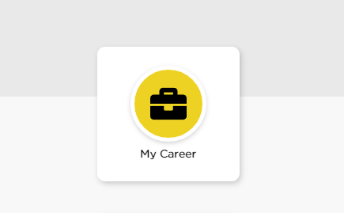
Internal candidates - go to Self-Service and select “Apply for Job Opportunities” in the My Career section of your Employee Self Service (then skip to pg. 17 of this manual)
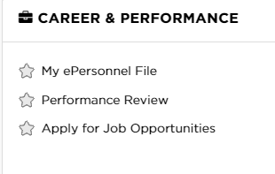

External candidates - go to jobs.uiowa.edu
Click “Browse Jobs” to find open positions

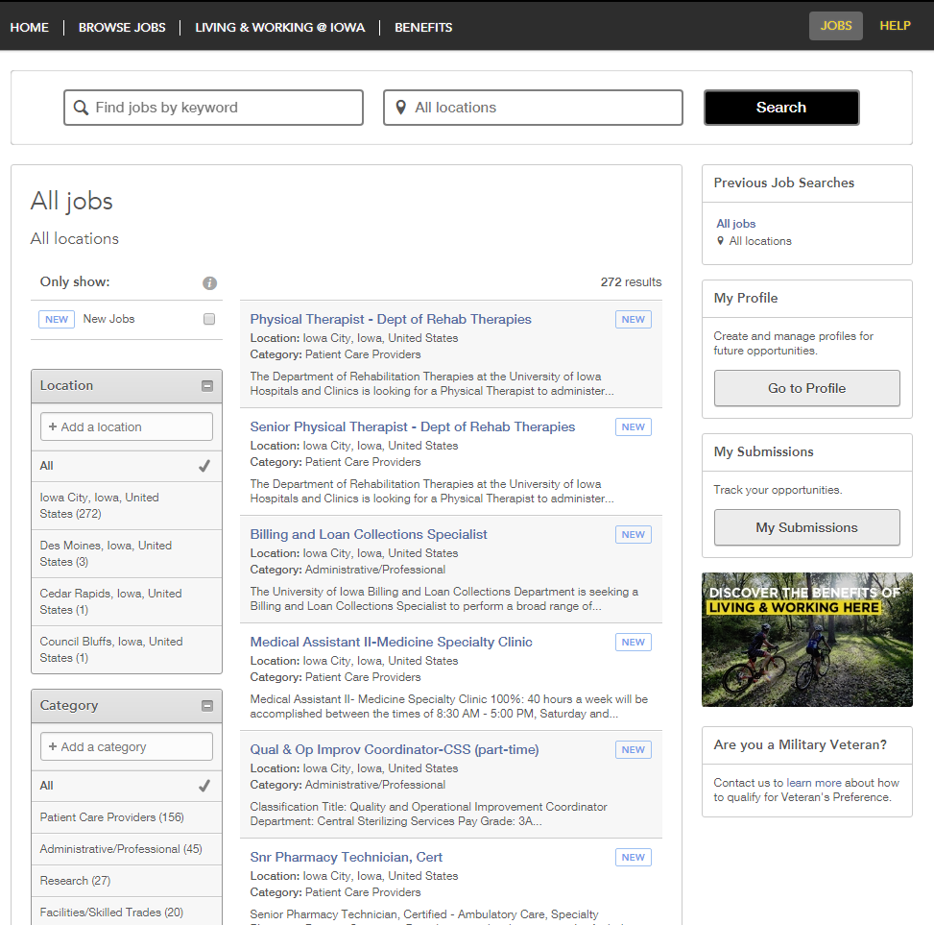
Log in to your account OR create an account by clicking “Go to Profile”
You can browse for open positions by choosing a job category. If you’re unsure of which category to choose, search by clicking “All Staff Jobs.”

Privacy Agreement
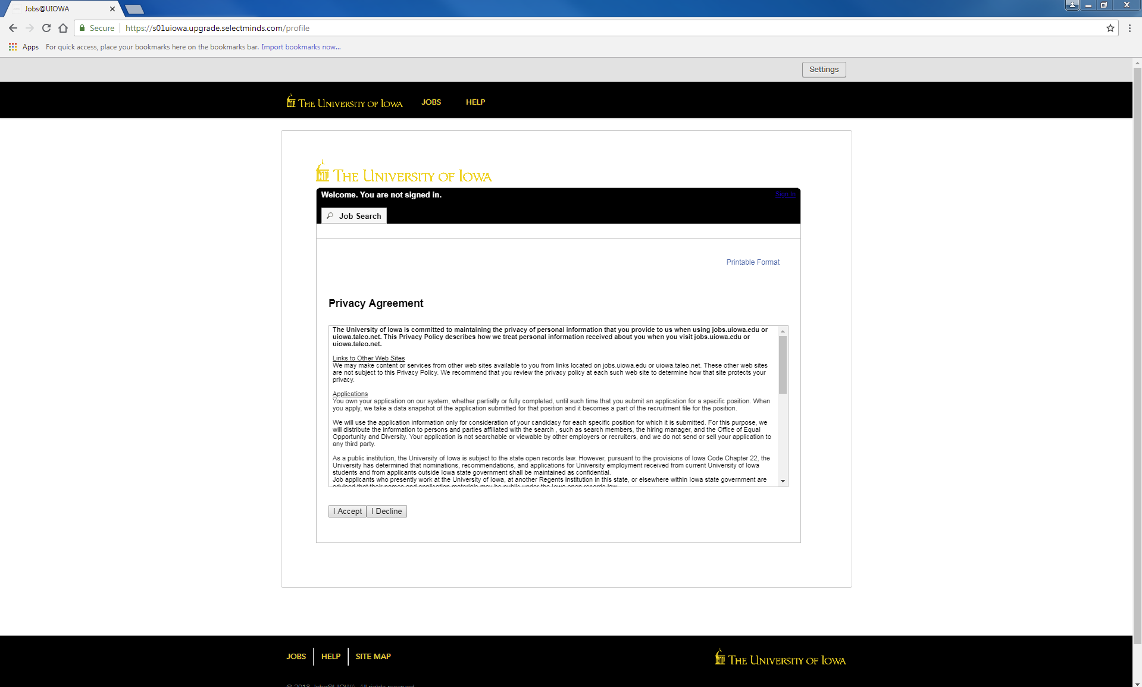

Login
Log in with current username or register as a new user
(If you have an existing profile, proceed to pg. 17 for further help)
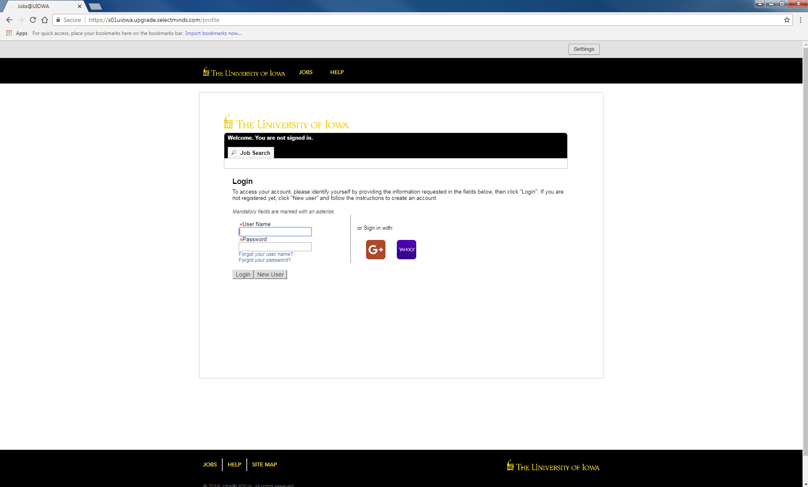

New User Registration
Steps:
- Create a username
- Create a password that contains at least 9 characters: must have at least 1 letter, 1 number, 1 special character (ex. $ ! @ # *+), and not contain more than 2 of the same characters in a row (ex. AAA, bbbb, $$$$)
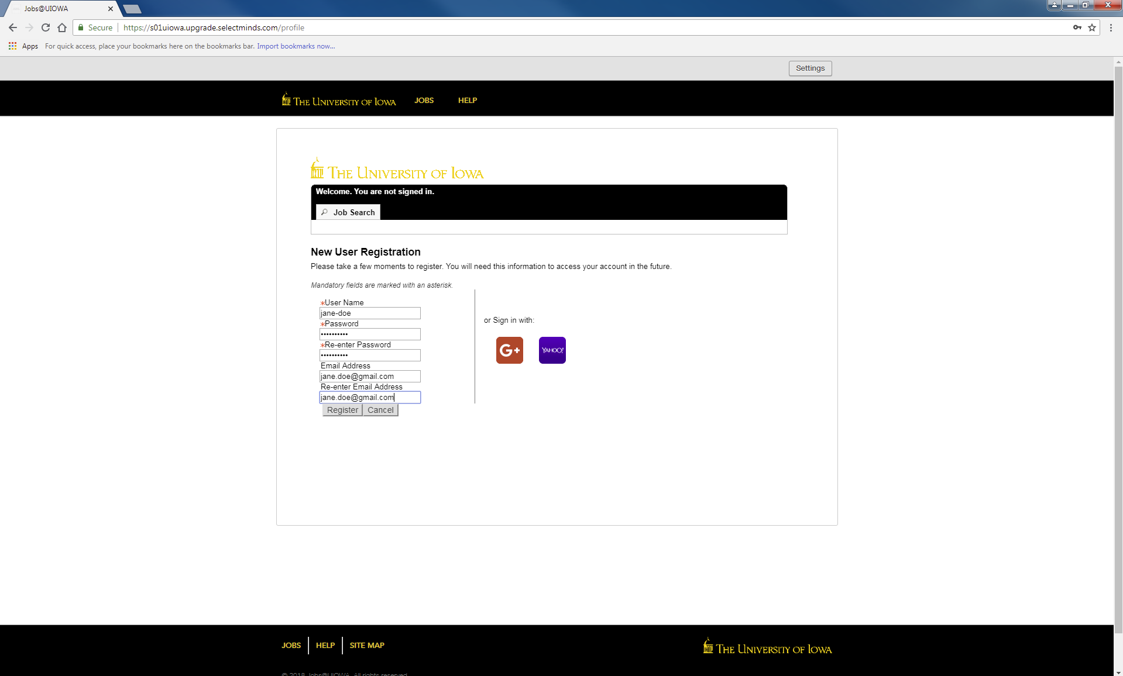
- Input email address to link with website so you can stay updated with job postings

Remember your username and password! It will be your only access to your account.

Press “Register” when all information is filled out
Resume/CV Upload
You can import work history a variety of ways:
- Connect your LinkedIn or Indeed profile
- Upload a resume/CV
- Manually input past work history
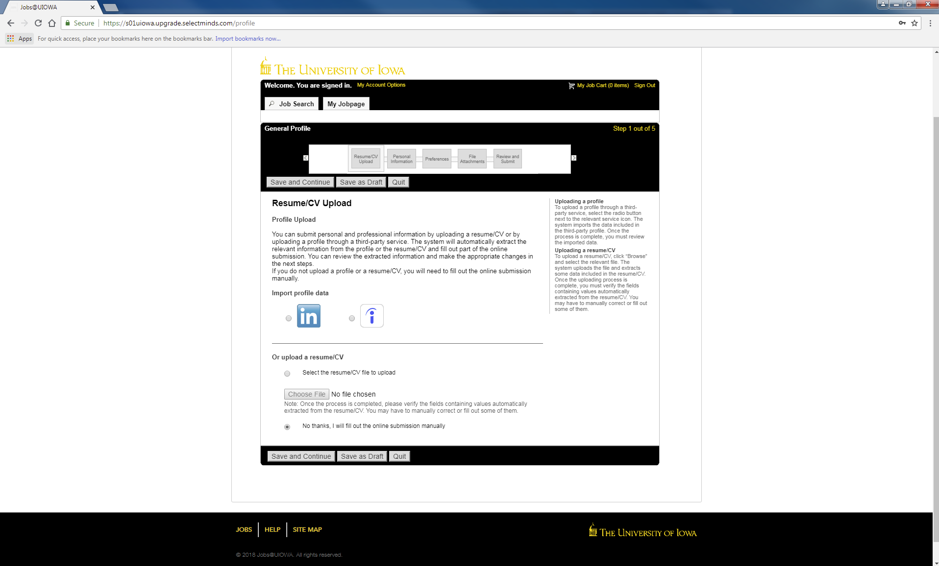

1
2
3

Personal Information
Input all required personal information and job preferences

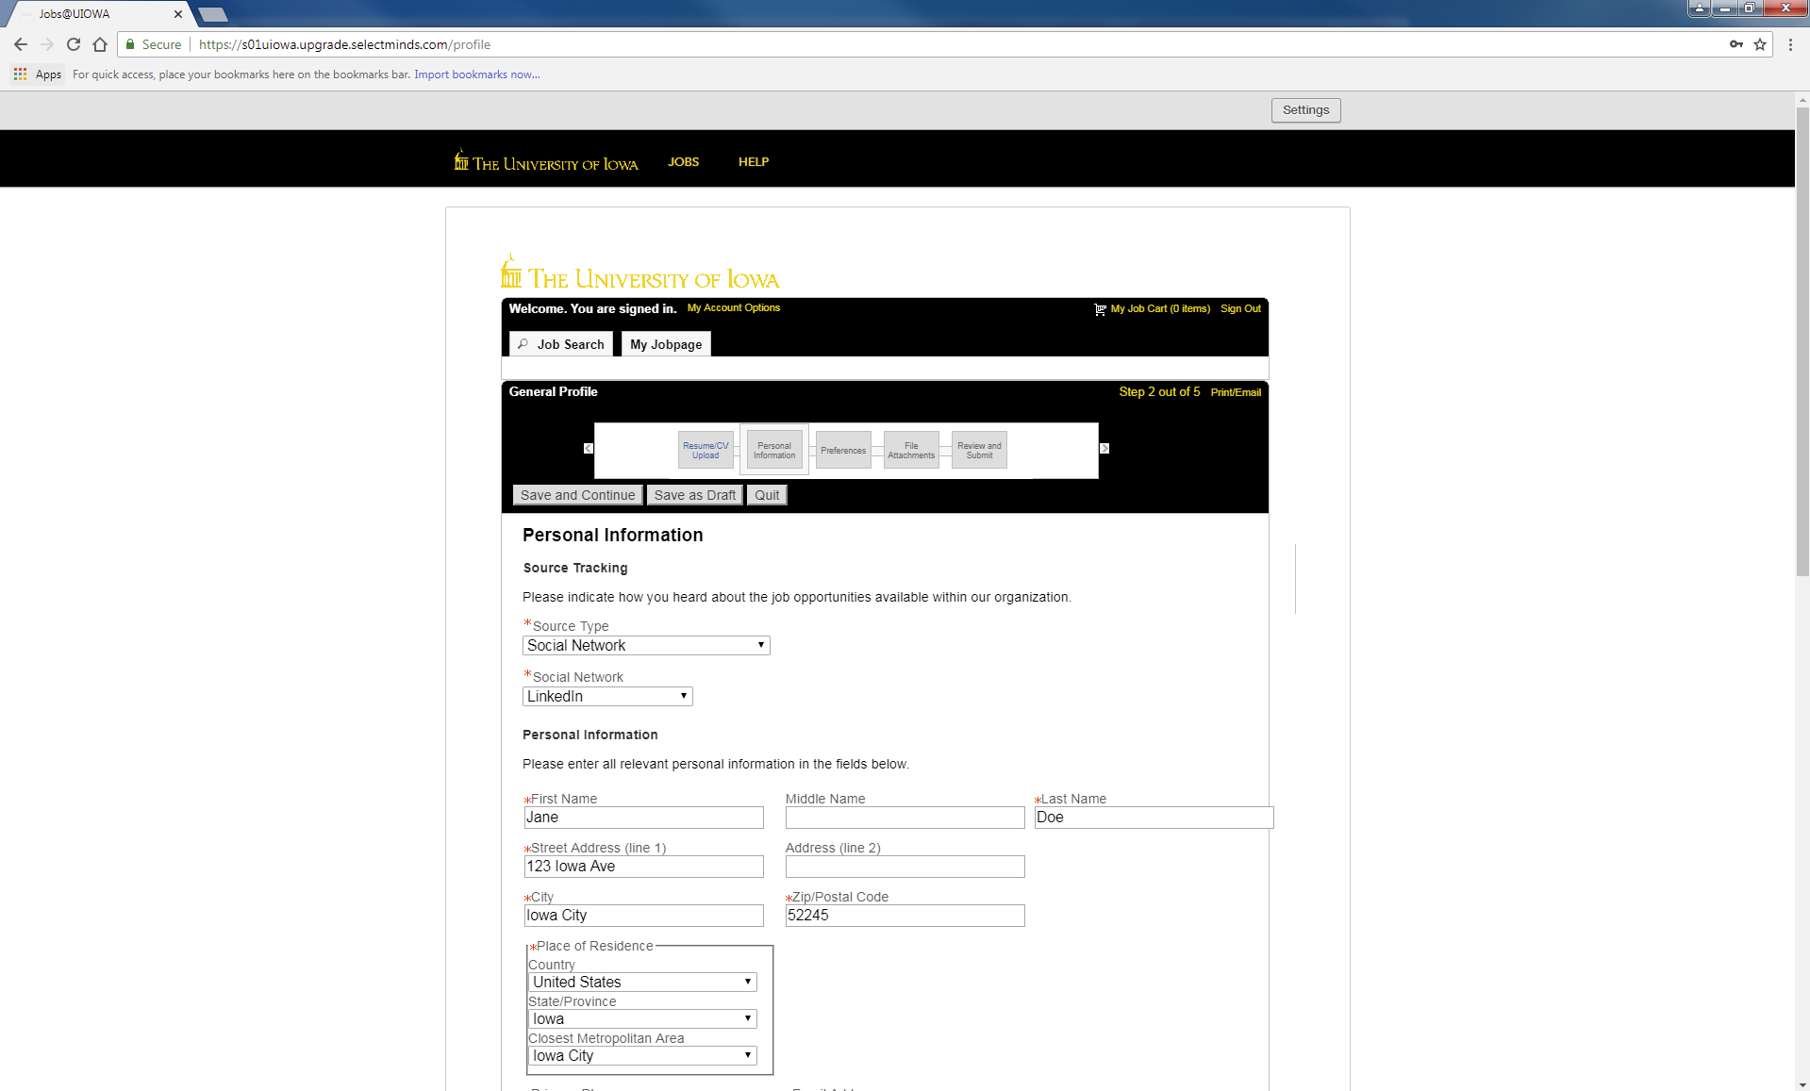

This bar tells you your progress when filling out profile

Personal Information continued…
Select preferred shifts, job level, job type, etc.
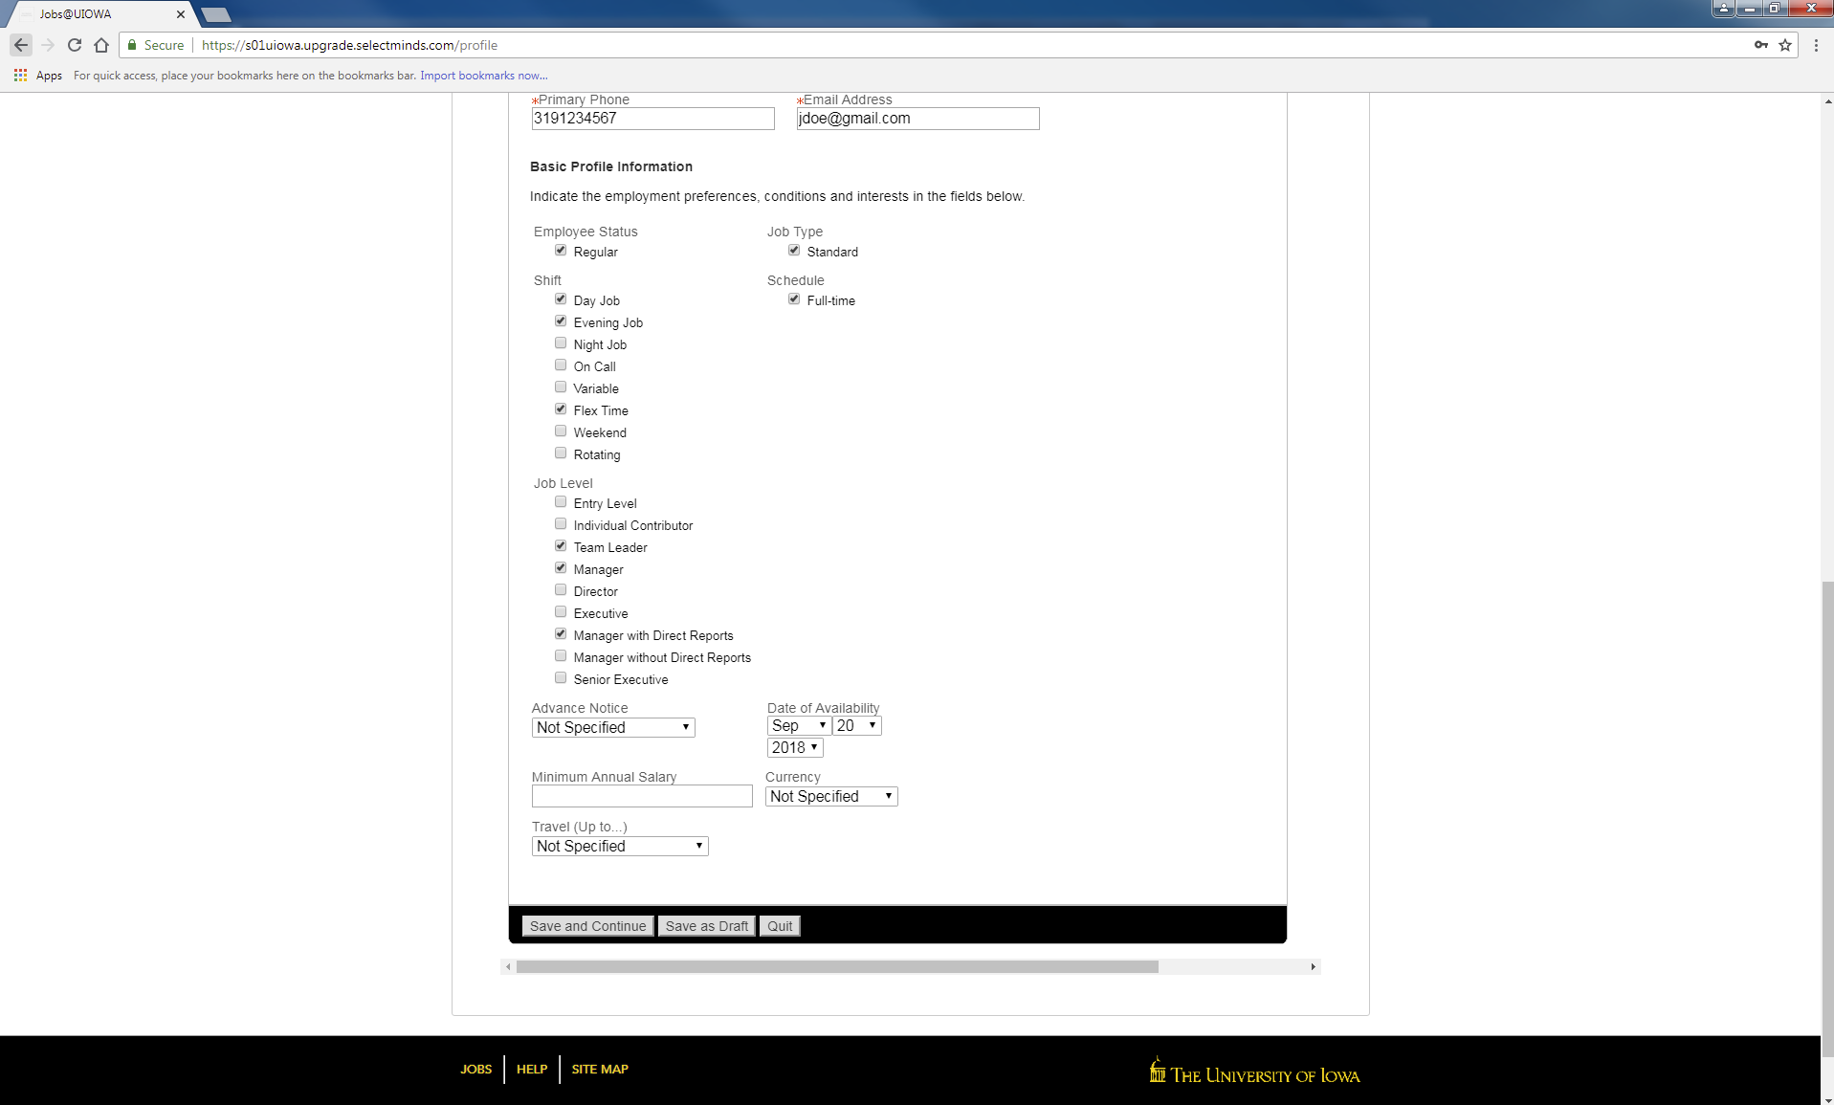

Preferences
Select as many preferences as you would like. Find the corresponding job field and press “Add to List”
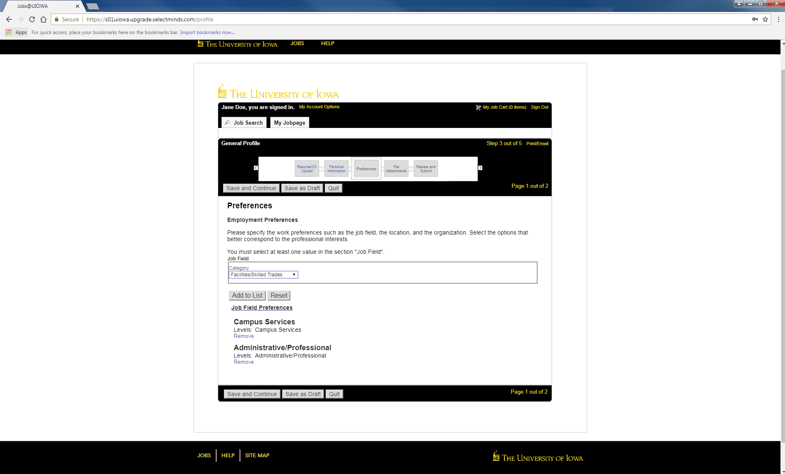
Selected preferences will show up here

Preferences continued…
Select your location preferences on this page
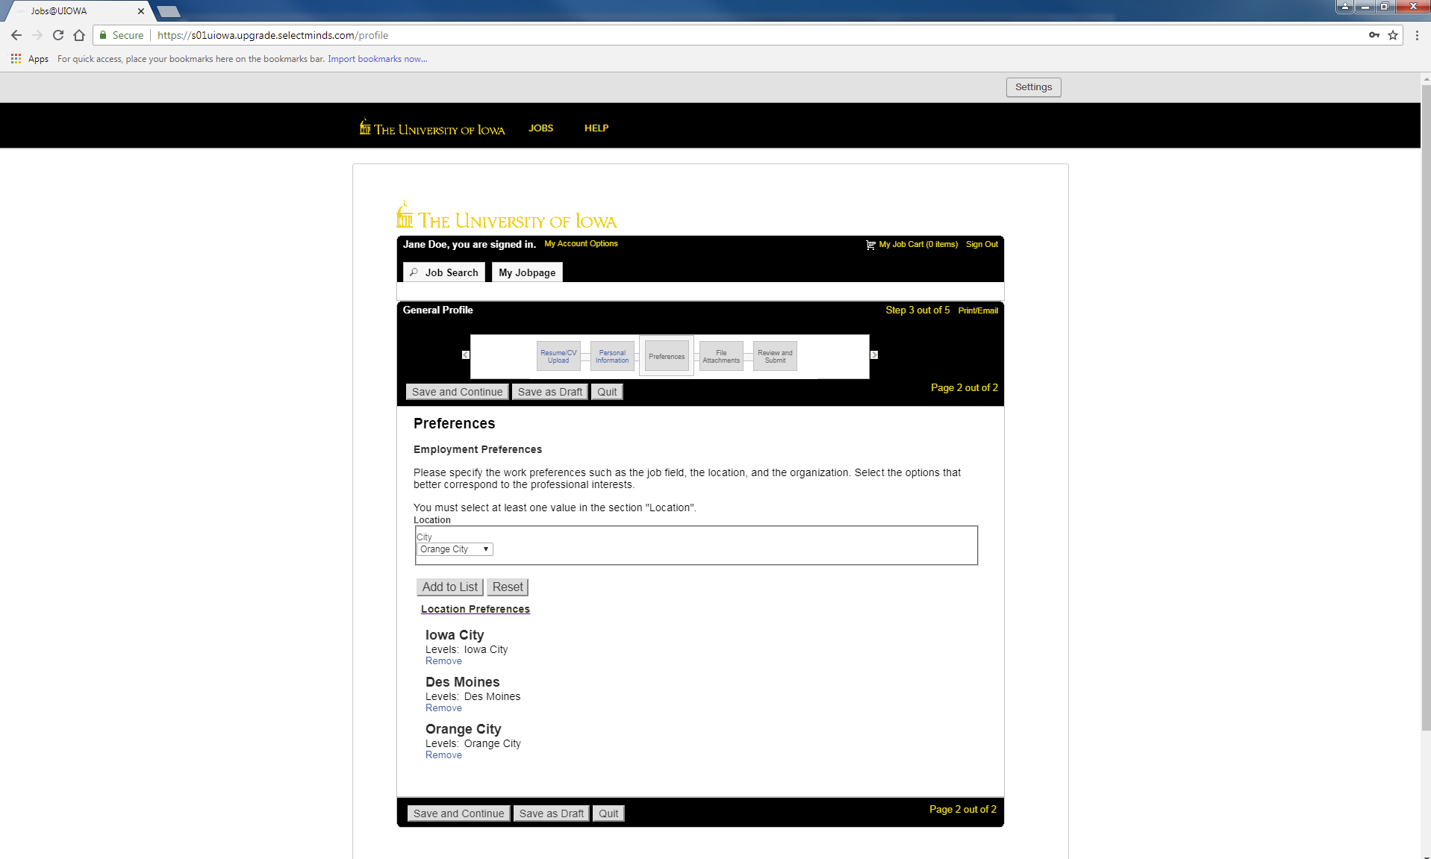

Selected preferences will show up here

File Attachments
Provide any additional attachments to your job profile
If you don’t have any attachments, press “Save and Continue”
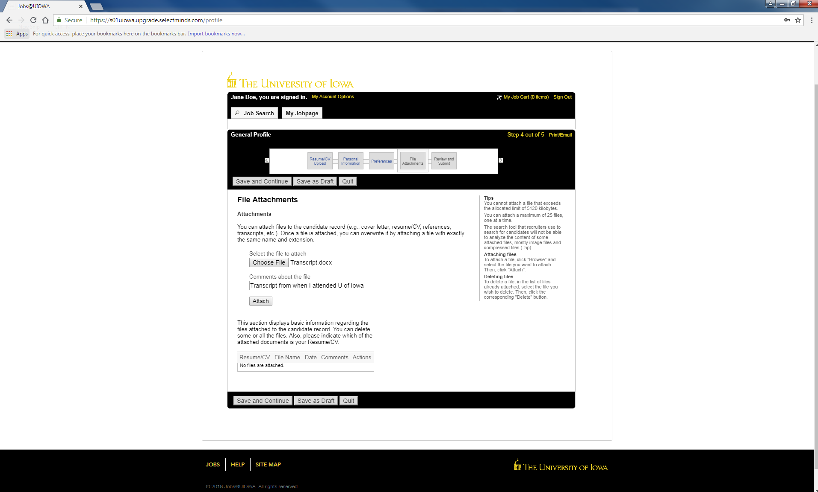
Review and Submit
Make sure to review all information before submitting your profile
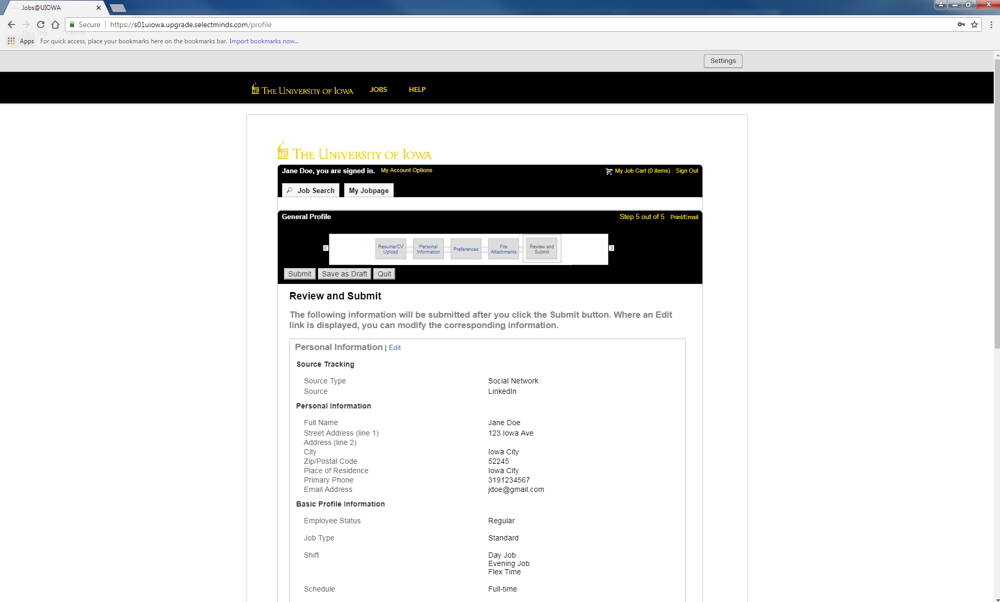
If you need to make any changes, press “Edit”

Thank You
Your profile has been created and you can begin searching for available jobs at the University of Iowa by selecting “View All Jobs”
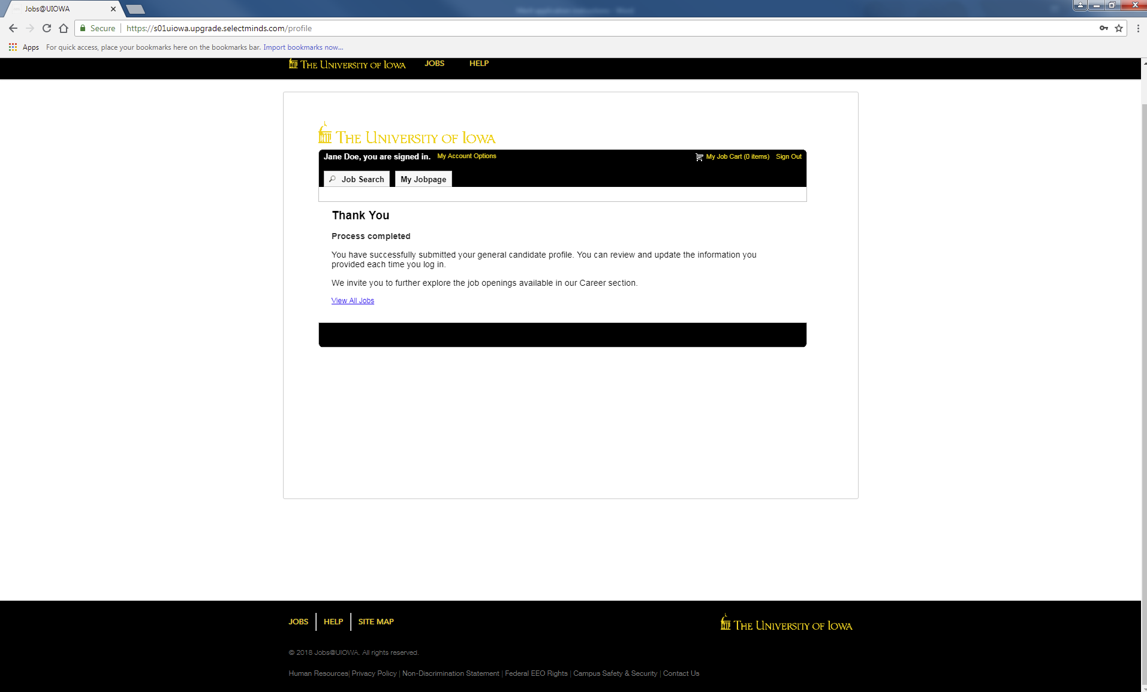
My Jobpage
On this page you can see jobs you’ve applied to (“My Submissions”), your JobCart, and Saved Jobs
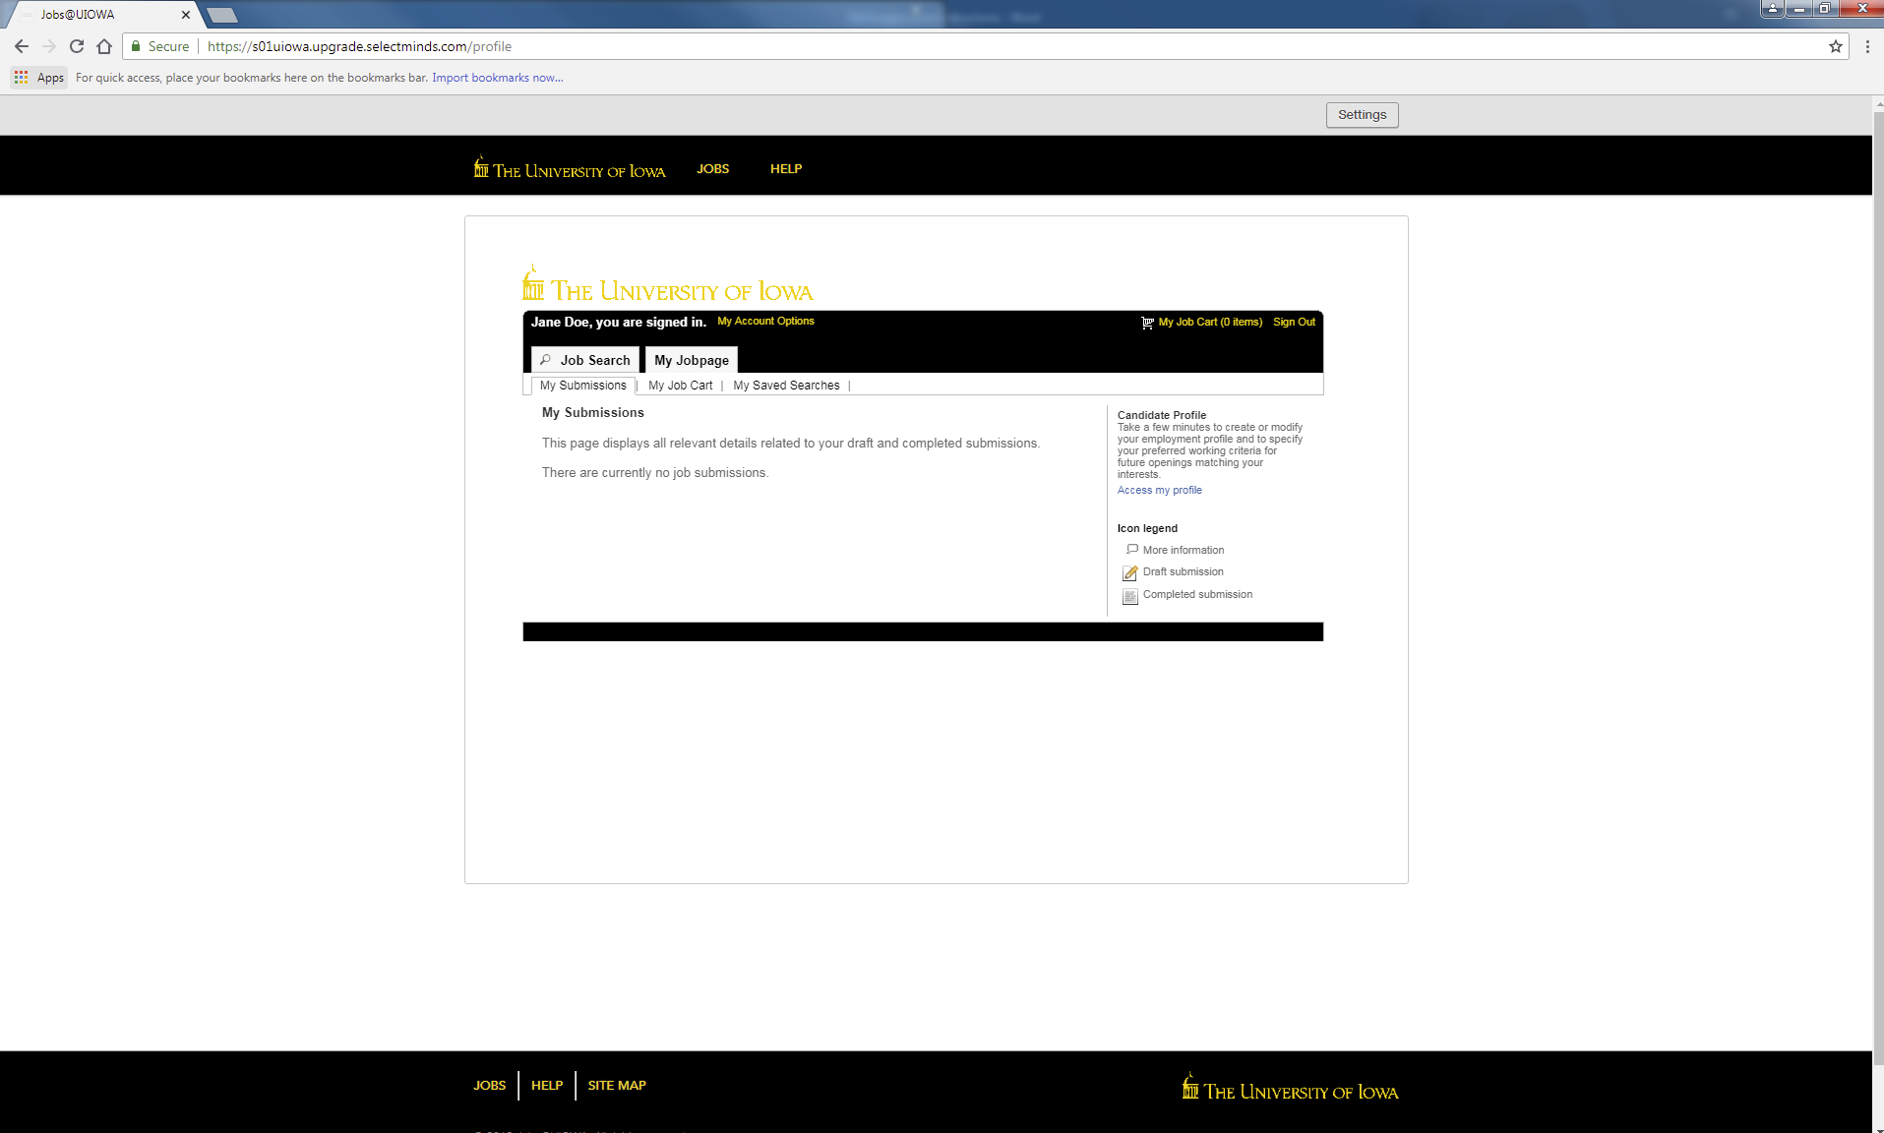

Applying to a job

Applying to a job
Once you find a job you want to apply for, select “Apply for Job”
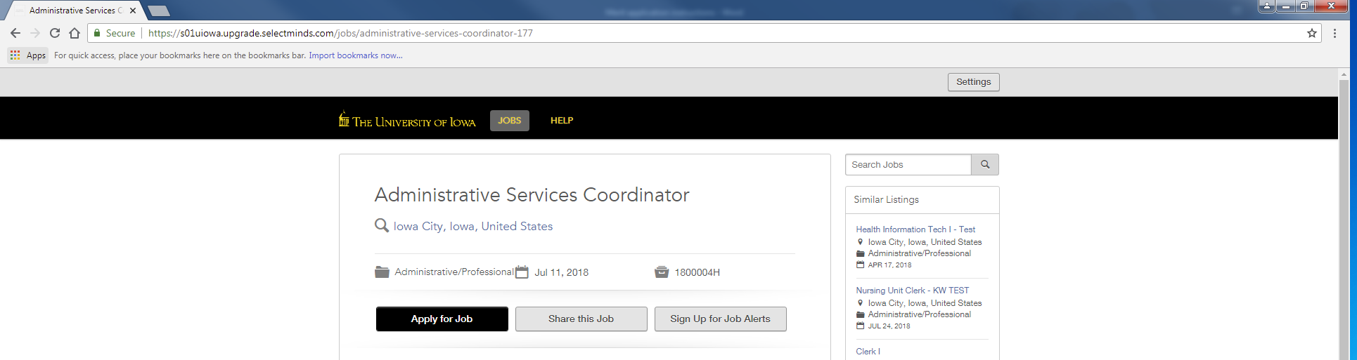

Login with your email address and press “Go”
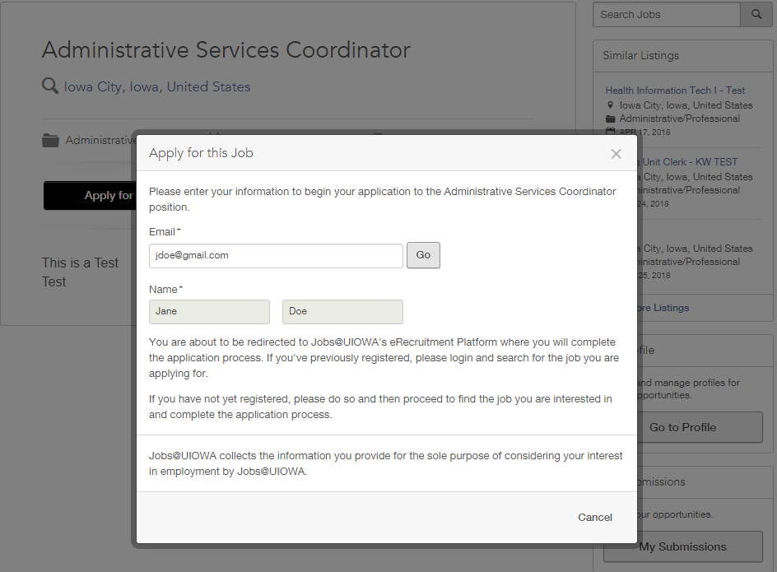

Personal Info
Some information will automatically be pulled from your general profile.
Double check that everything is correct and fill out any missing information.
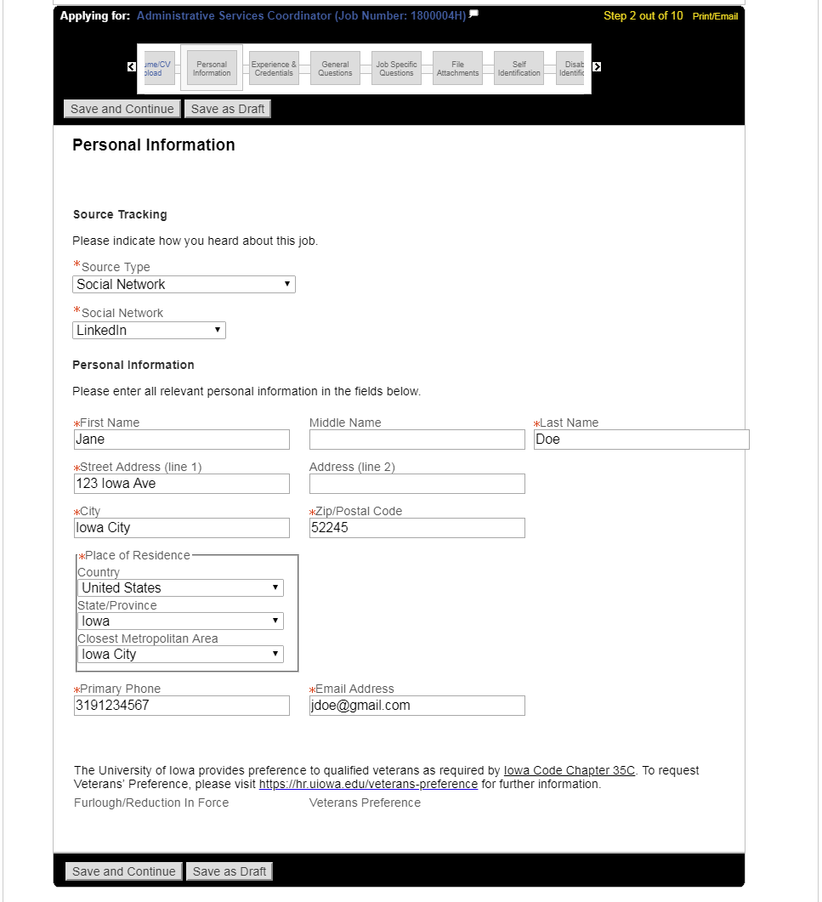
This show the position you’re applying for

Experience & Credentials
Input all experiences and credentials.
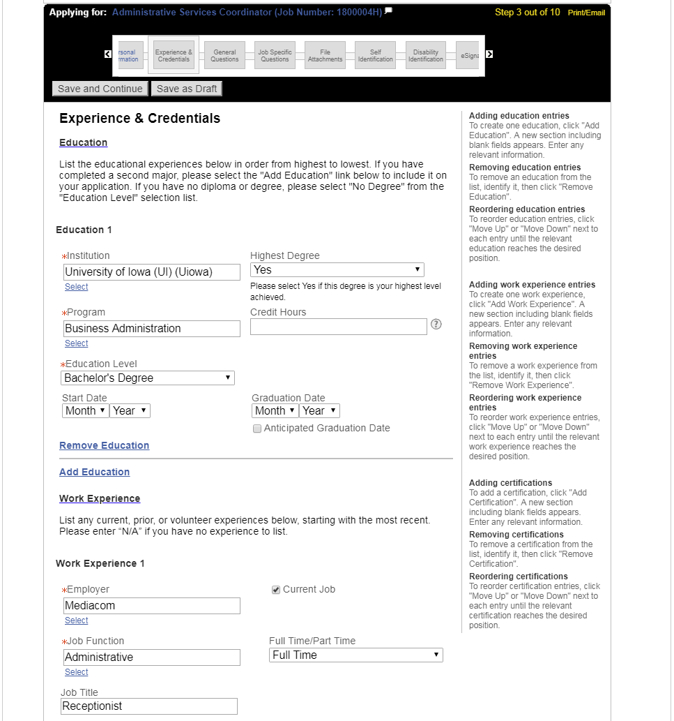
Note- some information may be already filled in from resume if uploaded earlier

Add any additional Education or Work Experience by selecting “Add Education” or “Add Work Experience”

General Questions
Answer the following questions
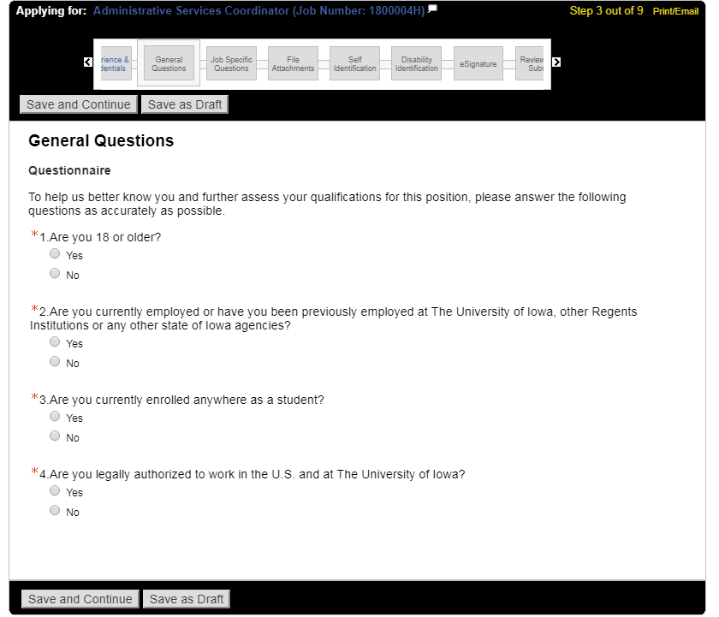

Job Specific Questions*
In this section, answer any job specific questions that are asked. Questions may vary depending on job
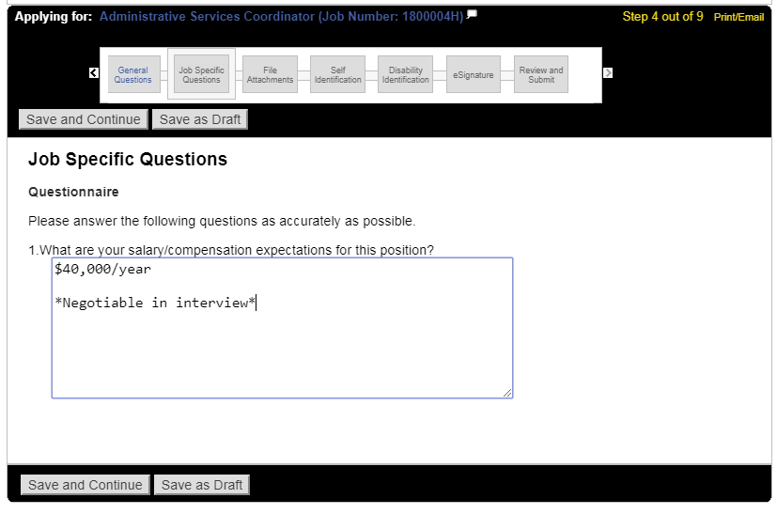

*Note- This may not show up for all jobs
File Attachments
Attach any additional files here (resume, cover letter, references, etc.) by selecting “Choose File.”
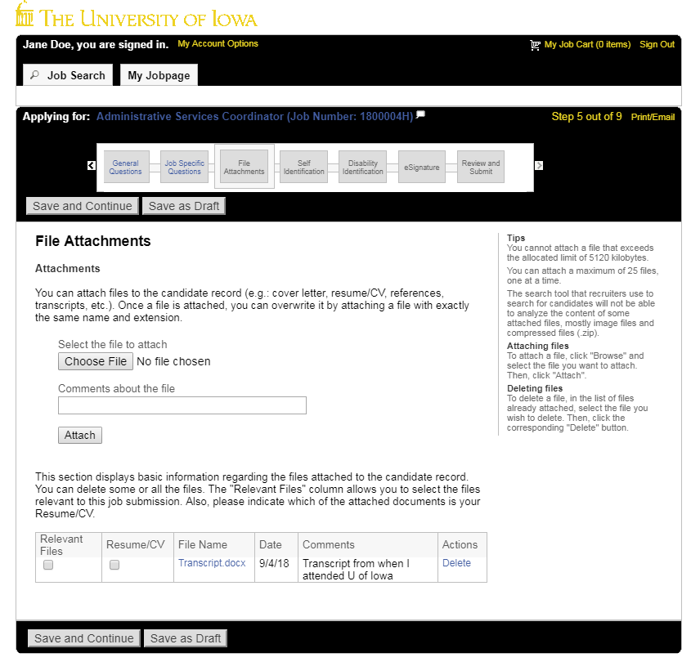
To attach it to your application, make sure to press “Attach” once your file is chosen

1

2

Self-Identification and Disability Identification
This information is voluntary and if you chose not to fill out, you will not be subject to adverse treatment.
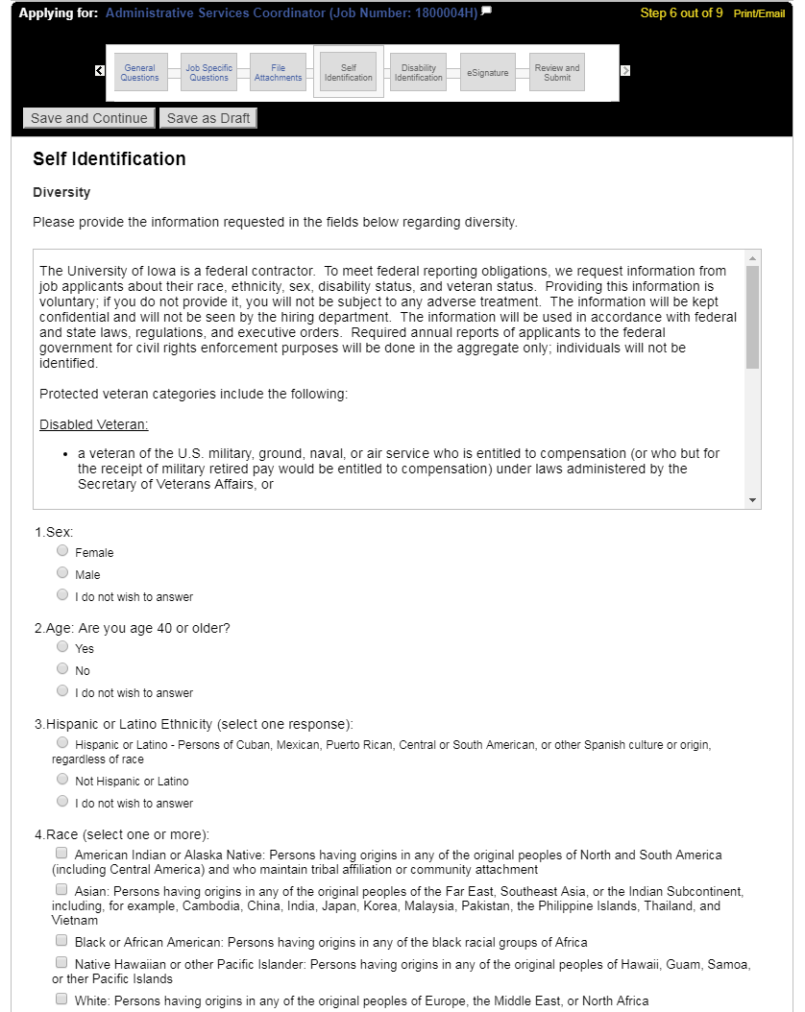
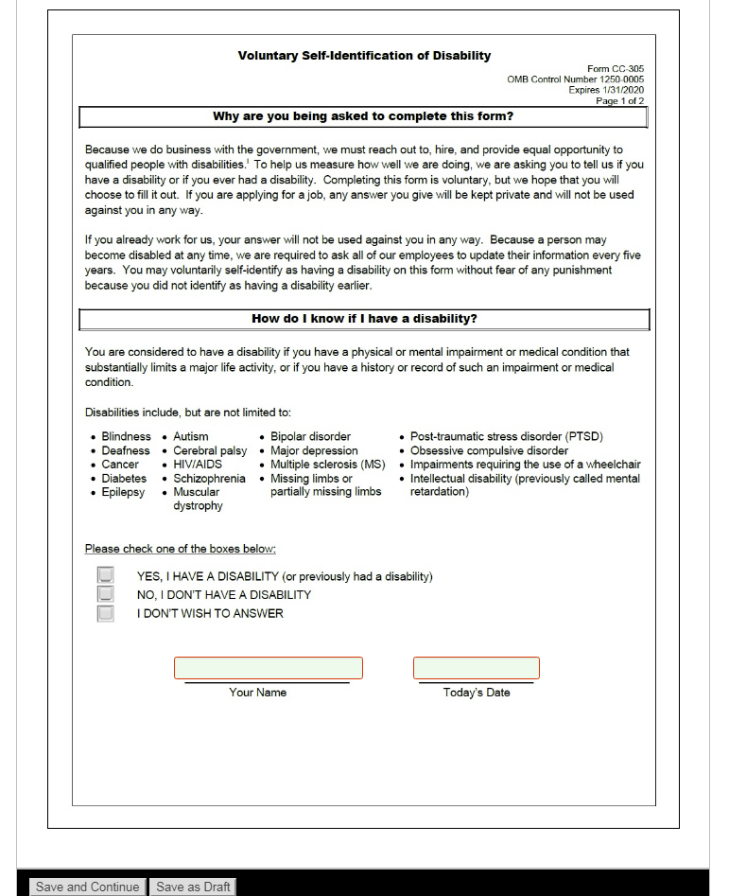

e-Signature
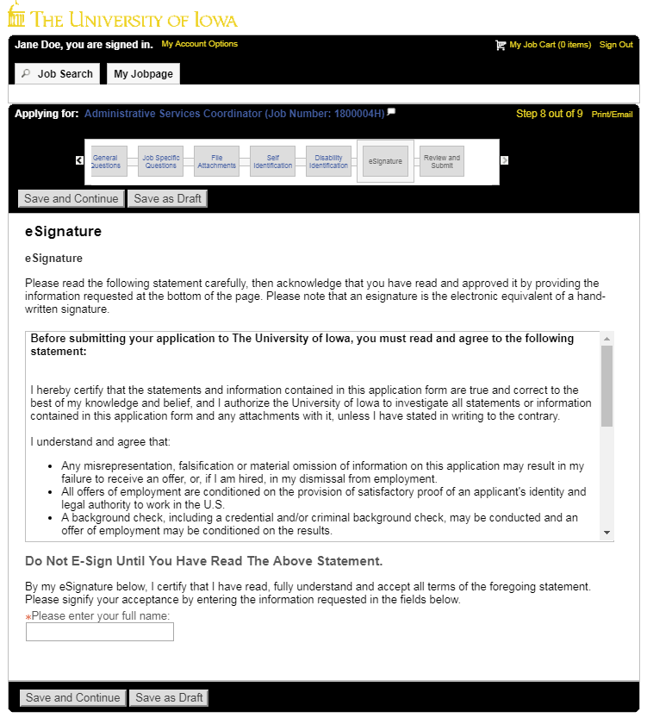

Sign your application here

Review and Submit
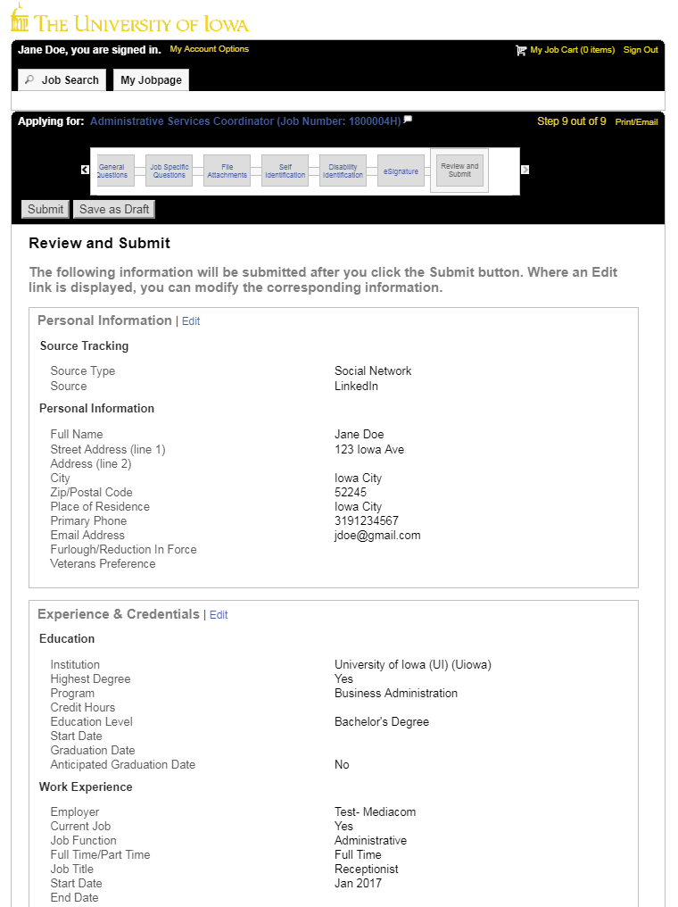
Make sure to review all information before submitting your profile. Once you press submit, have successfully applied for the job.

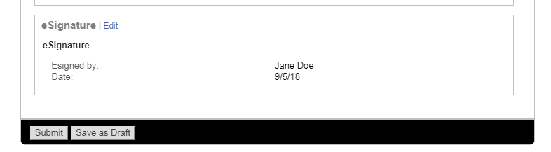

My Jobpage
You can view any completed or draft submissions under your Jobpage.
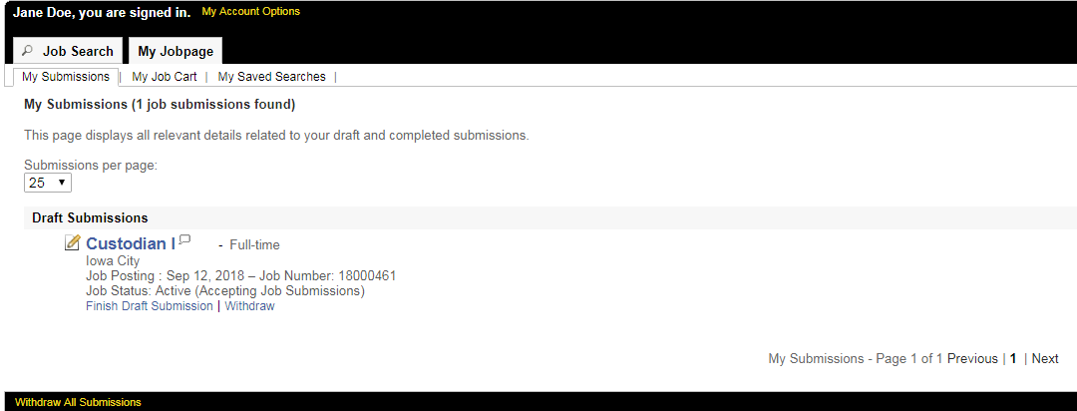

To continue applying for other available positions, click “Job Search” and you will return to the open positions.

