White, Scott G
Scott-white@uiowa.edu
A Tool to Improve the Zoom Experience
A source that with a quick search of the table of contents and a click, will get you an answer to your question. Test it out and see how it works. Be a better host in a few clicks.
Zoom host guide

Table of Contents
Foreword 6
Security 7
Zoom Software 7
Before the Meeting 7
General Strategies 7
Setting Up Additional Security in Meeting Settings 8
During the Meeting 14
General Practices 14
Remove a Participant 14
After the Meeting 15
Meeting Setup 16
Scheduling Meetings 16
Upcoming Meetings 16
Previous Meetings 19
Personal Meeting Room 19
Updating Scheduled Meetings 20
Using Meeting Templates 20
Scheduling a Meeting from a Template 21
Prior to Meeting 21
Polling for Meetings 21
Roles in a Meeting 22
Comparison 22
Alternative Host 23
Getting Started with Breakout Rooms 24
Prerequisites 24
Enable Breakout Rooms as an End-User 24
Joining a Meeting 25
Starting or Joining a Scheduled Meeting as the Host 25
Joining a Scheduled Meeting Method #1 26
Inviting Others to Join a Meeting 26
Instant Meeting Invite 26
Testing Computer or Device Audio 29
Prerequisites 29
Testing Audio before Joining a Meeting 29
Testing Audio Using Audio Settings 30
Testing Your Speaker 32
Testing your Microphone 32
Microphone Troubleshooting 32
Sharing Computer Sound during Screen Sharing 32
Screen Sharing with Computer Sound While Connected to Meeting Audio via Phone 33
Testing Your Video 33
Testing Video before a Meeting 34
Testing Video While in a Meeting 35
Optimizing a Shared Video Clip in Full Screen 35
Prerequisites 36
Starting a New Screen Share and Optimizing for Full-Screen Video 36
Optimizing for Full-Screen Video While Screen Sharing 37
Touching Up Your Appearance 37
Run Touch Up Your Appearance Prior to Meeting 37
Run Touch Up Your Appearance During a Meeting 38
Managing Participants 38
Using Mute All and Unmute All 38
Managing Participants in a Meeting 39
Controls for Hosts and Co-Hosts 39
Controls for Managing Participants 40
Prevent Participants from Screen Sharing 41
During Meeting 42
Editing Shortcuts 42
Available Keyboard Shortcuts 43
Meeting Controls for Host 44
Enabling and Adding a Co-Host 45
Using Co-Host in a Meeting 46
Polling 46
Creating a Poll 46
Launching a Poll 47
Downloading a Report of Poll Results 49
Changing the Video Layout 49
Full Screen 50
Active Speaker 50
Gallery View 51
Mini Window 52
Layout when Screensharing 53
Hiding Non-Video Participants 54
Hiding 54
Displaying Participants in Gallery View 56
Using the Spotlight Video Feature 57
Spotlight When I Speak 59
Sharing Your Screen 60
Share Screen Menu 61
Using dual monitors 63
Using Dual Monitors 63
Screen Sharing a PowerPoint Presentation 64
Dual Monitors with Slide Show and Presenter’s Views 64
Single Monitor Setup with Slide Show View in a Window 65
Single Monitor Setup with Slide Show in Full Screen 67
Sharing a Whiteboard 67
Multiple Whiteboards in a Meeting 68
Sharing Multiple Screens Simultaneously 68
Sharing Screens at the Same Time 69
Limitations 69
Controlling Chat 69
In-Meeting Chat 70
Access the Chat in Meeting from a Desktop Device 70
Accessing the Chat in a Meeting from a Mobile Device 71
Changing In-Meeting Chat Settings 72
Using Meeting Reactions 73
Sharing a Meeting Reaction 73
Setting the Skin Tone for your Reactions 73
Using Nonverbal Feedback during Meetings 74
Providing Nonverbal Feedback during Meetings (Attendees) 74
Managing Nonverbal Feedback (Hosts) 75
Managing Video Breakout Rooms 76
Creating Breakout Rooms 76
Options for Breakout Rooms 77
Assigning Participants to Rooms 78
Preparing Breakout Rooms 78
Managing Breakout Rooms in Progress 79
Ask for Help 80
Broadcasting a Message to all Breakout Rooms 80
Participating in Breakout Rooms 81
Joining a Breakout Room 81
Participating in the Breakout Room 81
Asking for Help 82
Recording while in a Breakout Room 82
Leaving the Breakout Room 83
After the Meeting 83
Saving the Chat Conversation 83
Save Chat Manually 83
Auto-Save Chat 83
Default Chat Save Location on Computer 84
Troubleshooting 86
Downloading the Latest Version of Zoom 86
Zoom Mobile App (iOS or Android) 86
Troubleshooting in Zoom 87
Addressing Audio Echo in a Meeting 87
Case 1: A participant has both the computer and telephone audio active 87
Case 2: Participants with computer or telephone speakers that are too close to each other 87
Case 3: Multiple computer with active audio in the same conference room 88
Other Tips: 88
Requesting or Giving Remote Control 88
Requesting Remote Control 89
Giving Remote Control 89
Identifying Error Code and Messages for Zoom Meetings 90
Error Codes and Messages 90
Tips from Blogs 91
Using Personal Meeting ID 92
Setting to Always Use PMI for Instant Meetings 92
Instant Meetings with PMI 93
Starting Meetings with PMI 93
Scheduling a Meeting with PMI 94
Customize Your PMI 94
Restrictions for Customizing Your PMI 95
Edit Personal Meeting Room Settings 96

Foreword
We’re faced with a whole new world to learn Zoom and other tools in a matter of days. There are numerous Zoom Help webpages to assist you, but you just want to get it up and running or you need a quick answer to get you back on track.
The Zoom Help Center offers a number of webpages to assist you. In fact, all the information in this document is gleaned from those pages. In this guide, an attempt is made to organize the information into one place and give you the chance to use the Table of Contents links to locate what you want or need to do. Just select the topic link to locate the instructions to complete that task.
This does not replace the need to try things out for yourself and improve how you host and deliver an excellent online experience. We hope you find this helpful and we at UI Organizational Effectiveness and Learning and Development are here to support you.

Security
Since the move toward social distancing, Zoom has become a tool for many across our university, state, and U.S. We start this guide out with providing you with the best methods to try and ensure privacy when and where you need it. IT Security has published a page to outline what you can do to improve security. The following are some more in-depth details in how to apply what the page recommends.

Zoom Software
The Zoom explosion has led to many new potential opportunities for hackers to gain access either to Zoom itself, individual meetings, or a way to gain access to networks such as ours at UI. Zoom offers regular updates to try to stay on top of these nefarious efforts. Make sure you update Zoom when the prompt appears. It usually takes a matter of seconds and the security is worth every second.

Before the Meeting

General Strategies
There are several ways you can build a secure meeting. It is up to you when you set up a meeting what level of security you require. Here are two basic strategies for all to employ:
- Share your meeting link privately via email or chat and not on social media.
- Disable the Join before host option

Join before Host
To disable the Join before host option, complete the following steps:
- Sign into Zoom.
- Click Sign In and complete the sign in process.
- Click Settings from the left navigation controls.
- Scroll down until the Join before host option appears.
- Ensure the setting is turned off.

Only Authenticated Users
To make it so participants have to authenticate prior to a meeting, complete the following steps:
- Sign into Zoom.
- Click Sign In and complete the sign in process.
- Click Settings from the left navigation controls.

- Scroll down until the Only authenticated users can join meetings options appear.
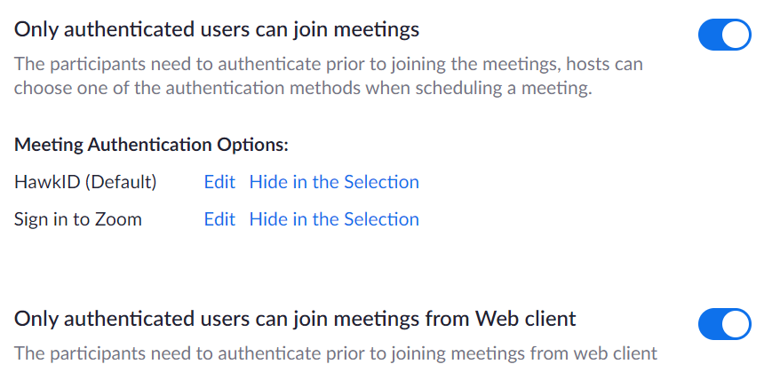
- Edit the meeting authentication options as necessary.
- Ensure each of the settings are turned on.

Setting Up Additional Security in Meeting Settings
If you’re not encountering individuals bombing your meeting and your discussions are not private, maybe there is no additional security you require. However, should you want or need additional security, here are some ways to add levels of security.

Require a Password for the Meeting
Zoom offers different ways to hold meetings. You can apply passwords to any one or more of these settings to improve security. To require a password for a meeting, complete the following steps:
- Sign into Zoom.
- Click Sign In and complete the sign in process.
- Click Settings from the left navigation controls.
- Scroll down until the password options appear.
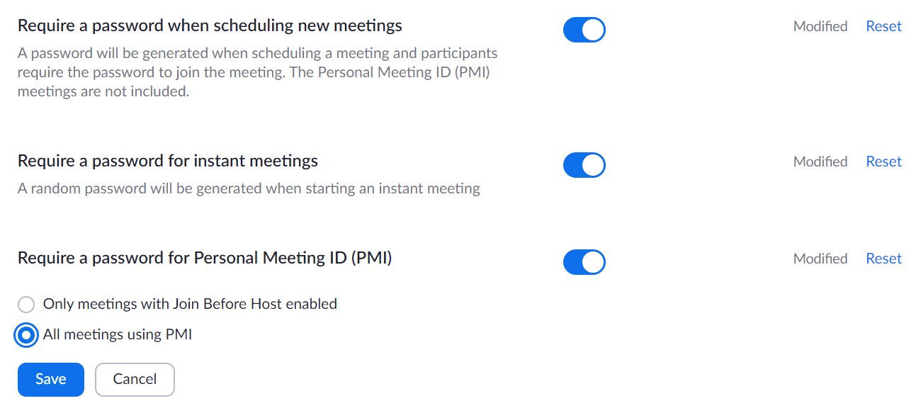
- Ensure the appropriate setting is turned on.

Allow Removed Participants to Rejoin
Should you identify unwanted guests, you reserve the right to remove them during the meeting. To avoid those who are removed from re-entering the meeting, complete the following steps:
- Sign into Zoom.
- Click Sign In and complete the sign in process.
- Click Settings from the left navigation controls.
- Scroll down until the Allow Removed Participants to Rejoin option appears.
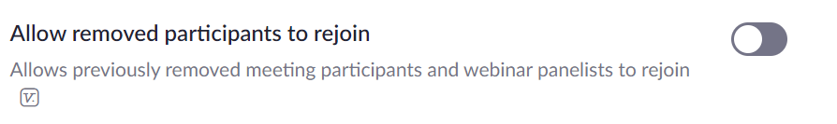
- Ensure the setting is turned off.

Play Sound when Participants Join or Leave
An audio cue that alerts you when someone enters or leaves is helpful, so you know when someone has dropped or joined the meeting. This can be a tip to review the participant list to see who is now in the meeting. To set a sound when a participant joins or leaves, complete the following steps:
- Sign into Zoom.
- Click Sign In and complete the sign in process.
- Click Settings from the left navigation controls.
- Scroll down until the Play sound when participants join or leave options appear.
- Ensure the option is turned on.
- Select Heard by host only.

Identify Guest Participants Outside the University
The host can check the participants list to see that a person outside of the university has joined the meeting. To enable this feature for your meetings, complete the following steps:
- Sign into Zoom.
- Click Sign In and complete the sign in process.
- Click Settings from the left navigation controls.
- Scroll down until the Identify Guest Participants options appear.
A guest is anyone that is not signed in, signed in from an email address that is not in the same account as the host, or signed in with a version of the Zoom client software older than the supported version. When a guest appears during the meeting, they will appear with an orange background visible to the host.
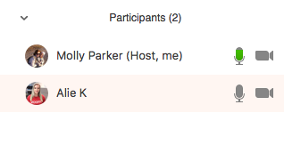

Enact a Waiting Room
The waiting room feature allows the host to control when a participant joins the meeting. As the meeting host, you can admit participants in one by one or hold all attendees in the waiting room and admit them all at once. Participants will see a screen like that shown below before the host allows them to join.
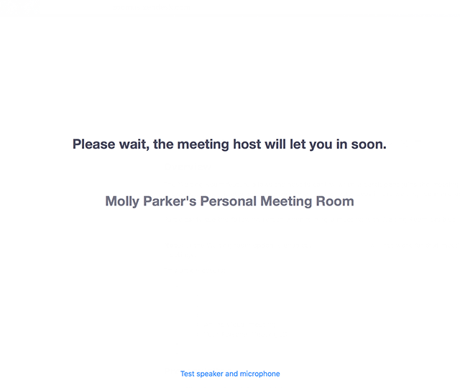
You can also customize the waiting room screen with your own logo, title, and description.
To enable the waiting room, complete the following steps:
- Sign into Zoom.
- Click Sign In and complete the sign in process.
- Click Settings from the left navigation controls.

- Scroll down until the Waiting room option appears.
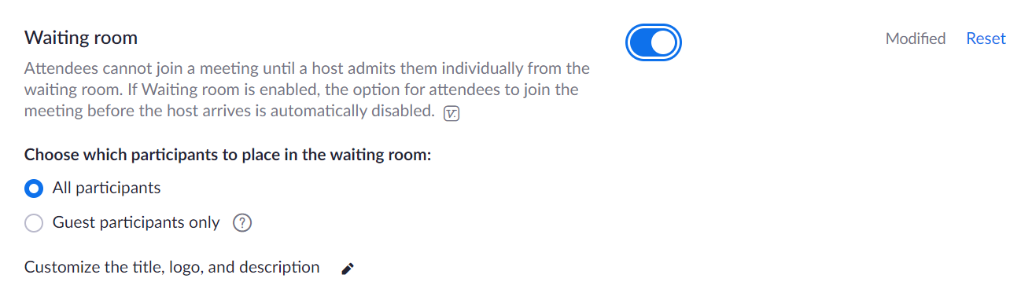
- Select which participants to place in the waiting room.
With these settings enacted, complete the following steps to admit participants during a meeting:
- Click Manage Participants from the navigation controls.
- Click Admit to allow a participant to join the meeting.
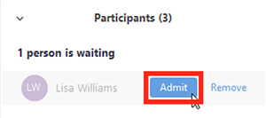
Or to have all participants join, click Admit All.
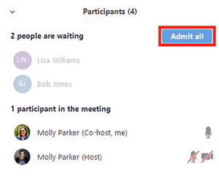
Customize the Waiting Room
To customize the waiting room, complete the following steps:
- Sign into Zoom.
- Click Sign In and complete the sign in process.
- Click Settings from the left navigation controls.

- Scroll down until the Waiting room option appears.
- Click the pencil icon.
The waiting room customization window appears.
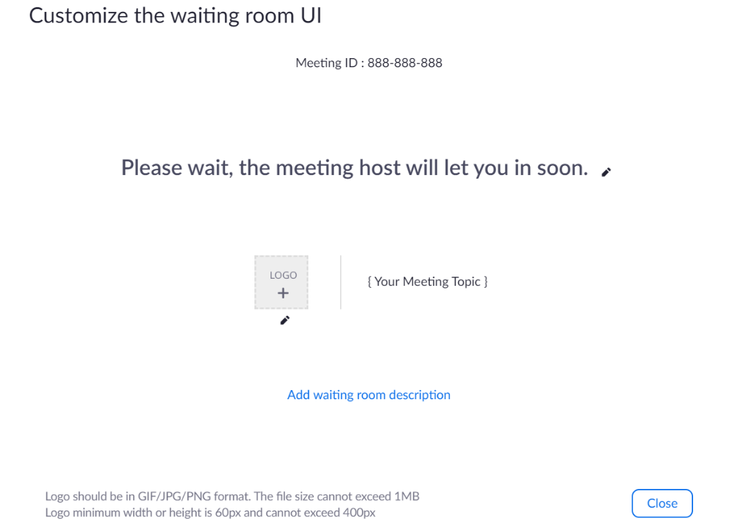
- Click the pencil icon for the items you want to customize.
- Title: Click the pencil icon next to Please wait, the meeting host will let you in soon to update the meeting title. Click the checkmark when done.
NOTE: The title is limited to 64 characters.
- Logo: Click the pencil icon underneath the Logo button.
NOTE: Logos can be in GIF, JPG, or PNG format. They cannot exceed 1MB. The minimum height and width is 60 pixels and the maximum is 400 pixels.

- Description: Click Add waiting room description to add a description to the waiting room. Click the checkmark when done.
NOTE: The description is limited to 400 characters.
- Click Close when you are done.
Participants will see your customized waiting room when they join the meeting.

During the Meeting

General Practices
General best practices to improve security include the following:
- Close any programs, websites, Outlook, and anything else that you do not need during the meeting and choose to only share what you want others to see
- Ensure confidential information is not visible to remote participants in the video webcam you share
- Monitor who else can hear your conversations including smart devices such as Alexa, Siri, and similar

Remove a Participant
Should you find a participant in your meeting that should not be there, complete the following steps to remove the participant:
- Click Manage Participants in the navigation controls to view the participants list:
- Click the drop-down menu located at the top-left corner to close the participants list or click Pop Out to separate the participants list from the meeting window:
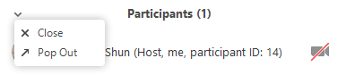
- Hover over a participant and click More for these options:
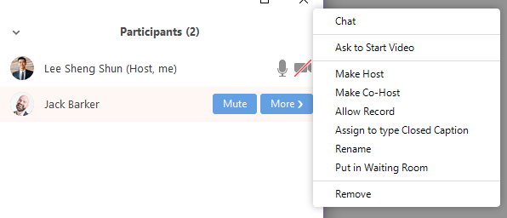
- Click Remove.

After the Meeting
When the meeting concludes, make sure you select End Meeting for All. Should you erroneously select Leave Meeting then the host roll is passed to another person still on the call.

Meeting Setup

Scheduling Meetings
There are a few ways to schedule meetings. To make it consistent and most reliable, we recommend that you use the University of Iowa Zoom account URL, https://uiowa.zoom.us, as the starting point. Complete the following steps to schedule a meeting:
- Click Sign In and complete the sign in process.
- Click Meeting from the left navigation controls.
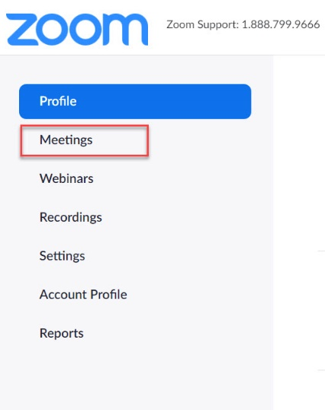
The Zoom meeting window appears. We’ll address each of the options listed from left to right, focusing first on completing the schedule of a new meeting.
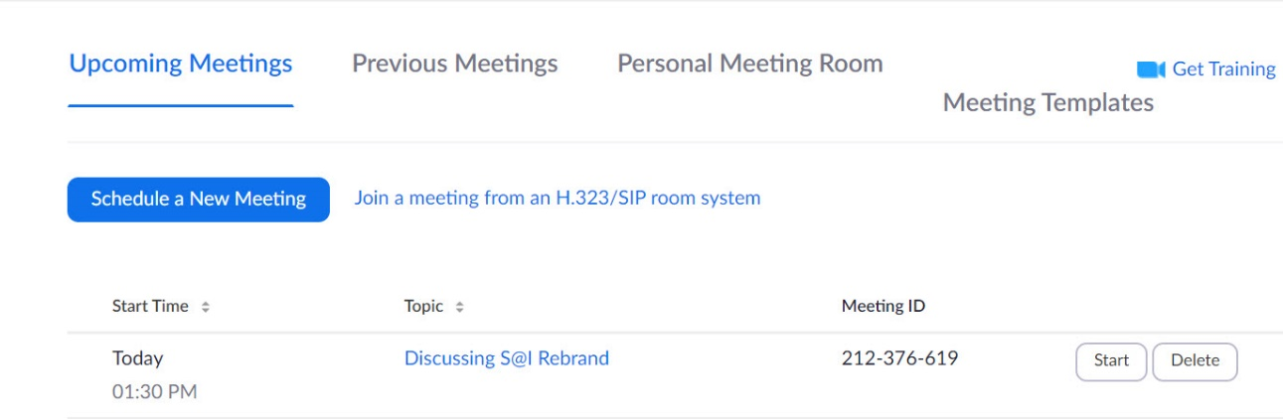

Upcoming Meetings
The Schedule a Meeting button will be at the top with any upcoming Zoom meetings appearing below.
- Click Schedule a New Meeting.
The Schedule a Meeting page appears.

- Select your meeting settings.
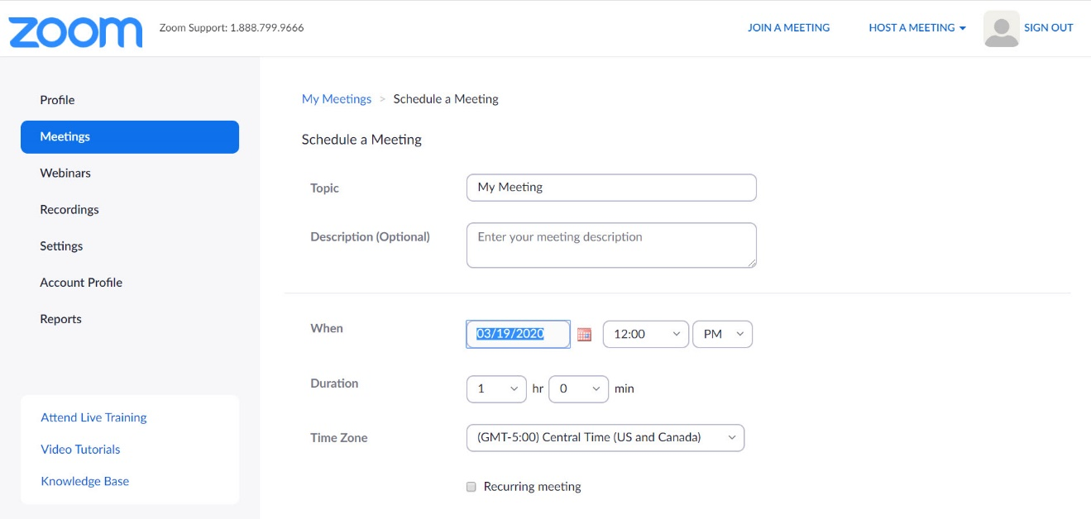
- Topic: Type topic or name for your meeting.
- Start: Select a date and time for your meeting. You can start your meeting at any time before the scheduled time.
- Duration: Choose the approximate duration of the meeting. This is only for scheduling purposes. The meeting will not end after this length of time.
- Time Zone: By default, Zoom uses your computer's time zone. Click the drop-down menu to select a different time zone.
Want to make the meeting recur? Check the Recurring meeting check box.
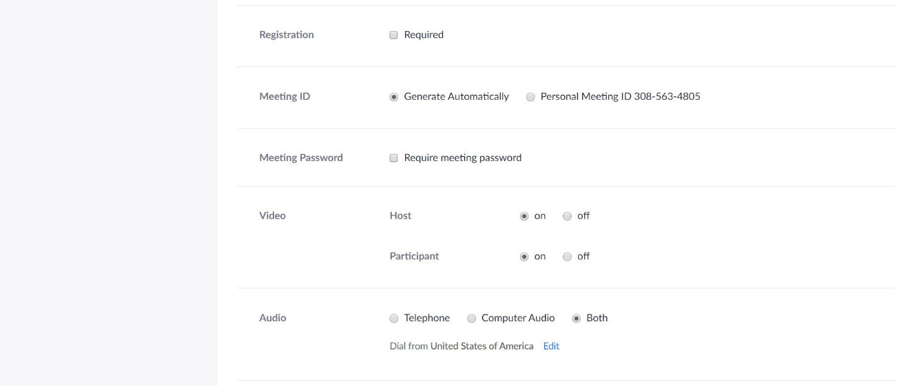
- Registration: Choose if you would like registration to be required (not typically recommended).
- Meeting ID: Choose if you would like to generate automatically or to use your personal meeting room.
- Meeting Password: You can select and input your meeting password here. Joining participants will be required to input this before joining your scheduled meeting.
Note: The meeting password must meet these requirements.
- 10 characters maximum
- Passwords are case sensitive
- We recommend using alphanumeric characters and these special characters: @ * _ -
- The Zoom desktop client allows alphanumeric characters and these special characters: @ * _ -
- The Zoom web portal allows any characters, but these characters are not allowed: & <> \
- Video
- Host: Choose if you would like the host video on or off when joining the meeting. Even if you choose off, the host will have the option to start their video.
- Participant: Choose if you would like the participants' videos on or off when joining the meeting. Even if you turn off, the participants will have the option to start their video.
- Audio: Choose whether to allow users to call in via Telephone only, Computer Audio only, or Both.
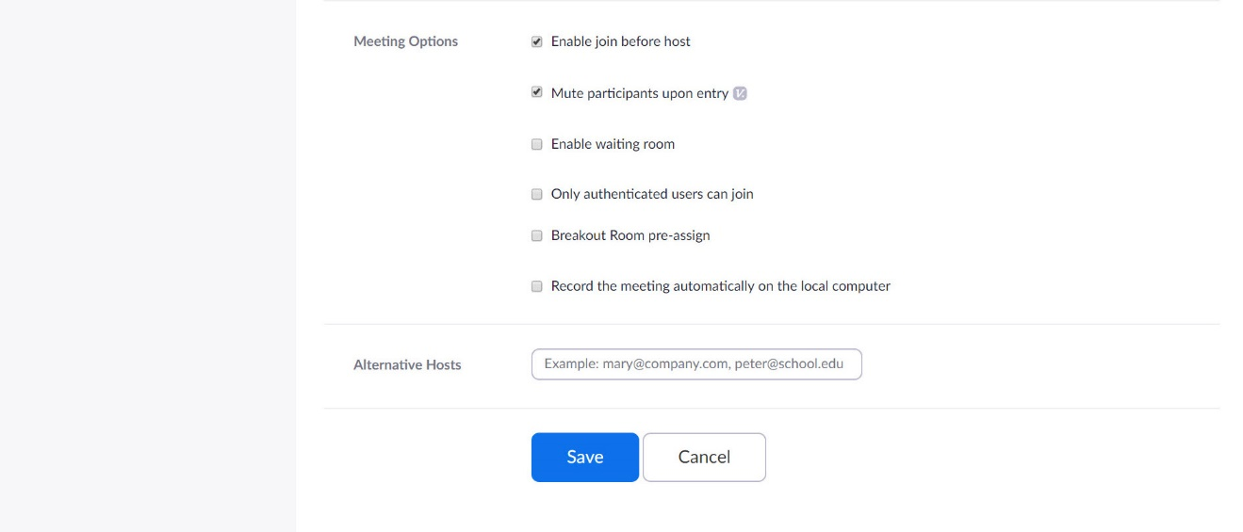
- Meeting Options
- Enable join before host: Allow participants to join the meeting without you or before you join. The meeting will end after 40-minutes for Basic (free) users if 3 or more people join the meeting.
- Mute participants on entry: If join before host is not enabled, this mutes participants as they join the meeting. Participants can unmute themselves after joining the meeting.
- Enable waiting room: This setting allows the host to have participants wait until the host joins and then admit either one by one or all attendees in at one time. This makes the Enable join before host option impossible. This is not something we recommend.
- Only authenticated users can join: This selection would make it a requirement for participants to authenticate prior to joining the meeting. This is another layer of security if you need it.
- Breakout Room pre-assign: If you have scheduling privileges for other users, you will be able to select who you want to schedule for from the drop-down menu.
- Record the meeting automatically on the local computer: Check this if you want the meeting to be automatically recorded.
- Alternative hosts: Type the email address of another licensed Zoom user on the University account to allow them to start the meeting in your absence.

Previous Meetings
The Schedule a Meeting button will be at the top with a list of your previously attended Zoom meetings appearing below.

Personal Meeting Room
Your personal room is your assigned classroom space, equivalent to a building and room number location in the university setting. If you need to create a quick on-the-spot meeting or to set up recurring one on one meetings, then this might be a good route to take.
Most of the screen is strictly information as you cannot change the fields. The three active pieces on the screen are as follows:
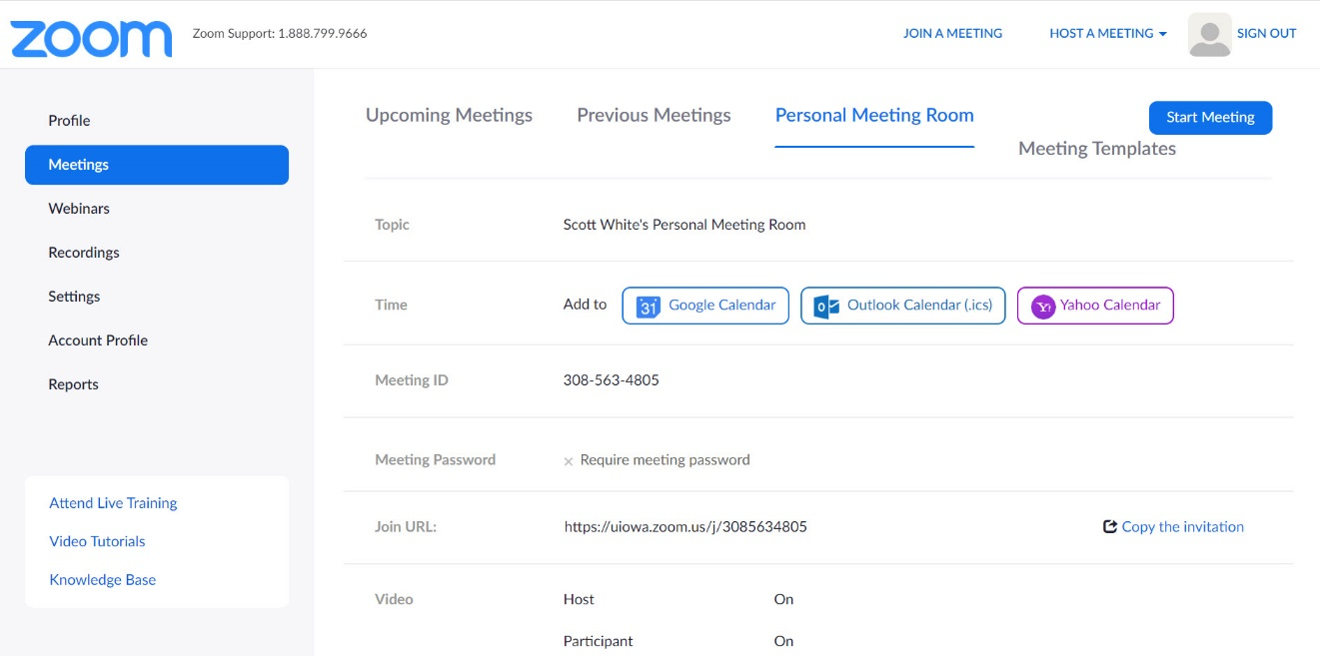
- Start Meeting: Launches Zoom with you as the lone participant. Use the Invite control to invite others to join your meeting.
- Meeting Templates: When wanting to have the same settings for different meetings, here you can create a template from an existing meeting. There must be a meeting on the schedule for you to use it as a template. See more on Using Meeting Templates.
- Time: Includes the options to add a meeting to your calendar of choice, Google, Outlook, or Yahoo.

Updating Scheduled Meetings
To make scheduling consistent and most reliable, we recommend that you use the University of Iowa Zoom account URL, https://uiowa.zoom.us, as the starting point.
- Click Sign In and complete the sign in process.
- Click Meeting from the left navigation controls.
- Click the link for the meeting you wish to update.
- Complete the fields the same as laid out in Scheduling Meetings.

Using Meeting Templates
When you schedule a meeting, you can save the settings for that meeting as a template for scheduling future meetings. The template includes settings like enabling join before host, automatic recording, and alternative hosts. For recurring meetings, you also have the option to save the recurrence schedule as part of the template.
After you save a meeting as a template, you can select that template when you want to create a meeting with similar settings. To create a template, complete the following steps:
- Click Sign In and complete the sign in process.
- Click Meeting from the left navigation controls.
- Click Schedule a Meeting.
- Change the settings that you would like to apply to the template.
NOTE: All settings made while scheduling the meeting will apply to the template. This includes polling.
- Click Save.
- Click Save as a Meeting Template.
- Specify the template name, then click Save as Template.
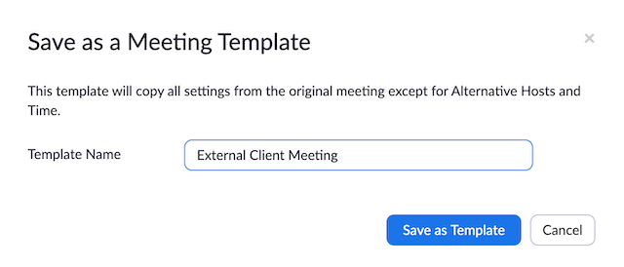

Scheduling a Meeting from a Template
After you have created one or more meeting templates, you can schedule a new meeting that includes all the settings from that template. Note that the new meeting does not include the dates. To schedule a meeting from an existing template, complete the following steps:
- Click Sign In and complete the sign in process.
- Click Meeting from the left navigation controls.
- Click Schedule a Meeting.
- Choose a previously saved template from Use a Template menu.
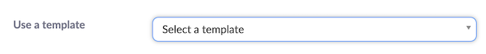
Basic and advanced settings from the template are copied into the newly created meeting.
- Update the meeting name and description (if needed) and update the date/time information or recurrence information if you saved this in the template.
- Change other settings as appropriate then click Save.

Prior to Meeting

Polling for Meetings
The polling feature for meetings allows you to create single choice or multiple choice polling questions for your meetings. You will be able to launch the poll during the meeting and gather the responses from your attendees. You also have the ability to download a report after the meeting. Polls can be conducted anonymously, if you do not wish to collect participant information with the poll results.
NOTE: Only the meeting host can edit or add polls during a meeting. If the host or co-host role is transferred to another user, that user will only be able to launch polls already created.
To enable polling for meetings, complete the following steps:
- Click Sign In and complete the sign in process.
- Click Settings from the left navigation controls.
- Click In Meeting (Basic).
- Navigate to the Polling option and verify that the setting is enabled.
If the setting is disabled, click the toggle to enable it. If a verification dialog appears, select Turn On to verify the change.
To create a poll, go to Creating a Poll. If you plan to use or reuse poll questions, consider Using Meeting Templates.

Roles in a Meeting
There are multiple roles available for a meeting: host, co-host, alternative hosts, and participants. The role that you have in a meeting is designated by the host.
- Host: The user that scheduled the meeting. They have full permissions to manage the meeting. There can only be one host of a meeting.
- Co-Hosts: Shares most of the controls that hosts have, allowing the co-host to manage the administrative side of the meetings, such as managing attendees. The host must assign a co-host during the meeting. Co-hosts cannot start a meeting. If a host needs someone else to start the meeting, they can assign an alternative host.
- Alternative Hosts: Share the same controls as co-hosts, but can also start the meeting. Hosts can assign alternative hosts when they schedule a meeting.

Comparison
The following tables compare the meeting controls available to the host, co-hosts, alternative hosts, and participants. Features with an asterisk (*) can be enabled or disabled by the host during the meeting.
Feature | Host | Co-Host / Alternative Host | Participants
Participating in the Meeting
Start the meeting
Mute/Unmute Themselves
Start/Stop Their Own Video |  |  | *
View Participants List
Share Screen |  |  | *
Request or Give Remote Control
Chat with Participants
Save In-Meeting Chat
Create or Edit Polls
Start Polling
Answer Polls
Assign Someone to Type Closed Captions
Type Closed Captions |  | * | *
End Meeting
Reactions and Nonverbal Feedback

Feature | Host | Co-Host / Alternative Host | Participants
Managing Participants
Mute/Unmute Participants
Stop Participant’s Video
Ask Participant to Start Video
Spotlight a Video
Promote Participant to Host or Co-Host
Change Who Attendees Can Chat With
Remove Attendees
Put Participants on Hold
Rename Participants
Invite Others to Join
Assign Participants to Breakout Rooms
Mute Controls for Participants (ask to mute, mute all, mute on entry)
Recording
Start Cloud Recording
Start Local Recording |  |  | *
Allow or Forbid a Participant to Start Local Recording
NOTE:
- Alternative hosts can start the meeting by using the meeting ID or meeting link from the invitation email. The meeting will not display in the upcoming meetings list in the desktop client or mobile app for alternative hosts.
- Co-Hosts cannot start meetings scheduled by the host. Co-Hosts cannot be assigned ahead of time. The host has to promote a participant to co-host. Alternatively, the host can assign a user as an alternative host.

Alternative Host
The alternative host option allows you to schedule meetings and designate another licensed UI user to start the meeting or webinar if you are unable to do so. This user will receive an email notifying them that they’ve been added as an alternative host, with a link to start the meeting. The alternative host will need to use the link in the email or have the calendar invite sent to them by the original host and use the join link there. The meeting will not display in the upcoming meetings list in the desktop client or mobile app for alternative hosts.
You can also give another licensed UI user scheduling privileges, which will make them an alternative host for all of your meetings and allow them to schedule meetings for you. If a host is attending a meeting but needs assistance with managing the meeting, they can assign a co-host during the meeting.

Getting Started with Breakout Rooms
Breakout rooms allow you to split your Zoom meeting in up to 50 separate sessions. The meeting host can choose to split the participants of the meeting into these separate sessions automatically or manually, and can switch between sessions at any time.
- Up to 50 breakout rooms can be created
- Max of 200 total participants across all breakout rooms (though this much requires Large Meeting 200 ad-on)
- Breakout room participants have full audio, video, and screen share capabilities
If the meeting is being cloud recorded, it only records the main room, regardless of what room the meeting host is in. If local recording is being used, it will record the room the participant who is recording is in. Multiple participants can record locally.

Prerequisites
To manage breakout rooms as the host requires the following:
- Zoom account
- Zoom desktop client
NOTE: Users joined into the Zoom meeting from the Zoom Desktop Client, Zoom Mobile App, or H.323/SIP devices can participate in breakout rooms. Users joined via the web client and Zoom Rooms are unable to join Breakout Rooms, but the main room can be used as an alternative session for these users.

Enable Breakout Rooms as an End-User
To enable the Breakout Room feature for your own use, complete the following steps:
- Click Sign In and complete the sign in process.
- Click Settings from the left navigation controls.
- Click In Meeting (Advanced).
- Navigate to the Breakout Room option and verify that the setting is enabled.
If the setting is disabled, click the toggle to enable it. If a verification dialog appears, select Turn On to verify the change.
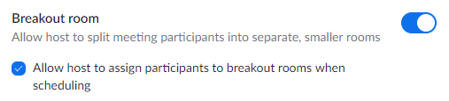
- (Optional) Click the checkbox to allow meeting hosts to pre-assign participants to breakout rooms.
NOTE: This functionality has not tested successfully so instructions of how to pre-assign participants to breakout rooms.

Joining a Meeting
- Click Sign In and complete the sign in process.
- Join a meeting using one of these methods:
- Click Join a Meeting if you want to join without signing in.
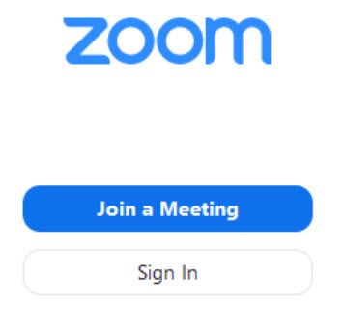
- Sign into Zoom then click Join.
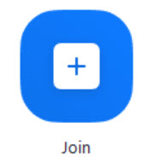
- Type the meeting ID number and your display name.
- If you’re signed in, change your name if you don’t want your default name to appear.
- If you’re not signed in, type a display name:
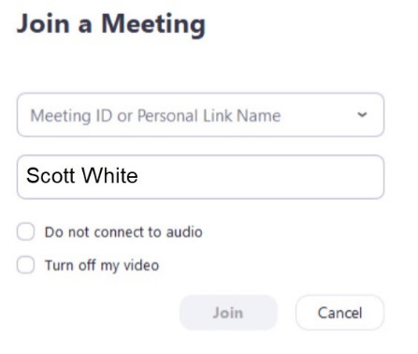
- Select if you would like to connect audio and/or video and click Join.

Starting or Joining a Scheduled Meeting as the Host
There are several ways to join a scheduled meeting as a host. Here is the preferred method.

Joining a Scheduled Meeting Method #1
- Click Sign In and complete the sign in process.
- Click Meetings from the left navigation controls.
- Click the meeting link you want to join.
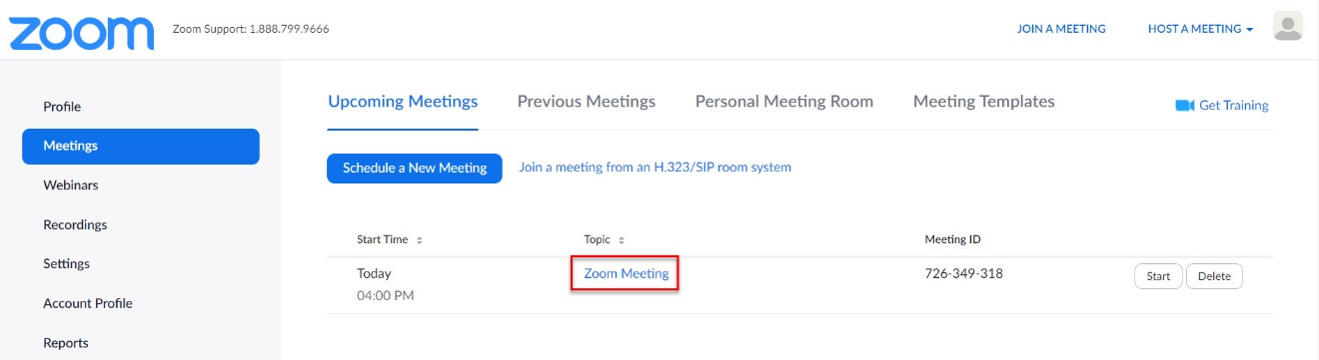
The meeting window appears.
- Click Start this Meeting.
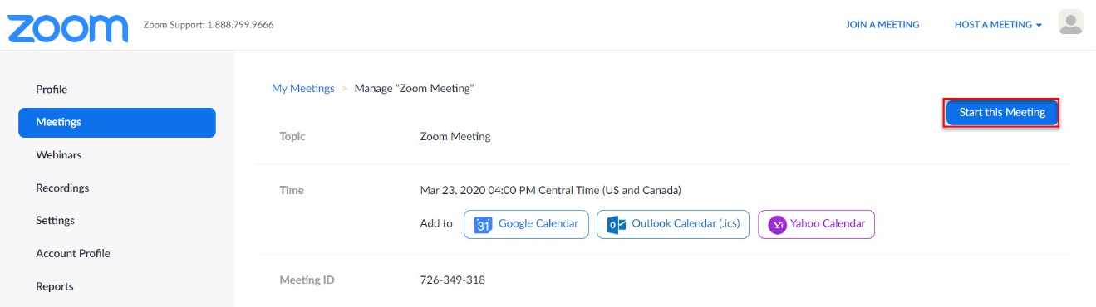

Inviting Others to Join a Meeting
There are several ways to invite participants to a scheduled or instant meeting.

Instant Meeting Invite
During a meeting you can click the Invite tab in your meeting controls.
Once you click Invite, you can select the option to Invite by Email, Invite by Contacts, or copy and share the meeting URL in the format of your choice.

Invite by Email
- Click Invite from the meeting controls.
The Invitation menu appears.
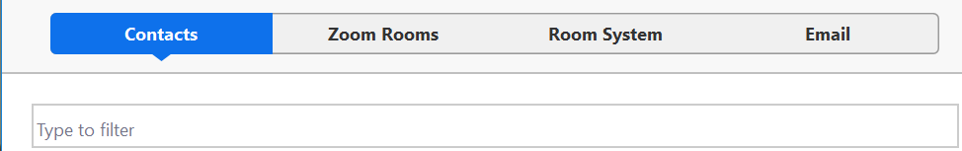
- Click Email.
The invite by email menu appears.
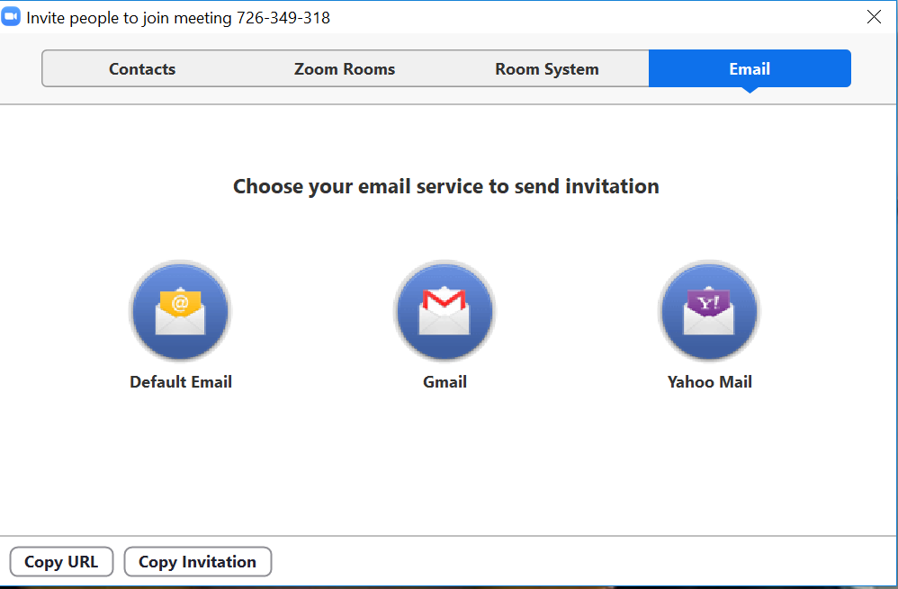
- Click Default Email.
Outlook opens with the invitation included in the body of the email.

Invite by Contacts
- Click Invite from the meeting controls.
The Invitation menu appears.
- Click Contacts.

- Select their name from the window or search for a contact (where the screen reads “Type to filter”).
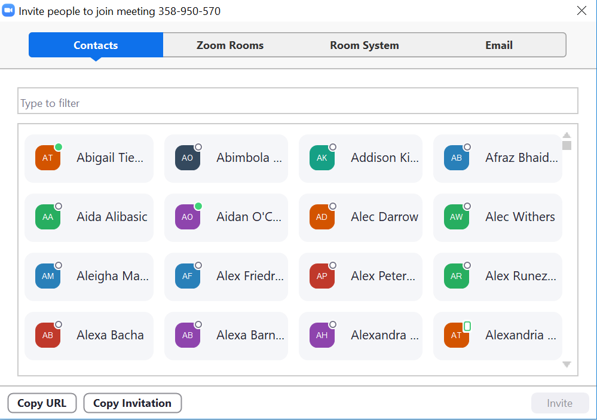
- Click Invite in the lower right corner.

Copy URL or Copy Invitation
- Click Invite from the meeting controls.
The Invitation menu appears.
- Click Copy URL or Copy Invitation.
Copy URL will copy the join link and Copy Invitation will copy the full invitation text. Paste the text with Crtl-V on a PC, Command-V on a Mac, or right-click and select Paste.

Testing Computer or Device Audio
There are two ways to join meeting audio, via computer or via telephone. Follow these sections to test your audio before or after joining a meeting.

Prerequisites
- Microphone, such as the built in microphone, a USB microphone or an inline microphone on headphones
- Speaker or headphones

Testing Audio before Joining a Meeting
If you haven’t enabled the setting to automatically join by computer audio, you can test your speaker and microphone before joining a meeting. Complete the following steps to test your audio before joining a meeting:
- After joining a meeting, click Test speaker and microphone.
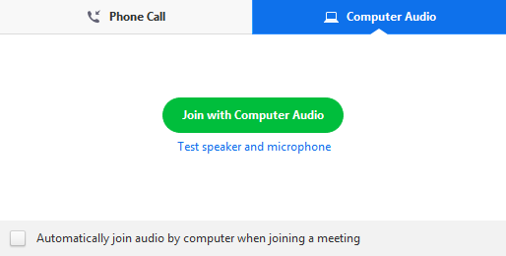
A window appears to test your speakers. If you don’t hear the ringtone, use the drop-down menu or click No to switch speakers until you hear the ringtone.
- Click Yes to continue to the microphone test.
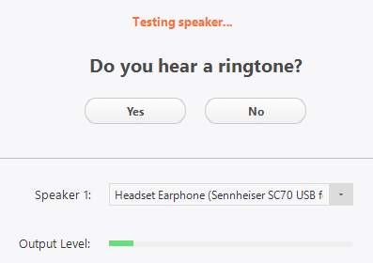
If you don’t hear an audio replay, use the drop-down menu or click No to switch microphones until you hear the replay.
- Click Yes when you hear the replay.
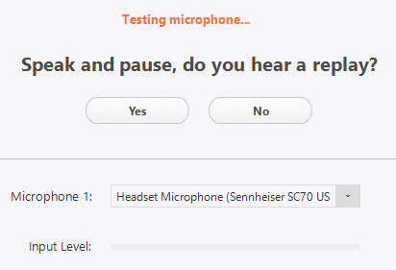
- Click Join with Computer Audio.
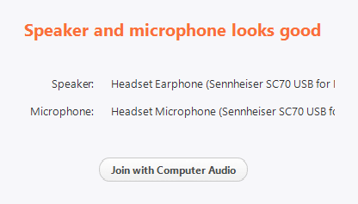
- Click Join with Computer Audio to join the meeting with the selected microphone and speakers.

Testing Audio Using Audio Settings
To test your audio, navigate to your audio settings before or during a meeting and complete the following steps:

Before a meeting
- Log into the Zoom client.
- Click your profile picture then click Settings.
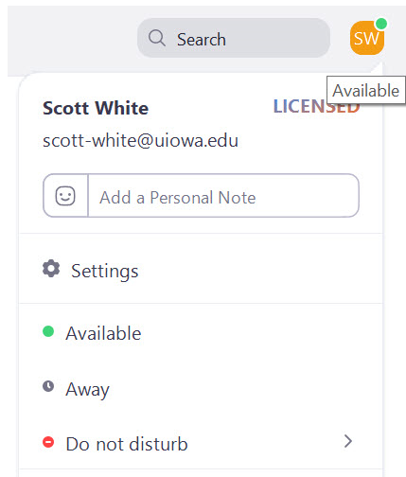
- Click the Audio tab.
- Follow the sections below to test your speaker or microphone.

During a Meeting
- Click the arrow next to Mute/Unmute in the meeting controls.
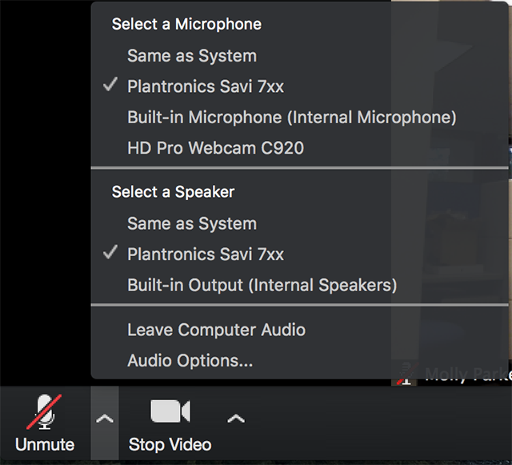
- Click Audio Options.
The audio settings open.

Testing Your Speaker
- Click Test Speaker to play a test tone.
If you cannot hear it, select a different speaker from the menu or adjust the volume.
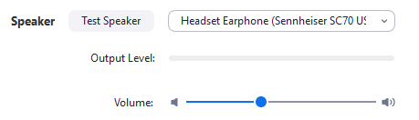

Testing your Microphone
- Click Test Mic to test your microphone.
The green Input Level bar in the Microphone section moves when Zoom is picking up audio.
Your audio starts recording.
- Click Recording when done and it will play back.
You can select another microphone from the menu or adjust the input level.
- Check Automatically adjust volume settings if you want Zoom to adjust the input volume automatically.
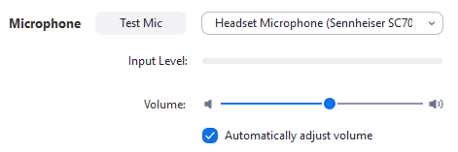

Microphone Troubleshooting
- If you are on Mac OS 10.14 Mojave or earlier and can't access the microphone, check your operating system permissions to confirm that Zoom has access to the microphone.
- If you are on Windows 10 and can't access the microphone, use the Windows search box to navigate to Microphone privacy settings. Switch on the Allow apps to access your microphone toggle, and enable access for Zoom.

Sharing Computer Sound during Screen Sharing
Zoom screen sharing allow you to share the desktop, window, application or audio/video. Zoom allows you to also send computer audio to the remote attendees when sharing a video or audio clip.
NOTE: Computer sound cannot be shared while multiple screens are being shared.
To share computer audio such as YouTube, Pandora, or similar sources during screen sharing, check the Share Computer Sound check box.
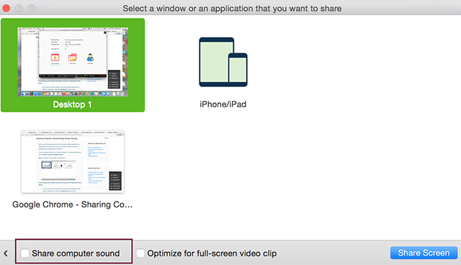

Screen Sharing with Computer Sound While Connected to Meeting Audio via Phone
This applies to users who join the meeting via both phone and computer to receive audio via the phone and video/screen sharing via computer and enter their Meeting ID and Participant ID to bind devices together.
If this individual checks Share Computer Sound on their computer, it triggers the audio to channel through both their phone device as well as their computer audio.
To stop sending audio in this situation, click Stop Share at the top of the meeting screen OR mute the speaker of your phone or the speaker of the computer.

Testing Your Video
You can test your video before joining the meeting or you can test the video while in the meeting.

Testing Video before a Meeting
- Log into the Zoom client.
- Click your profile picture then click Settings.
- Click the Video tab.
A preview of what your camera sees appears.
- Select a different camera if needed.
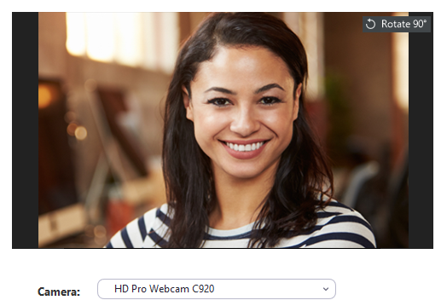

Testing Video While in a Meeting
- Click the arrow next to Start Video/Stop Video.
- Select Video Settings.
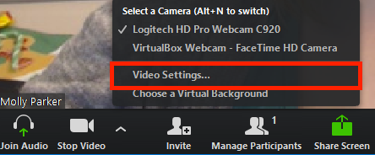
Zoom shows your camera and video settings.
If you don’t see your camera’s video, select the drop-down menu and select another camera.

Optimizing a Shared Video Clip in Full Screen
Zoom optimizes screen sharing of a full screen video clip to ensure the attendees have the best quality experience. You can optimize prior to screen sharing or during screen sharing.
NOTE: Only follow these steps if you are screen sharing a video clip. If you are not sharing a video, turn off the option to again maximize attendee experience.

Prerequisites
- At least 1.5Mbps uplink and downlink for full screen HD
- Play video at full screen

Starting a New Screen Share and Optimizing for Full-Screen Video
- Click the Screen Share button in your meeting controls.
- Select the screen you want to share and select Optimize for full-screen video clip.
Share 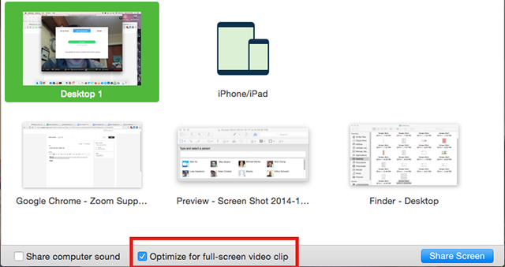
- Click Share Screen.
- Start playing your video in full-screen while sharing your screen.

Optimizing for Full-Screen Video While Screen Sharing
- Click More in the screen share controls.
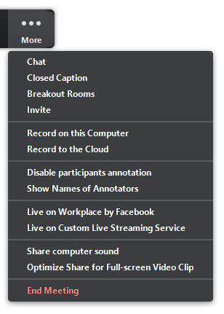
- Click Optimize Share for Full Screen Video Clip to enable it.
- Start playing your video while sharing your screen.

Touching Up Your Appearance
The Touch Up My Appearance options retouches your video display with a soft focus. This can help smooth out the skin tone on your face to present a more polished looking appearance when you share. This option is available prior to or while a meeting is in progress.

Run Touch Up Your Appearance Prior to Meeting
- Log into the Zoom client.
- Click Settings.
- Click Video.

Run Touch Up Your Appearance During a Meeting
- Click the arrow next to Start Video/Stop Video.
- Select Video Settings.
The video settings window appears.
- Click Touch up my appearance.
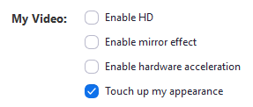
- Check this option to display your video with the touch up.
Zoom remembers your preference and uses it the next time you start or join a meeting on this computer.

Managing Participants

Using Mute All and Unmute All
Complete the following steps to mute all meeting participants:
- Click Manage Participants.
The Participants window appears.

- Click Mute All to mute participants.
The Mute All window appears.
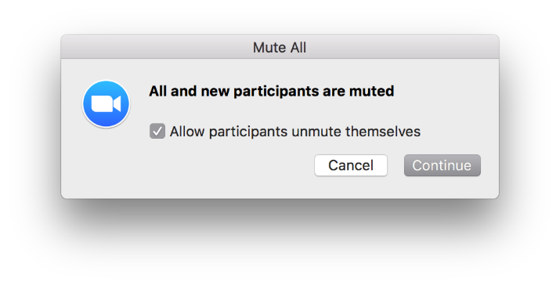
- Check or uncheck the Allow participants unmute themselves as you deem appropriate.
- Click Continue to mute all current and new participants.

Managing Participants in a Meeting
The participants appear in the following order:
- You
- The host (if you’re not the host)
- Phone numbers with no names
- Unmuted participants (sorted alphabetically)
- Muted participants (sorted alphabetically)

Controls for Hosts and Co-Hosts
Hosts and co-hosts can control the following features in meetings:
- Mute participants
- Request that a participant unmutes
- Stop a participant’s video
- Request that a participant starts their video
- Prevent participants from screen sharing
- Rename a participant
- Put a participant on hold (if enabled)
- Choose to play an enter or exit chime
- Lock the meeting to prevent anyone new from joining
Only hosts have access to these features:
- Give a participant the ability to record locally
- Make a participant host or co-host

Controls for Managing Participants
- Click Manage Participants in the host controls to show the participants list.
- Click the drop-down menu located at the top-left corner to close the participants list or click Pop Out to separate the participants list from the meeting window.
- Hover over a participant and click More for additional options.
NOTE: Not all these options may appear for you as it depends on the settings set by UI as well as your own.
- Chat: Open the Chat window to send messages directly to the panelist.
- Stop Video: Stop the participant’s video stream so they are unable to start their video. If the participant has not started their video, the Ask to Start Video option appears instead.
- Make Host (only available to the host): Assign the attendee to be the host. There can only be one host.
- Make Co-Host (only available to the host): Assign the attendee to be a co-host. There can be an unlimited number of co-hosts.
- Allow Record (only available to the host): Allow the attendee to start or stop a local recording of the meeting. Attendees do not have access to start a cloud recording.
- Assign to type Closed Caption (only available to the host): Assign the attendee to type closed caption during the meeting.
- Rename: Change the attendee name that appears to other participants. This change only applies to the current meeting.
NOTE: To change your own name that appears, hover over your name in the participants list and click Rename. You can permanently change your name in your profile.
- Put in Waiting Room: Place the attendee is a virtual waiting room while you prepare for the meeting. The host must enable waiting room for this option to appear.
- Put on Hold: If the waiting room is not enabled, this option appears to place the attendee on hold.
- Remove: Dismiss a participant from the meeting. They won’t be able to rejoin unless you allow participants and panelists to rejoin.
At the bottom of the participants list you can select more to see more options to enable or disable.
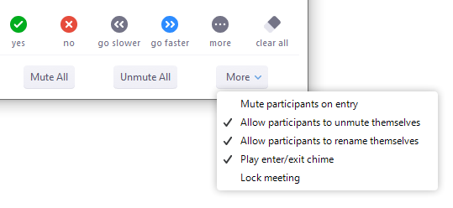
- Mute All / Unmute All: Mute or unmute all participants currently in the meeting.
- Mute participants on entry: Automatically mute participants as they join the meeting.
- Allow participants to unmute themselves: Participants can unmute themselves if they want to speak to others in the meeting.
- Allow participants to rename themselves: Participants can change their screen name that appears to other participants.
- Play enter/exit chime: Play a sound when participants join and leave the meeting.
- Lock meeting: Don’t allow other participants to join the meeting in progress.
- Merge to meeting window: Merge the participants list with the main meeting window. This option is only available if you separated the participants list from the main meeting window.

Prevent Participants from Screen Sharing
To prevent participants from screen sharing, complete the following steps:
- Click the arrow next to Share Screen.
- Click Advanced Sharing Options.
- Select Only Host under Who can share?
- Close the window.

During Meeting
You can view and edit keyboard shortcuts in your Accessibility settings.
- Log in to your Zoom desktop client.
- Click your profile picture then click Settings.
- Click Keyboard Shortcuts.
The keyboard shortcuts appear.

Editing Shortcuts
You can edit a shortcut by clicking on the shortcut and then pressing the shortcut key that you would like to use.
Some of the shortcuts can be used as global shortcuts, meaning they will work even when Zoom is not in focus. To enable a shortcut globally, check the option next to the shortcut.

Available Keyboard Shortcuts
Shortcut | Purpose | Shortcut | Purpose
F6 | Navigate among Zoom popup windows | Alt+T | Pause or resume screen share Note: Will only work when meeting control toolbar has focus
PageUp | View previous 25 video streams in gallery view | Alt+S | Launch share screen window and stop screen share Note: Will only work when meeting control toolbar has focus
PageDown | View next 25 video streams in gallery view | Alt+Shift+S | Start/stop new screen share Note: Will only work when meeting control toolbar has focus
Ctrl+Alt+Shift | Move focus to Zoom's meeting controls | Alt+I | Open Invite window
Alt | Turn on/off the option Always show meeting control toolbar in Accessibility Settings | Alt+Y | Raise/lower hand
Alt+F1 | Switch to active speaker view in video meeting | Alt+Shift+R | Gain Remote Control
Alt+F2 | Switch to gallery video view in video meeting | Alt+Shift+G | Stop Remote Control
Alt+F4 | Close the current window | Ctrl+2 | Read active speaker name
Alt+V | Start/Stop Video | Ctrl+Alt+Shift+H | Show/Hide floating meeting controls
Alt+A | Mute/unmute audio | Alt+Shift+T | Screenshot
Alt+M | Mute/unmute audio for everyone except host Note: For the meeting host only | Alt+L | Switch to portrait/landscape view
Alt+R | Start/stop local recording | Ctrl+W | Close current chat session
Alt+C | Start/stop cloud recording | Ctrl+Up | Go to previous chat
Alt+P | Pause or resume recording | Ctrl+Down | Go to next chat
Alt+F | Enter or exit full screen | Ctrl+T | Jump to chat with someone
Alt+H | Display/hide In-Meeting Chat panel | Ctrl+F | Search
Alt+U | Display/hide Participants panel | Ctrl+Tab | Move to the next tab (right)
 |  | Ctrl+Shift+Tab | Move to the previous tab (left)

Meeting Controls for Host
As a host you are able to control various aspects of the Zoom meeting such as managing the participants.
The co-host feature allows the host to share hosting privileges with another user, allowing the co-host to manage the administrative side of the meeting, such as managing participants or starting/stopping a recording. The host must assign a co-host. There is no limitation on the number of co-hosts you can have in a meeting or a webinar. Co-hosts do not have access to the following controls as they are only available as host controls in a meeting:
- Start closed captioning and assign someone to provide closed captioning
- Start live streaming
- End meeting for all participants
- Make another participant a co-host
- Start breakout rooms or move participants from one breakout room to another
Co-hosts also cannot start a meeting. If a host needs someone else to be able to start the meeting, they can assign an alternative host.
The host controls will appear at the bottom of your screen if you are not currently screen sharing. While screen sharing the controls appear when moving your mouse over the top portion of the screen.
- Mute/Unmute: This allows you to mute or unmute your microphone.
- Audio Controls (click ^ next to Mute/Unmute): The audio controls allow you to change the microphone and speaker that Zoom is currently using on your computer, leave computer audio, and access the full audio options in the Zoom settings.
- Start/Stop Video: This allows you to start or stop your own video.
- Video Controls (click ^ next to Start/Stop Video): If you have multiple cameras on your computer, you can select which Zoom is using, access the full video controls, and select a Virtual Background.
- Invite: Invite others to join your meeting.
- Manage Participants: Opens the Participants window.
- Polling: Allows you to create, edit, and launch your polls. The options to create or launch polls will open up the Zoom web portal in your default browser.
- Share Screen: Start sharing your screen. You will be able to select the desktop or application you want to share.
- Screen Share Controls (click ^ next to Share Screen): Select who can share in your meeting and if you want only the host or any participant to be able to start a new share when someone is sharing.
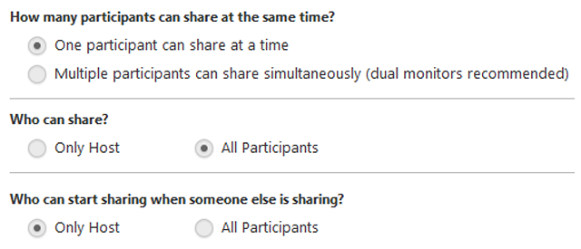
- Chat: Access the chat window to chat with the participants.
- Record: Start or stop a cloud or local recording.
- Closed Caption (only available to the host): If you have enabled closed captioning for your account, click here to access the closed caption options.
- Breakout Rooms (only available to the host): Start breakout rooms.
- More: Click More to gain access to streaming options.
NOTE: We are not currently using these options, though we continue to explore if and when we may want to use them in the future.
- End Meeting (only available to the host): This will end the meeting for all participants. If you want to have the meeting continue, you should give another participant host control before leaving the meeting.
When you are screen sharing, the controls will appear at the top of your screen, but you can drag it to another location.
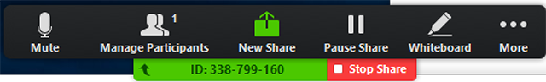

Enabling and Adding a Co-Host
The co-host feature allows you to share hosting privileges with another user in a meeting. This can be useful to allow another user to manage the administrative side of the meeting, such as muting participants or starting/stopping the recording.
Co-hosts are assigned during a meeting and cannot start a meeting. If a host needs someone else to start the meeting, they can assign an alternative host <<insert link>>.

Using Co-Host in a Meeting
Complete the following steps to make a user a co-host:
- Click Manage Participants in the meeting controls.
- Hover over the name of the participant who is going to be a co-host and select More.
- Click Make Co-Host.
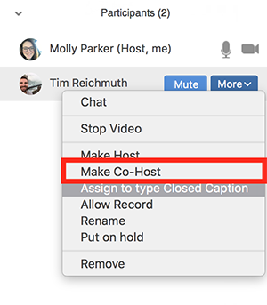
Once a participant has been made a co-host, they have access to the co-host controls.

Polling

Creating a Poll
Polls can be created either before or during the meeting.

Creating a Poll Prior to a Meeting
- Click Sign In and complete the sign in process.
- Click Meetings from the left navigation controls.
- Click the meeting link you want to add a poll or polls.
- Scroll down to the Poll option and click Add to begin creating a poll.
- Type a title and your first question.
- (Optional) Check the box to make the poll anonymous, which keeps the participant’s polling information anonymous in the meeting and in the reports.
- Select whether you want the question to be single choice (participants can only select one answer) or multiple choice question (participants can select multiple answers).
- Type the answers to your question and click Save at the bottom.
- Click Add a Question to create a new question for that particular poll if you want another question.
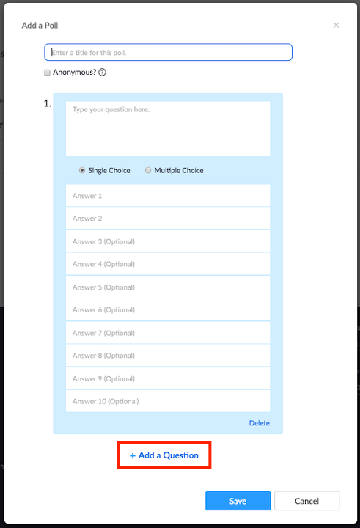
You can add additional polls by repeating steps 4 to 7.

Creating a Poll during a Meeting
- Start the scheduled Zoom meeting that has polling enabled.
- Click Polling in the navigation controls.
The default web browser opens to allow the addition of polling questions.
NOTE: There is a max of 25 polls for a single meeting.

Launching a Poll
- Start the scheduled Zoom meeting that has polling enabled.
- Click Polling in the navigation controls.
- Select the poll you would like to launch.

- Click Launch Poll.
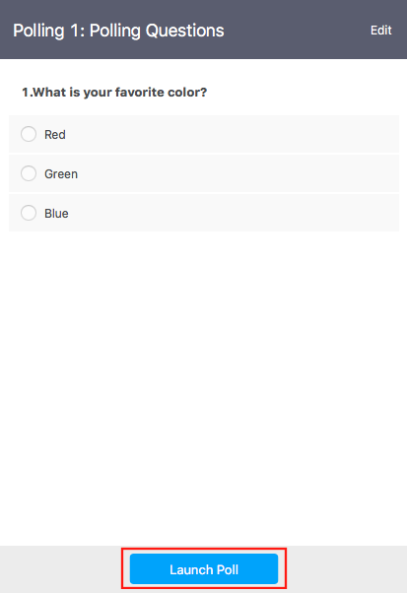
The participants in the meeting are prompted to answer the polling question(s). The host can see the results live.
- Click End Poll to stop the poll.
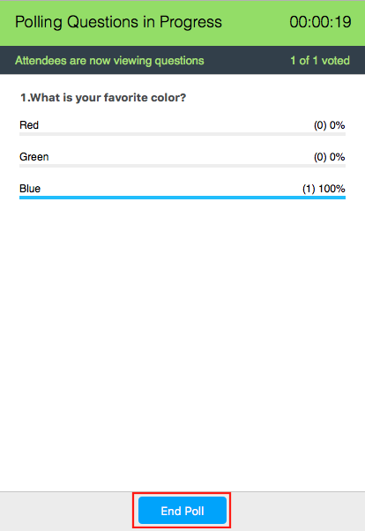

- (Optional) Click Share Results if you would like to share the results to the participants in the meeting.
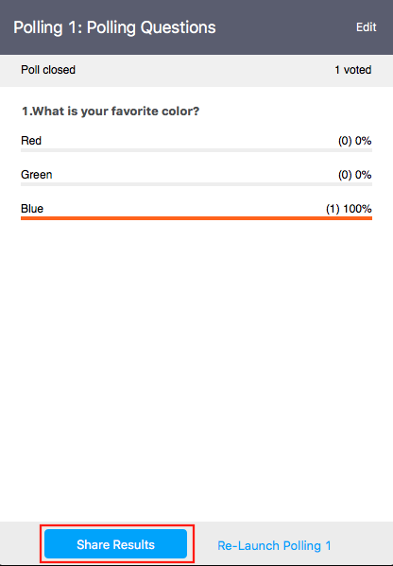
Participants see the results of the polling question(s).

Downloading a Report of Poll Results
You can download a report of the poll results after the meeting. If the poll was anonymous, it will show “anonymous” for the participants’ names and email addresses.

Changing the Video Layout
There are three video layouts possible when no one in the meeting is screen sharing: Active Speaker, Gallery, and Mini. When someone is screen sharing, you can use side-by-side mode or view the screen share with Active Speaker or Gallery View. You can also Hide Non-Video Participants. Any of these can be used in full screen or windowed mode, with the exception of Mini Window.
You can also pin or spotlight a participant’s video. Pin video allows you to disable active speaker view and only view a specific speaker. Pinning another user’s video will only affect your computer and local recordings, not the view of other participants or cloud recordings. Learn more about pinning a video <<Link to this>>.
Spotlight video puts a user as the primary active speaker for all participants in the meeting and cloud recordings. To spotlight, you need at least three participants in the meeting with their video on and can only be done by the host. Learn more about spotlighting a video <<Link to this>>.

Full Screen
Click the icon with four arrows at the top right corner of your Zoom window to full screen. All layouts except Mini Window allows full screen. You can exit full screen in one of two ways:
- Press Exit Full Screen in the top right corner of your Zoom window
- Press Esc on your keyboard
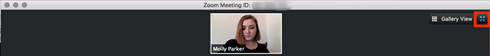

Active Speaker
Active speaker is the default video layout. It switches the large video window between who is speaking. If it is a one-on-one meeting, your video appears at the top and the other participant’s video below.
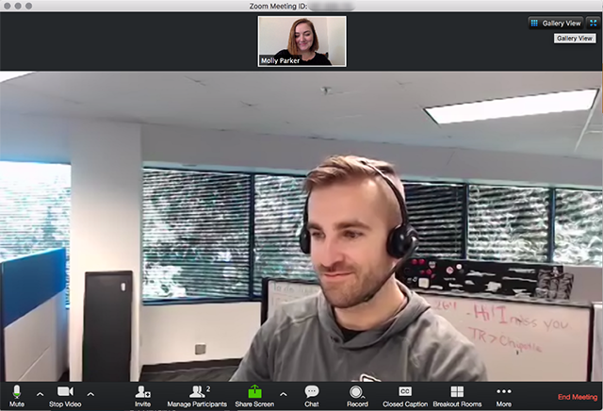

Gallery View
You can also select to view your video layout in Gallery View. When using Gallery View, you can see up to 49 participants at a time, and an arrow to scroll through to the remaining participants.
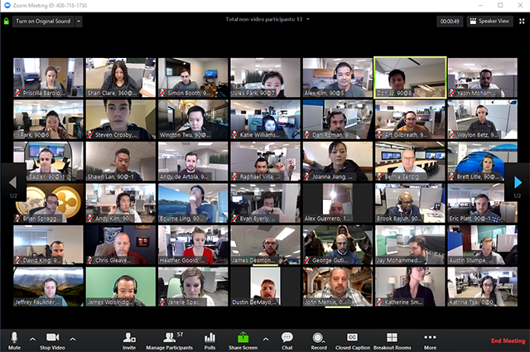
Click Gallery View in the upper right corner of your Zoom window to enter Gallery View.

Mini Window
Mini window allows you to minimize the Zoom video, but keep it on top of any other applications you have open on your computer. You can move the window around your screen or hide the video entirely.
- Click the minimize icon, located at the top right for Windows or top left for Mac, to switch to the mini-window view.
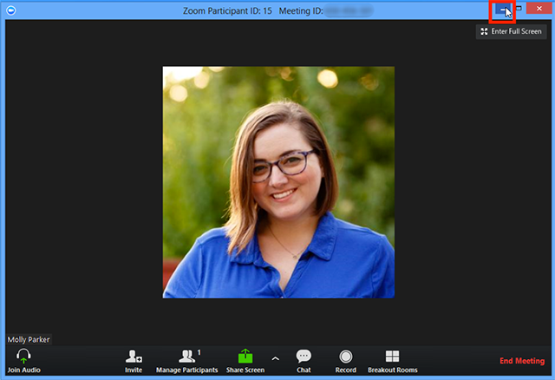
- Click the arrow on the left side to collapse the video once in mini window mode.
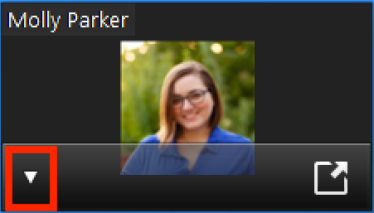

- Click the arrow on the right side to exit mini window view.
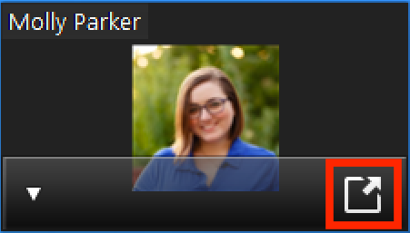

Layout when Screensharing
The views available while sharing your screen are active speaker or gallery view at the top of your screen or in side-by-side mode.
- Click the swap icon at the upper right corner of the Zoom window to switch the content for the video feed.
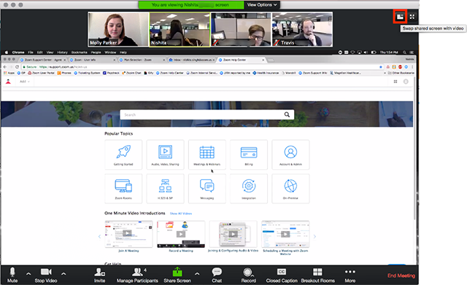
- Click the icon at the upper right to swap it back or click Switch to Sharing Content.
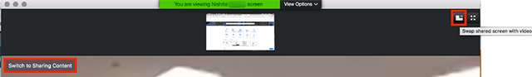

- Click View Options then Side-by-Side Mode to switch into side-by-side mode.
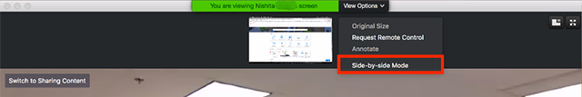

Hiding Non-Video Participants
- Right-click on a participant that either has their video off or dialed in via telephone while in Gallery View or click the three dots at the upper right of their participant box.
- Select Hide Non-Video Participants to hide all users with their video off.
- Click Total non-video participants at the top of your screen and select Show non-video participants to show non-video participants again.

Hiding
To hide your video from your own display, complete the following steps:
- Start or join a Zoom meeting. The meeting automatically begins in Speaker View and you can see your own video.
- Right-click your video to display the menu, then select Hide Myself.
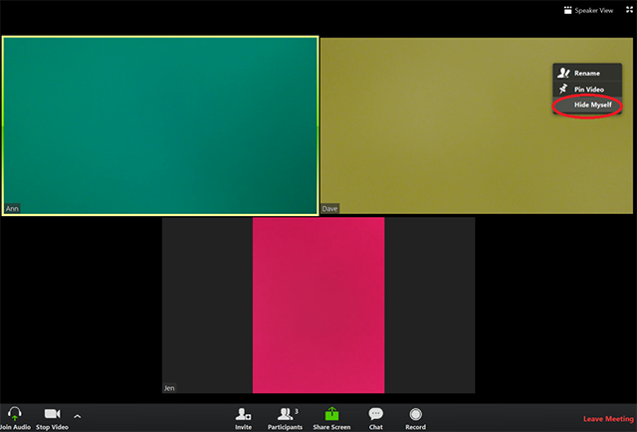

- You no longer can see the video of yourself, while others in the meeting still can see the video of you.
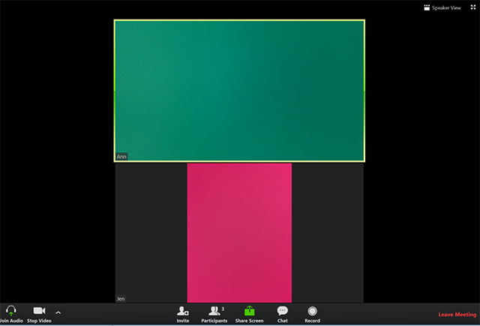
To restore the video of yourself, complete the following steps:
- Right-click any visible user’s display to show the menu.
- Select Show Myself.
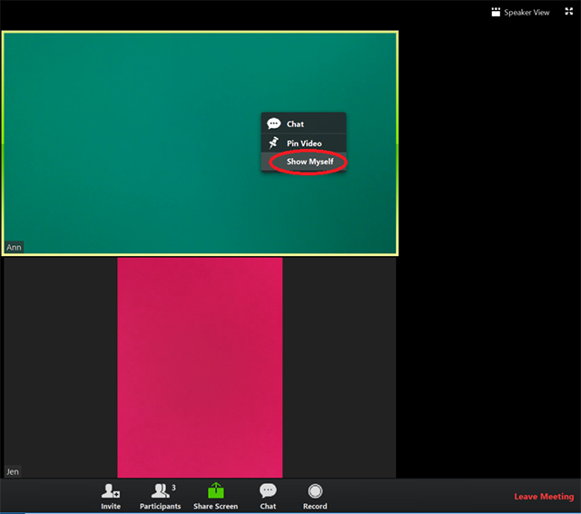

The video of yourself appears on your screen.
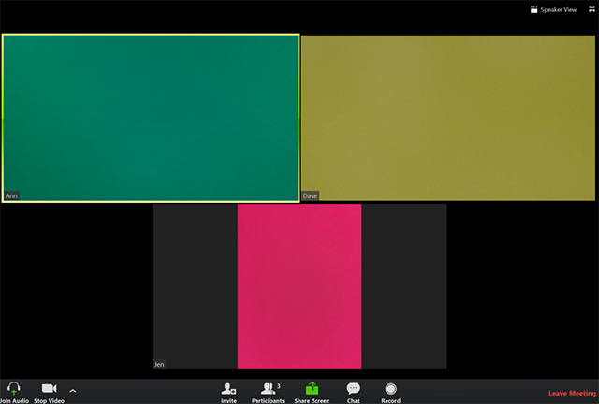

Displaying Participants in Gallery View
Gallery view lets you see thumbnail images of participants, in a grid pattern, which expands and contracts as participants join and leave the meeting. Depending on your CPU, you can view up to 49 participants in a single screen of the gallery view. If more than 49 attendees are in the meeting, 49 thumbnails appear on each page and use the right or left arrows to show the next 49 participants. There can be up to 1,000 participants to appear in gallery view.
To show up to 49 participants on a single screen of the gallery view, complete the following steps:
- Sign into the Zoom client.
- Click Settings.
- Click Video to open the video settings page.
- Enable the option Display up to 49 participants per screen in Gallery View. Note that if your computer does not meet the CPU requirements, this option is not available.
- Start or join a meeting.

- Click Gallery View in the top-right corner.
If the meeting has 49 or fewer attendees, all of them appear on a single page. If more than 49 attendees are in the meeting, 49 thumbnails appear on each page.
NOTE: You may need to change to full-screen mode or adjust the size of your window to accommodate all 49 thumbnails.

Using the Spotlight Video Feature
Spotlight video puts a participant as the primary active speaker for all participants. All participants will only see this speaker as the active speaker. This feature is often used to spotlight a keynote speaker.

To spotlight a video, complete the following steps:
- Hover over the video of the participant you want to spotlight and click … at the top of your screen.
- Select Spotlight Video from the menu that appears.
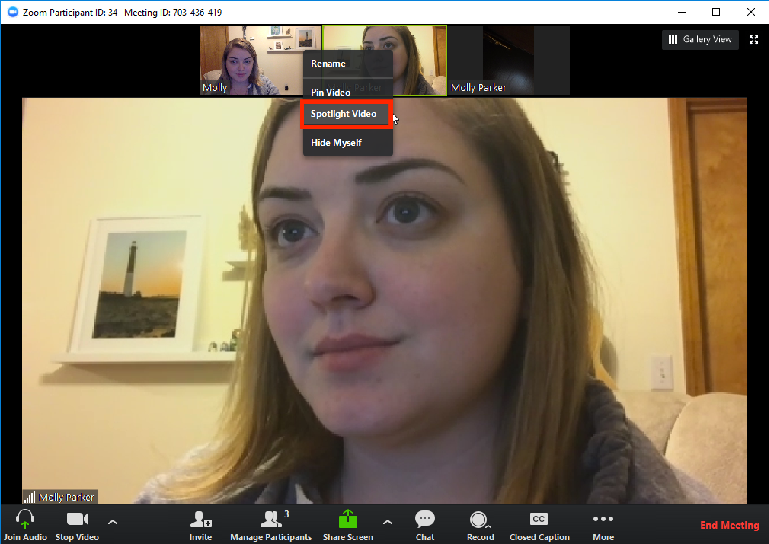

To cancel a spotlight, complete the following steps:
- Click Cancel the Spotlight Video in the upper-left corner.
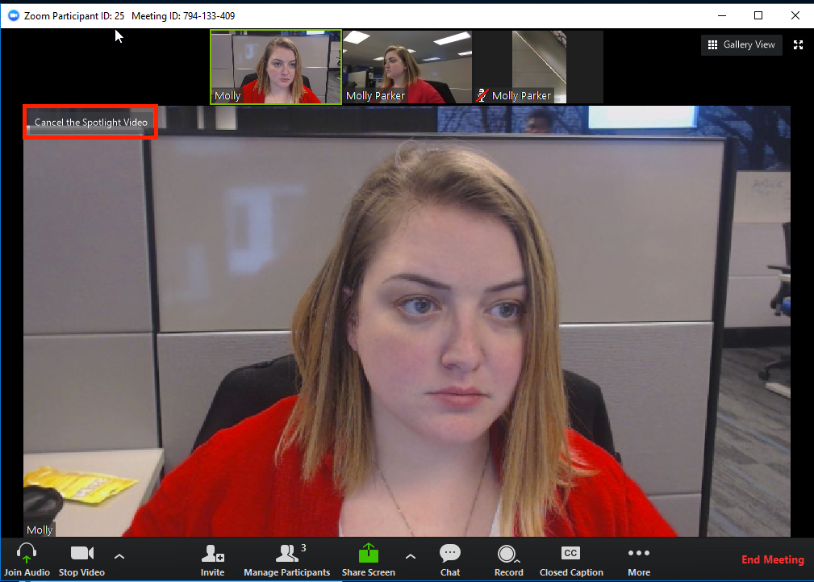
The meeting returns to active speaker view.

Spotlight When I Speak
Spotlight when I speak is a feature that shows your video on your own screen when you are in active speaker video layout and are talking. This can be useful if you are recording locally.

To enable spotlight when I speak, complete the following steps:
- Log into the Zoom client.
- Click your profile picture then click Settings.
- Click the Video tab.
- Select Spotlight my video when I speak.
Share 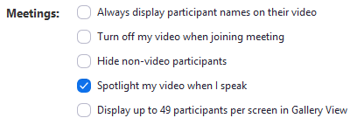

Sharing Your Screen
To share your screen, complete the following steps:
- Click the Share Screen button in your meeting controls.
- Select the screen you want to share.
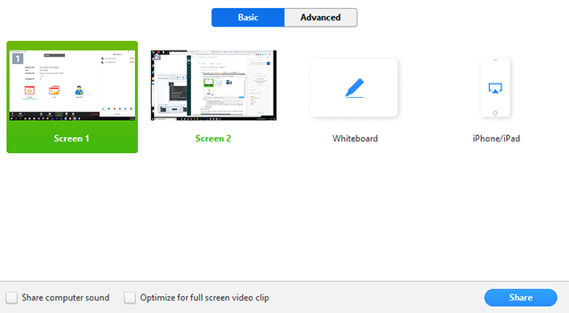
- (Optional) Enable these features:
- Check Share Computer Sound: If you check this option, any sound played by your computer will be shared in the meeting.
- Check Optimize for full screen video clip: Check this if you will be sharing a video clip in full screen mode. Do not check this otherwise, as it may cause the shared screen to be blurry.
- Click Share.
- Zoom will automatically switch to full screen to optimize the shared screen view. To exit full-screen, click Exit Full Screen in the top-right corner or press the Esc key.

Share Screen Menu
When you start sharing your screen, the meeting controls move into a menu that you can drag around your screen.
- Mute/Unmute: Mute or unmute your microphone.
- Start/Stop Video: Start or stop your in-meeting video.
- Participants/Manage Participants: View or manage the participants (if the host).
- New Share: Start a new screen share. A prompt to select which screen you want to share again appears.
- Pause Share: Pause your current shared screen.
- Annotate / Whiteboard: Display annotation tools for drawing, adding text, etc.
- More: Hover over more for additional options.
- Chat: Open the chat window.
- Invite: Invite others to join the meeting.
- Record: Start recording locally or to the cloud.
- Allow/Disable participants annotation: Allow or prevent the participants from annotating on your shared screen.
- Show/Hide Names of Annotators: Show or hide the participants' name when they are annotating on a screen share. If set to show, the participant's name will briefly display beside their annotation.
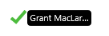
- Live on Workplace by Facebook: Share your meeting or webinar on Workplace by Facebook.
- Optimize Share for Full-screen Video Clip: Start optimizing for a video clip in full screen mode.
NOTE: Do not enable this setting if you are not sharing a full screen video clip, as it will blur your screen share.
- End Meeting: Leave the meeting or end the meeting for all participants.

Using dual monitors
If you are using a dual monitor set-up, you can turn on the Use Dual Monitors feature to see the screen sharing on one monitor and participants on the second.

Using Dual Monitors
The dual-monitor display feature allows the video layout and screen share content to be placed on two separate monitors/screens. Gallery or speaker view can be displayed on one monitor while the other monitor displays a content share. This is useful for PPT presentations and hiding notes from the participants.
To enable the dual monitors feature, complete the following steps:
- Log into the Zoom client.
- Click your profile picture then click Settings.
- Click the General tab.
- Navigate to the Use dual monitors option and verify that the setting is enabled.
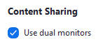

Screen Sharing a PowerPoint Presentation
There are three methods you can use to screen share a PowerPoint presentation in a Zoom meeting. If you have dual monitors, you can share a slide show while viewing presenter’s notes in another monitor. If you have a single monitor, you can also start the slide show in a window so you have access to other meeting features while sharing your presentation.

Dual Monitors with Slide Show and Presenter’s Views
Complete the following steps if Complete the following steps if you are using dual monitors and want to present your PowerPoint file in one monitor while viewing the presenter’s notes in another monitor:
- Open the PowerPoint file you want to present.
- Start or join a Zoom meeting.
- Click Share in the meeting controls.
- Select your primary monitor then click Share. If you are not sure which monitor is your primary, select the one that PowerPoint opens in.
- Switch to slide show mode in PowerPoint while sharing your screen.
Participants see the PowerPoint in slide show view if shared correctly. The green border indicates the monitor you are currently sharing.
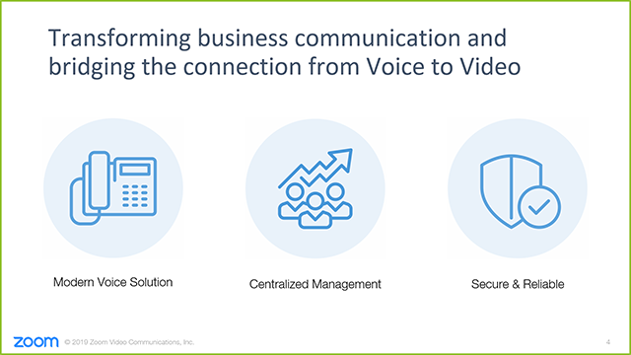

The presenter’s view appears on your secondary monitor. Use this to view your slides notes and control the presentation.
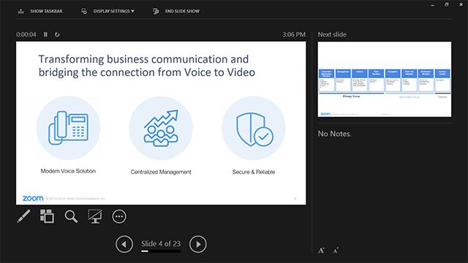
- Click Display Settings then Swap Presenter View and Slide Show if you are not sharing the correct monitor. PowerPoint will switch the monitor that is used for slide show view.
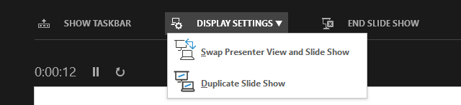
Alternatively, you can click New Share on your screen share controls and select the screen showing the PowerPoint in slide show view.

Single Monitor Setup with Slide Show View in a Window
Complete the following steps if you have a single monitor and want to share your PowerPoint presentation in slide show view, but have it contained in a window than in full screen. This is useful if you need to access meeting features like in-meeting chat or managing participants while sharing your PowerPoint presentation.
- Open the PowerPoint file you want to present.
- Click the Slide Show tab > Set Up Slide Show.

- Select Browsed by an individual (window) under Show Type.
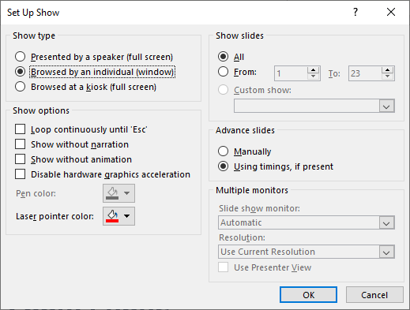
- Click OK.
- Click the Slide Show tab and switch PowerPoint to slide show.
The PowerPoint slide show appears in a window.
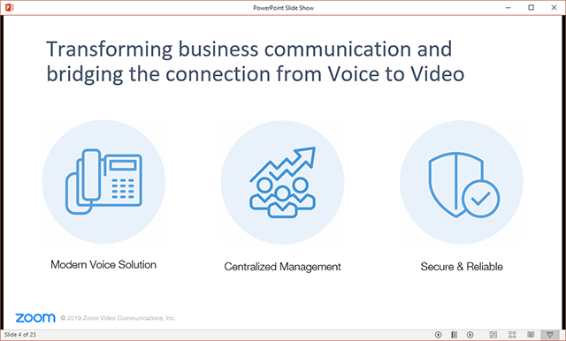
- Start or join a Zoom meeting.
- Click Share in the meeting controls.
- Select the PowerPoint window then click Share.

Single Monitor Setup with Slide Show in Full Screen
- Open the PowerPoint file you want to present.
- Start or join a Zoom meeting.
- Click Share in the meeting controls.
- Select your monitor then click Share.
- Switch the presentation in PowerPoint to slide show mode from the Slide Show tab.
The green border indicates the monitor you are currently sharing.

Sharing a Whiteboard
The whiteboard feature allows you to share a whiteboard that you and other participants (if allowed) can annotate on. To share a whiteboard, complete the following steps:
- Click Share Screen in your meeting controls.
- Click Whiteboard.
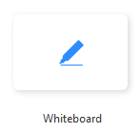
- Click Share.
The annotation tools appear automatically, but you can press the Whiteboard option in the meeting controls to show and hide them.

Use the page controls in the bottom-right corner of the whiteboard to create new pages and switch between pages.
NOTE: Only the participant or host that started sharing the whiteboard has access to create and switch pages.
- When you are done, click Stop Share.

Multiple Whiteboards in a Meeting
If you have simultaneous screen sharing on, multiple participants will be able to share a whiteboard at once. However, to see two whiteboards at once, or your own whiteboard and another participant's, you will need to have dual monitors enabled.

Sharing Multiple Screens Simultaneously
Hosts using the Zoom desktop client can allow multiple participants share their screens simultaneously during a meeting. This can useful for a real-time comparison of documents or other materials by participants. To make full use of this feature, enable the dual monitors option <<link to this>> in the Zoom client settings.
To enable simultaneous screen sharing as the meeting host, complete the following steps:
- Start your Zoom meeting as the host.
- Click the arrow to the right of Share Screen and select Multiple participants can share simultaneously.
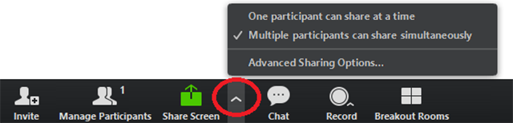
This allows multiple participants to share their screen at the same time.

Sharing Screens at the Same Time
Any participants, including the host, using the Zoom desktop client can click Share Screen to begin sharing. Even if someone is already sharing a screen, another participant can begin sharing.
Depending on their setup, participants see the following:
- Participants using dual monitors can see the two most recently shared screens on each monitor.
- Participants using a single monitor see the most recently shared screen. Participants can select View Options to change the screen they are viewing.
- Participants using the Zoom mobile app see the most recently shared screen. They cannot change the screen they are viewing.
As the host, you can choose to switch the option One participant can share at a time for any portion of the meeting.

Limitations
Sharing multiple screens simultaneously has the following limitations:
- When you enable the option to share the multiple screens simultaneously, the options Share computer audio and Optimize for full-screen video clip are not available.
- Participants using the mobile app cannot share when anyone else is sharing.

Controlling Chat
As the host, you can control who meeting participants are allowed to chat with and you can also disable the chat for all participants or disable private chat, so participants cannot send private messages.
To control chat access, complete the following steps:
- Start your Zoom meeting as the host.
- Click Chat in the meeting controls.
- Click More at the bottom of the Chat window and choose an option for Allow attendees to chat with. The host can allow attendees to chat with everyone or just the host.
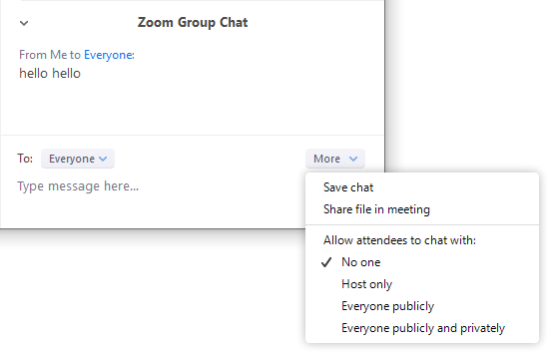

In-Meeting Chat
The in-meeting chat allows you to send chat messages to other users within a meeting. You can send a private message to an individual user or you can send a message to an entire group. As the host, you can choose who the participants can chat with you as well.
In-meeting chat can be saved manually or automatically. Auto-save chat will automatically save your in-meeting chat locally on your computer. You can also manually save your chat when you start local or cloud recording.

Access the Chat in Meeting from a Desktop Device

Video Only or While Viewing a Screen Share
- Click Chat in the meeting controls (while in a meeting).
The Chat window appears on the right part of the screen. You can type a message into the chat box or select the to: drop-down to select a specific individual to send the chat message.
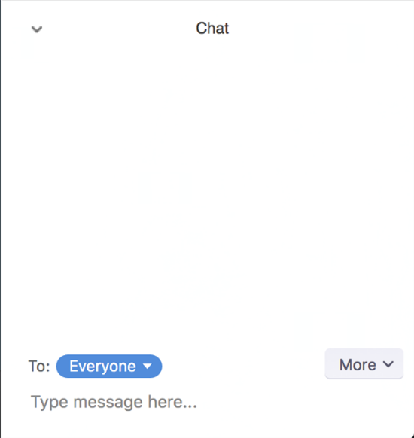
When new chat messages are sent to you or everyone, a preview of the message appears and Chat will flash orange in your host controls.

While Screen Sharing
- Click More in the meeting controls while screen sharing.
- Select Chat.
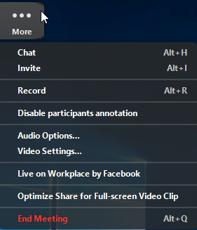
The Chat window appears. Typically the default is center screen. Drag the
If you receive new chat messages while sharing your screen, the More button will flash orange to indicate the incoming message.
- Click More.
- Click Chat to open the window.

Accessing the Chat in a Meeting from a Mobile Device
- Tap the screen while in a meeting to make the screen to make the controls appear.
- Click Participants.
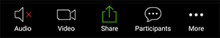
- Click Chat at the bottom of the participants list.
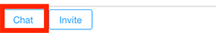
Type your chat message and click Send or, if you want to change who it is being sent to, click the arrow next to Send to: and select a different person.

- Click Participants and Chat to view the incoming chats that appear at the bottom of your screen.
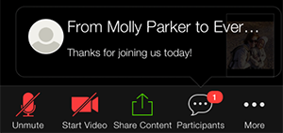

Changing In-Meeting Chat Settings
Complete the following steps to change the in-meeting chat settings while in a meeting:
- Click Chat in the meeting controls.
- Click More to view the in-meeting chat settings.
The following options are available to you:
- Save chat: Save all chat message in a TXT file.
- Share file in meeting: Send a file in the chat.
- Allow attendees to chat with: Control who participants can chat with.
- No one: Disables in-meeting chat.
- Host only: Only the host can send messages to everyone. Participants can still send private messages to the host.
- Everyone publicly: Participants can send public or private messages. Public messages are visible to all participants. Participants can still send private messages to the host.
- Everyone publicly and privately: Participants can send public or private messages. Public messages are visible to all participants. Private messages are sent to a specific participant.

Using Meeting Reactions
Meeting participants can react during a meeting by sending a thumbs up or clapping to communicate without interrupting the meeting. Reactions appear on screen for five seconds.
By default, the meeting reactions have a yellow skin tone. You can set your skin tone on the Zoom desktop client.

Sharing a Meeting Reaction
- Click Reaction in the meeting controls.
- Click the reaction you would like to send clapping hands or thumbs up.
The reaction appears for five seconds.
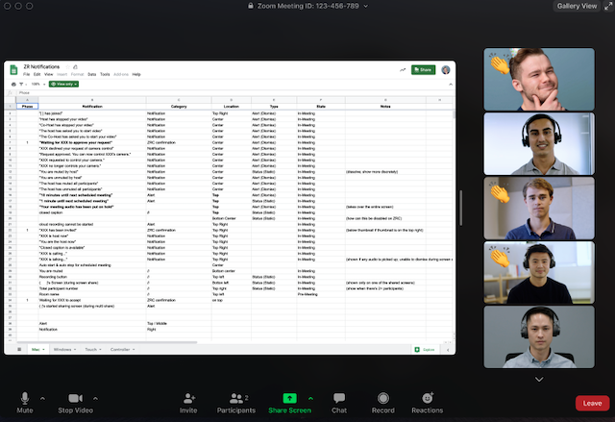

Setting the Skin Tone for your Reactions
- Log into the Zoom client.
- Click your profile picture then click Settings.
- In the General tab, select your reaction skin tone.
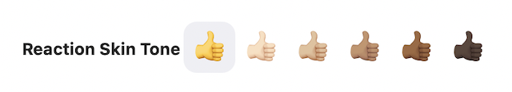

Using Nonverbal Feedback during Meetings

Providing Nonverbal Feedback during Meetings (Attendees)
To provide nonverbal feedback to the host of the meeting, complete the following steps:
- Join a Zoom meeting as a participant.
- Click the Participants button.

- Click one of the icons to provide feedback to the host. Click the icon again to remove it.
NOTE: You can only have one icon active at a time.
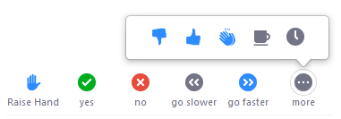
- Raise Hand / Lower Hand
- yes
- no
- go slower
- go faster
- Additional icons are available by clicking the more button:
- agree
- disagree
- clap
- need a break
- away
The icon will appear next to your name in the participants list.

Managing Nonverbal Feedback (Hosts)
- Click the Participants button to see a list of participants and their nonverbal feedback.
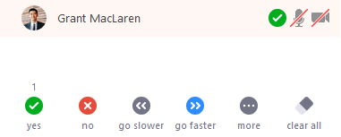

In the participants list, you can view and manage feedback using these features:
- If a participant clicked on a feedback icon, you'll see that icon beside their name.
- The number above each feedback icon shows the how many participants have clicked on that icon.
- If a participant clicked raise hand, you can lower their hand by hovering over their name and clicking Lower Hand.
- Click clear all to remove all nonverbal feedback icons.

Managing Video Breakout Rooms
Breakout rooms allow you to split your Zoom meeting in up to 50 separate sessions. The meeting host can choose to split the participants of the meeting into these separate sessions automatically or manually, and can switch between sessions at any time.
- Up to 50 breakout rooms can be created
- Max 200 participants across all breakout rooms (requires Large Meeting 200 add-on)
- Breakout room participants have full audio, video and screen share capabilities

Creating Breakout Rooms
Note: You can also pre-assign participants to breakout rooms <<link to this>> when you schedule the meeting instead of managing them during the meeting.
- Start an instant or scheduled meeting.
- Click Breakout Rooms.
- Select the number of rooms you would like to create, and how you would like to assign your participants to those rooms:
- Automatically: Let Zoom split your participants up evenly into each of the rooms.
- Manually: Choose which participants you would like in each room.
- Click Create Breakout Rooms.
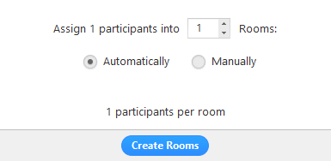
Your rooms will be created, but will not start automatically. You can manage the rooms prior to starting them by following the instructions below.

Options for Breakout Rooms
- Click Options after creating the breakout rooms to view additional breakout room options.
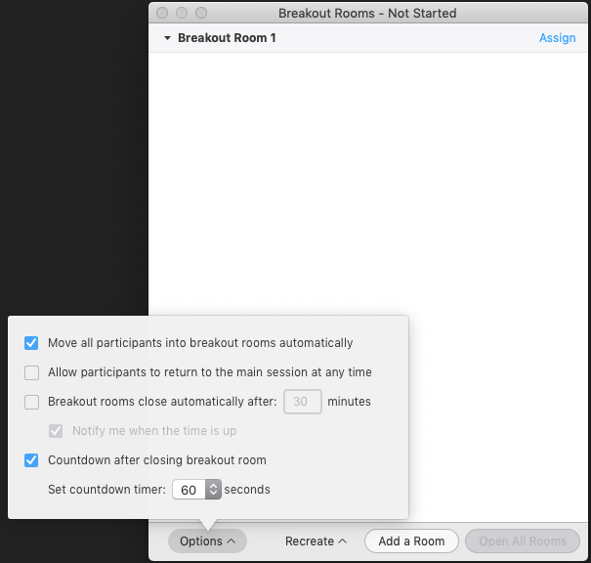
- Check any options that you would like to use for your breakout rooms.
- Move all participants into breakout rooms automatically: Checking this option will move all participants into the breakout rooms automatically. If this option is unchecked, the participants will need to click Join to be added to the breakout room.
- Allow participants to return to the main session at any time: If this option is checked, the participants can move back to the main session from their meeting controls. If this is disabled, they need to wait for the host to end the breakout rooms.
- Breakout rooms close automatically after x minutes: If this option is checked, the breakout rooms will automatically end after the configured time.
- Notify me when the time is up: If this option is checked, the host will be notified when the breakout room time is up.
- Countdown after closing breakout rooms: If this option is checked, the participants will be given a countdown of how much time they have left before being returned to the main room.
Complete the following steps to assign participants to rooms or click Open All Rooms to start the breakout rooms.

Assigning Participants to Rooms
To assign participants to your rooms, select Assign next to the room you wish to assign participants to and select participants you want to assign to that room. Repeat this for each room.
Once a participant has been assigned (manually or automatically), the number of participants will show in place of the Assign button.

Preparing Breakout Rooms
After manually or automatically assigning participants to rooms, you can rearrange the participants. Participants who are not assigned to breakout sessions will remain in the main meeting when the rooms are started.
- Move to (participant): Select a room to move the participant to.
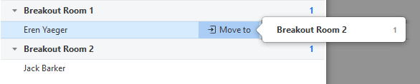
- Exchange (participant): Select a participant in another room to swap the selected participant with.
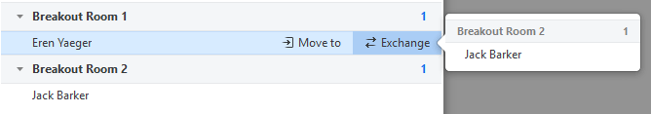
- Delete Room: Delete the selected room.
- Recreate: Deletes existing breakout rooms and creates new ones.
- Add a Room: Add another breakout room.

- Open All Rooms: Start the rooms. All participants will be moved to their respective rooms after confirming the prompt to join the breakout room. The host will be left in the main meeting until manually joining one of the rooms. The participants (and the host when manually joining a room) will see the following message shown when joining the breakout room.
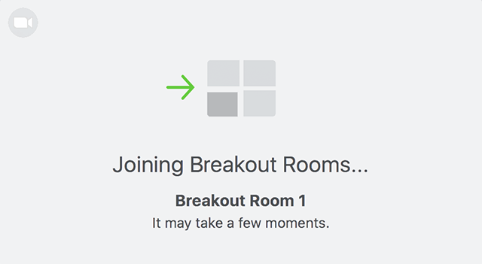

Managing Breakout Rooms in Progress
Once the Breakout Rooms have been started, the participants will be asked to join the Breakout Session. The host will stay in the main meeting until joining a session manually. If a participant has not joined the session yet, it will be noted by (not joined) next to their name.
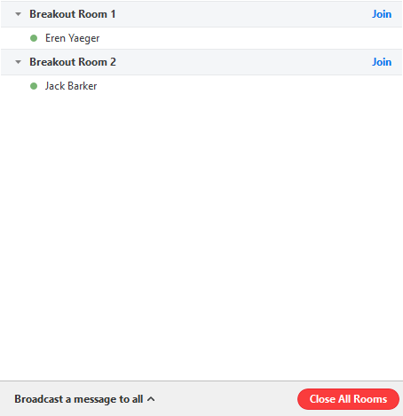
- Join: Join the breakout room.
- Leave: Leave the room and return to the main meeting (only shows when in a breakout room).
- Close All Rooms: Stops all rooms after a 60 second countdown, shown to the host and participants, and returns all participants back to the main meeting.

Ask for Help
Participants in breakout rooms can request that the meeting host join their meeting by clicking Ask for Help.
The host will be prompted to join the room where the request originated from. Click Join Breakout Room to join the room.
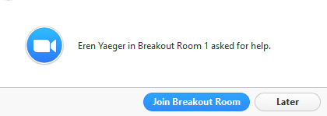

Broadcasting a Message to all Breakout Rooms
The host can broadcast a message to all breakout rooms to share information with all participants.
- Click Breakout Rooms in the meeting controls.
- Click Broadcast a message to all, enter your message and click Broadcast.
The message will now appear for all participants in Breakout Rooms.
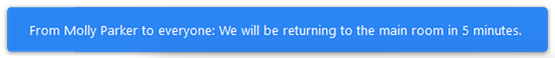

Participating in Breakout Rooms
Breakout rooms are sessions that are split off from the main Zoom meeting. They allow the participants to meet in smaller groups. Breakout rooms can be used for collaboration and discussion of the meeting.

Joining a Breakout Room
The host will need to invite you to join the breakout room.
- Click Join.
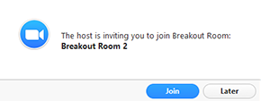
If you choose Later, you can join by clicking the Breakout Rooms option in your meeting controls.
- Click Join Breakout Room.
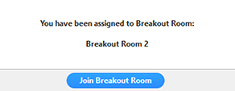

Participating in the Breakout Room
Once you've joined the breakout room, you will have full controls similar to the meeting. You can:
- Mute/Unmute to speak
- Start/Stop Video
- Participants - view the Participants list
- Share screen
- Chat - type messages to the other participants in your breakout room
- Record - you can record the Breakout Room locally if the host gives you recording permission.
- Ask for Help - request help from the meeting host

Asking for Help
If you click Ask for Help, it will notify the meeting host that you need assistance and they will be asked to join your breakout room.
- Click Ask for Help in the meeting controls.
- Click Invite Host to confirm that you would like assistance.
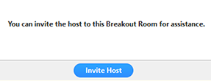

Recording while in a Breakout Room
- Ask the host for permission to record. The host needs to allow recording before opening the breakout rooms. If the host has already open the breakouts rooms, they can join your breakout room to allow you to record.
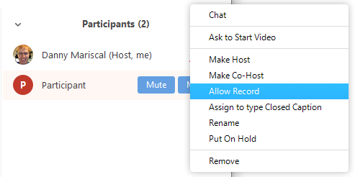
- Click Record in the meeting controls to start a local recording.
The host will need to invite you to join the breakout room.
- Click the pause or stop icon in the meeting controls to pause or stop the recording.
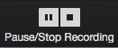
The recording can also be stopped or paused by clicking the indicator in the top left corner.

Leaving the Breakout Room
You can leave the breakout room and return to the main meeting session at any time, or you can leave the meeting entirely from the breakout room.
- Click Leave Breakout Room.
- Choose if you want to leave the breakout room or the entire meeting.
When the host ends the breakout rooms, you will be notified and given the option to return to the main room immediately, or in 60 seconds.

After the Meeting

Saving the Chat Conversation
You can automatically or manually save in-meeting chat to your computer. If you save the chat locally to your computer, it will save any chats that you can see – those sent directly to you and those sent to everyone in the meeting.

Save Chat Manually
You can save your in-meeting chat manually during the meeting. This will save it locally to your computer.
- Click Chat when in the meeting.
- Click Save Chat at the bottom of the Chat window.
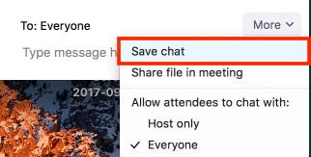
This will save your chat to your local recording location. The default is your Documents folder > Zoom > Folder with meeting name, date, and time.

Auto-Save Chat
- Sign in to the Zoom client.
- Click Settings.

- Click Edit on the right side of the Meeting (Basic) window.
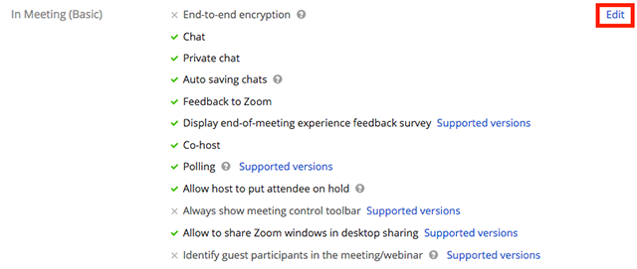
- Check the option for Auto saving chats.
- Click Save Changes.
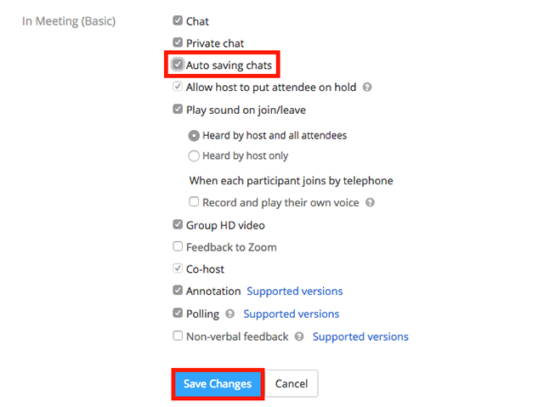

Default Chat Save Location on Computer
The in-meeting chat will save to your local recording location. The default is your Documents folder > Zoom > Folder with meeting name, date and time.
To view the recording path or change the default, complete the following steps:
- Log into the Zoom client.
- Click your profile picture then click Settings.
- Select Recording.
The selected recording path appears.
- Click Change to select a new file location.
NOTE: Zoom does not recommend using a network or cloud drive location, as this may cause file corruption if the connection is disrupted.

Troubleshooting

Downloading the Latest Version of Zoom
To check for updates on your installed Zoom desktop client, complete the following steps:
- Log into the Zoom client.
- Click your profile picture then click Check for Updates.
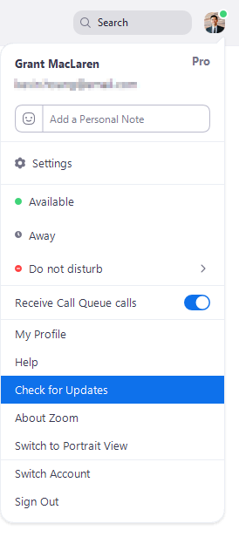
If there is a newer version, Zoom will download and install it.
There are three types of updates: web-only, mandatory and optional.
- Web-only updates are available for new fixes that are being tested.
- Mandatory updates will start once you click update. You cannot proceed further until you update.
- Optional updates will start once you click update. You can proceed should you decide to postpone the update until a later time and update manually.
NOTE: If you choose to postpone your optional update, you will only be prompted to update the next time you login.

Zoom Mobile App (iOS or Android)
Download the Zoom mobile app from the Apple Appstore or Google Play.
Zoom shows a mobile notification whenever there is a new update.

Troubleshooting in Zoom
Online help for many troubleshooting issues is available at https://support.zoom.us/hc/en-us/sections/200305593-Troubleshooting.

Addressing Audio Echo in a Meeting
If you hear audio echo or audio feedback during your meeting, there are 3 possible causes:
- A participant has both the computer and telephone audio active
- Participants with computer and telephones speakers that are too close to each other
- Multiple computer with active audio in the same conference room

Case 1: A participant has both the computer and telephone audio active
If you join from a computer and call in from the telephone, please make sure you either
- Type your participant ID when calling in or type your #participant ID# when already in the call
- Manually leave computer audio on your computer
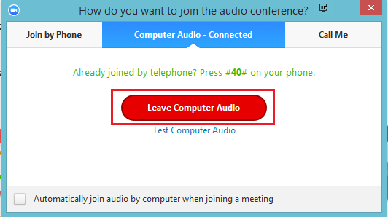

Case 2: Participants with computer or telephone speakers that are too close to each other
If another participant is too close to you, and both of you have speakers on, please leave audio conference on one of the computers or hang up one of the telephone connections.

Case 3: Multiple computer with active audio in the same conference room
If you are in a conference room with multiple devices, please disconnect computer audio from the other devices.
- Select Audio Options > Leave Computer Audio (PC/Mac) or Disconnect (Android/iPhone)
Muting is not enough as you mute the mic but the speaker is still on.

Other Tips:
Generally, if you are hearing echo, it means that there is a device out there that is channeling your audio back. To isolate the attendee:
- Host can mute the attendee one at a time
- Host can mute all and unmute one at a time
- Attendees can mute themselves
The source of echo can also be from:
- Speakers (such as TV or soundbar) that are too loud
- Echo cancellation has failed (device or performance issue)
- A bad microphone

Requesting or Giving Remote Control
The remote control feature allows you to take control of another participant’s screen in a meeting. You can either request remote control of another participant’s screen or the other participant can give control to you.

Requesting Remote Control
You can request remote control from the host or participant who is sharing their screen.
- Click the View Options drop-down menu located at the top of your in-meeting window while viewing another participant's screen share.
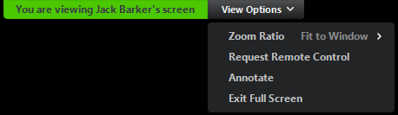
- Select Request Remote Control, then click Request to confirm.
The host or participant will get a notification asking if they want to allow you to control their screen.
- Click inside the screen share to start controlling the participant's screen.
- To stop remote control, click the View Options drop-down and select Give Up Remote Control to stop the remote control.
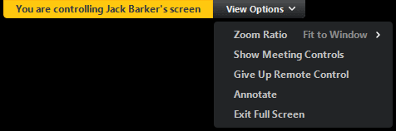

Giving Remote Control
While screen sharing, you can give remote control to another participant who is in the meeting. If the participant is on iOS or Android, they can remote control your screen using their mobile device.
- While screen sharing, click Remote Control and select the participant you want to give control to.
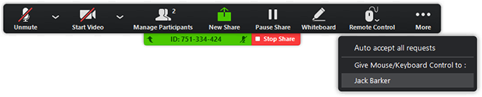
The participant can click anywhere on their screen to start control.
- Click anywhere on your screen to regain control. The other user can still restart remote control by clicking on their screen.
Tip: You can also click Stop Share to regain control and not allow the other participant to start remote control again.

Identifying Error Code and Messages for Zoom Meetings
The following table explains common error codes or messages while using meetings or installing the Zoom desktop client.

Error Codes and Messages
Error Code or Message | Issue | Suggested Troubleshooting
5000  5003  5004  104101  104102  104103  104104  104105  104106  104110  104111  104112  104113  104114  104115  104116  104117  104118 | Connectivity issues with Zoom’s servers | If you are on a network with a firewall or a proxy, contact a network administrator to check your firewall and proxy settings.  An antivirus software like AVG may be blocking your connection to Zoom. Disable the service and try again.  Check with your Internet service provider to ensure you can connect to the Zoom service.
The meeting has an unexpected error. Error code: 2008 | Webinar license is not applied to the user; or the applied license is no longer valid on the account. | Contact IT to confirm license information is current.
XmppDll.dll is missing from your computer |  | Please manually install Zoom. If this does not resolve the issue, please contact IT.
Entry Point Not Found  The procedure entry point could not be located. |  | Contact IT to reinstall Microsoft C++ 2008 SP1.
0 (during installation) | This error encountered when upgrading Version 0.9 or 1.0.  The source link of the Zoom installer is broken.  Antivirus software could have quarantined files downloaded by the installer. | Download the Zoom client installer and manually install it.  If the problem persists, contact IT to get the installer.txt file located in C:/users/username/AppData/Roaming/Zoom and submit a ticket to Zoom.
There is no disk in the drive. Please insert a disk into drive | The Zoom application is looking for a file path on your Windows machine that doesn’t exist. Typically this occurs when joining or leaving a meeting. | Uninstall Zoom and reinstall an updated version of Zoom.
3000 (during installation) | Zoom installer has failed to overwrite an existing file due to a running process. | Uninstall Zoom and reinstall an updated version of Zoom.
10002 (during installation) | The source link of the Zoom installer package is broken.  Antivirus software could have quarantined files downloaded by the Zoom installer. | Check your disc space for sufficient space.  Download the Zoom client installer manually and install it.  If the problem persists, contact IT to get the installer.txt file located in C:/users/username/AppData/Roaming/Zoom and submit a ticket to Zoom.
10006 (during installation) | The target disk is full.  Antivirus software could have quarantined files downloaded by the Zoom installer. | Download the Zoom client installer manually and install it.  If the problem persists, contact IT to get the installer.txt file located in C:/users/username/AppData/Roaming/Zoom and submit a ticket to Zoom.
13003 (during installation) | User’s permissions do not allow the installation of apps.  There is a conflict with drivers. | Download the Zoom client installer manually and then run the installer as the admin. These permissions are likely available only to IT.  Make sure video and audio drivers are current.

Tips from Blogs
Three Ways to Use Polls in Meetings
How to Make Learning & Development Interactive in Zoom
The Top 10 Most Asked Questions about Zoom Video Webinars
Zoom Tips and Tricks

Using Personal Meeting ID
Your Personal Meeting Room is a virtual meeting room permanently reserved for you that you can access with your Personal Meeting ID (PMI) or personal ink, if applicable. You can start instant meetings with your PMI, or you can schedule a meeting that uses your PMI.
Your Personal Meeting Room is ideal for use with people you meet with regularly. However, because it is always accessible with the same Meeting ID and personal link, it should not be used for back-to-back meetings or people you do not meet with regularly. Once a participant has the link to your PMI, they can join it any time the meeting is in use.

Setting to Always Use PMI for Instant Meetings
You can set your Zoom profile to always use your Personal Meeting ID for instant meetings. This will lock this setting so whether you are starting the instant meeting on the web with the Zoom desktop client or with the Zoom mobile app, it will use your Personal Meeting ID. If you schedule a meeting, you will need to use your PMI.
To change the setting to always use PMI for instant meetings, complete the following steps:
- Sign in to Zoom web portal.
- Click Profile.
- Click Edit next to Personal Meeting ID.
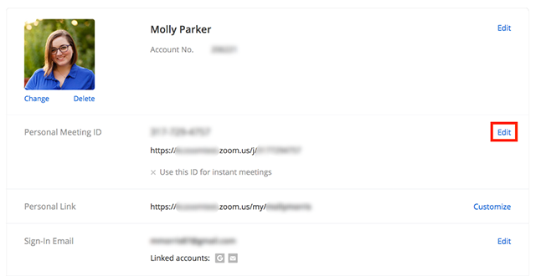
- Check Use this ID for instant meetings.

- Click Save Changes.
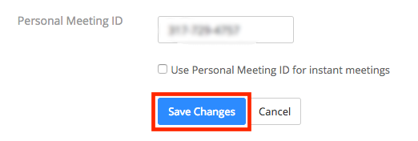

Instant Meetings with PMI

Starting Meetings with PMI
To start an instant meeting with your PMI, complete the following steps:
- Click Meetings.
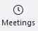
- Click the arrow next to New Meeting and check Use My Personal Meeting ID.
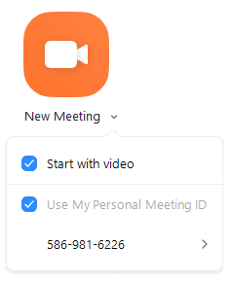
Now when you click Start with Video or Start without Video on this computer, it will use your PMI.

Scheduling a Meeting with PMI
To schedule a meeting with your PMI, complete the following steps:
- Click Schedule.
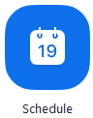
- Select your meeting settings.
- Click the arrow next to Advanced Options.
- Check Use Personal Meeting ID.
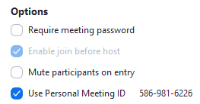
- Click Schedule.

Customize Your PMI
- Click Sign In and complete the sign in process.
- Click Profile.

- Click Edit next to Personal Meeting ID.
- Type a 10-digit digital ID.
- Click the check box if you want to use your PMI for instant meetings.
- Click Save Changes.

Restrictions for Customizing Your PMI
There are some restrictions for customizing your PMI. The number you select must meet the following criteria:
- Start with 2 – 9 (cannot start with 1 or 0)
- Following PMI prefixes (toll-free number prefixes) are not allowed:
800, 400, 888, 877, 866, 855, 803, 804, 807, 808, 809, 660, 508, 900, 200, 300, 500, 600, 700
- Must not repeat 3 digit groups like 247 247 247x or x247 247 247
- Must not repeat 3 digit groups like 222 444 777x or x222 444 777
- Must not use the same 8 digits like 222 x22 222x
- Must not have the same number 5 or more times consecutively like 11111xxxxx, x11111xxxx, xx11111xxx, xxx11111xx, xxxx11111x, xxxxx11111
- Sequential numbers are not allowed; for example, 123456789x
- Meeting IDs already in use are not allowed

Edit Personal Meeting Room Settings
- Click Sign In and complete the sign in process.
- Click Meetings.
- Click Personal Meeting Room.
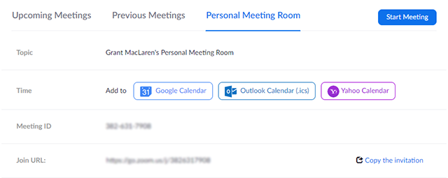
- Click Edit this Meeting.
- Change the desired settings.
- Click Save.

