White, Scott G
Scott-white@uiowa.edu
A Tool to Improve the Zoom Experience
A source that with a quick search of the table of contents and a click, will get you an answer to your question. Test it out and see how it works. Improve your Zoom participation in a few clicks.
Zoom Participant guide

Table of Contents
Prior to Meeting 2
Downloading Zoom 2
Joining a Meeting 3
Testing Audio 5
During the Meeting 7
Using Buttons and Controls 7
Using Reactions 8
Using Chat 9
Using a Virtual Background 10
Troubleshooting 11
Participating in Breakout Rooms 11
Before Leaving a Meeting 12
Saving In-Meeting Chat 12

The Zoom Help Center offers a number of webpages to assist you. In fact, all the information in this document is gleaned from those pages. In this guide, an attempt is made to organize the information into one place and give you the chance to use the Table of Contents links to locate what you want or need to do. Just select the topic link to locate the instructions to complete that task.

Prior to Meeting

Downloading Zoom
Zoom provides a pop-up notification on your PC or Mac when there is a new mandatory or optional update within 24 hours of logging in. You can manually download the latest version at https://zoom.us.
Complete the following steps to check for updates:
- Sign into the Zoom desktop client.
- Click your profile picture then click Check for Updates.
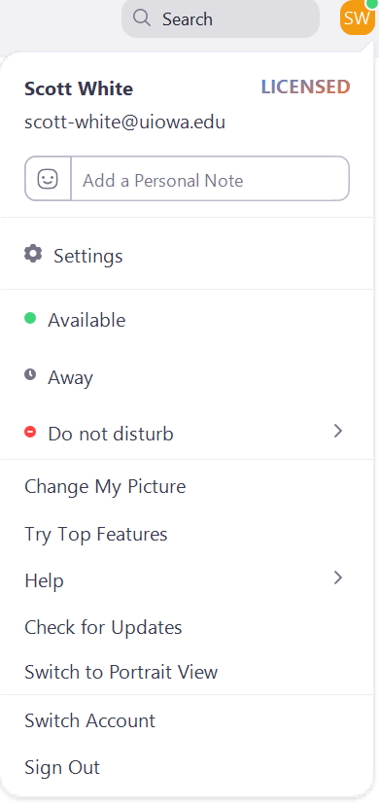
If there is a new version, Zoom will download and install it.
There are three types of updates: web-only, mandatory, and optional.
- Web-only updates are for new fixes that are being tested.
- Mandatory updates will start once you click on update. You cannot proceed further until you update.
- Optional updates will start once you click on update. You can proceed should you decide to postpone the update until a later time and update manually.

Joining a Meeting
For PC and Mac users, complete the following steps to join a meeting:
- Open the Zoom meeting invitation.
- Click the Zoom Meeting link.
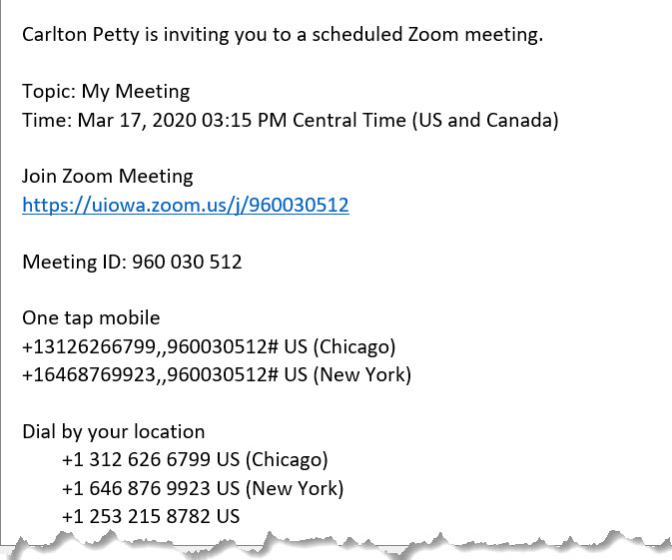
Zoom begins the launch process. The Open Zoom window appears.
- Click Open Zoom.
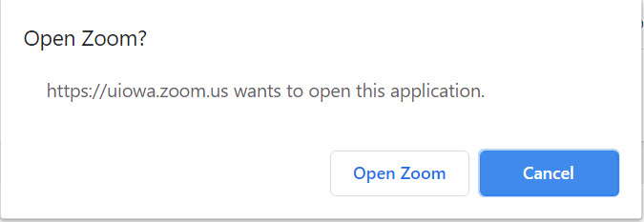
The Zoom meeting opens.

Alternatively, you can get to any scheduled meetings if you have the Zoom client downloaded from our dedicated Zoom site.
- Open the Zoom desktop client.
- Join a meeting using one of these two methods:
- Click Join a Meeting if you want to join without signing in.
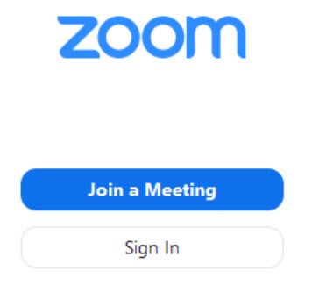
- Sign into Zoom then click Join.
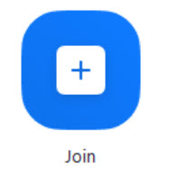
- Type the meeting ID number and your Display name in the respective fields.
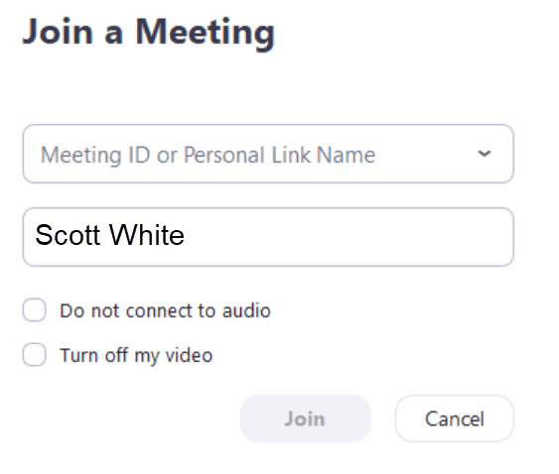

Testing Audio
After joining a meeting, complete the following steps to test your audio:
- Click Test Speaker and Microphone.
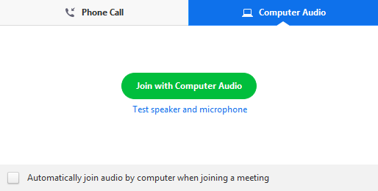
A window appears to test your speakers.
- Click Yes if you hear the ringtone.
If you don’t hear the ringtone, check the volume on your PC or Mac and adjust as necessary. Still don’t hear the ringtone, click No.
Select another speaker from the drop-down menu that appears. Continue testing until you hear the ringtone. Contact your meeting host if you are unable to get sound.
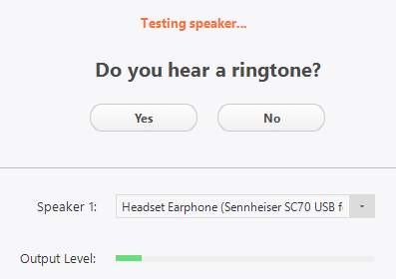
A window appears to test your microphone.
- Speak and see if the input level moves.
- Click Yes if you’re happy with the microphone volume.
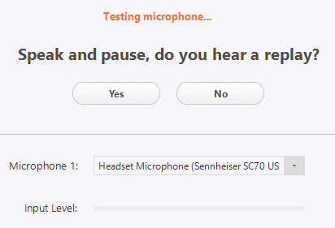
If you don’t hear yourself, check the volume on your PC or Mac and adjust as necessary. Still don’t hear yourself, click No.
Select another microphone from the drop-down menu that appears. Continue testing until you hear yourself. Proceed to the meeting and tell or send a chat message to the host informing them of your difficulties.
- Click Join with Computer Audio.
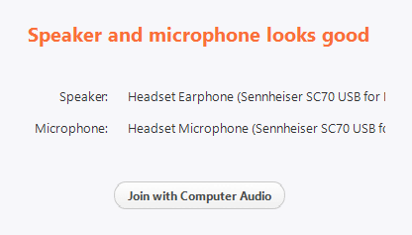
- Click Join with Computer Audio to join the meeting with the selected microphone and speakers.

During the Meeting

Using Buttons and Controls
The navigation controls default to the bottom of the screen.
You have access to the following features (from left to right):
- Mute/Unmute: Mute and unmute your microphone.
TIP: Use the following keyboard shortcuts to mute and unmute your microphone:
PC: Alt + A
Mac: Shift + Command + A
- Audio controls (arrow to the right of mute/unmute and to the left of stop/start video): allows you to change the microphone and speaker that Zoom is currently using on your computer, leave computer audio, and access to the full audio settings.
- Start Video/Stop Video: Turns your camera on or off.
- Invite: Invite others to join your meeting.
- Participants: Lists who is currently in the meeting. It also allows access to additional features which, when selected, places the same icon chosen next to your name for you to nonverbally connect to the host.
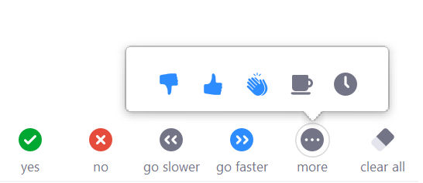
- The host may ask you to answer simple yes or no questions that you can answer here.
- If you have an opinion as to whether the host is going too slow or too fast you can share your opinion here.
- If you would like to provide instantaneous feedback on how the host is doing, you can like, dislike, or applaud as you see fit.
- If you would like a break or need to step away briefly, use the coffee cup and clock icons respectively.
- Share Screen: Allows you to share your screen. Please do so only at the request of the host.
- Chat: Access that chat window to chat with the host(s), presenters, and other participants.
- Record: Start or stop a recording to your device. Requires permission from the host. Use the chat feature to request permission.
- Reactions: Opens options to clap or show a thumbs up image on screen for all participants to view. Images will appear for three to five seconds.
- Leave Meeting: Leave the meeting while it continues for the other participants. Only the host can end the meeting.

Using Reactions
To share a meeting reaction, complete the following steps:
- Click Reactions from the meeting navigation controls.
- Click the reaction you wish to send, clapping hands or thumbs up.
The reaction will appear on the video screen for 5 seconds.
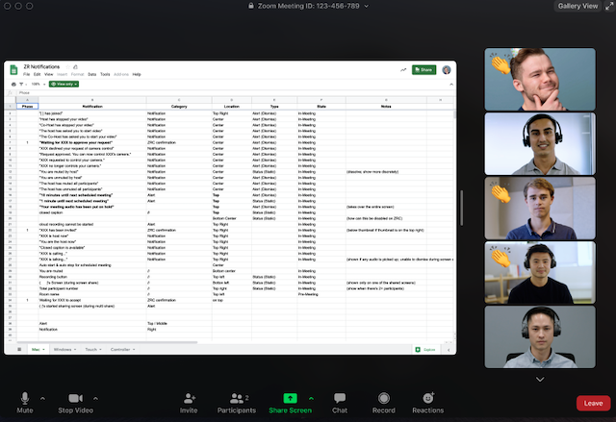
To set the skin tone for the reaction, complete the following steps:
- Open the Zoom desktop client.
- Click your profile picture.
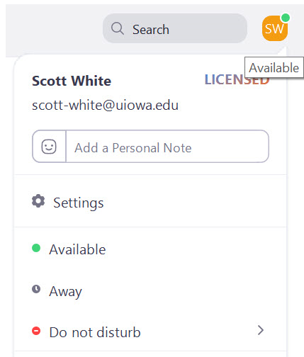
- Select Settings.
- Select your reaction skin tone from the General tab.
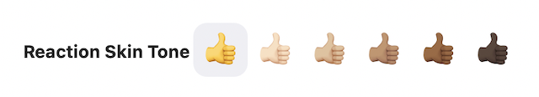

Using Chat
To access chat, complete the following step:
- Click Chat in the meeting controls, the navigation at the bottom of the screen.
The Chat window appears to the right of the video.

To send a message, complete the following steps:
- Select who to send the message to from the To drop-down menu.
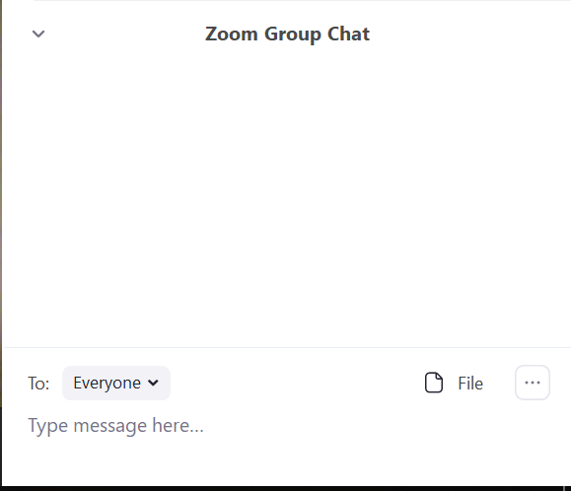
- Type your message where the Type message here… phrase appears.
- Press Enter to send.
When a new message is sent to you, the Chat meeting control will flash orange.

Using a Virtual Background
To use a virtual background, if the host has enabled the feature, complete the following steps:
- Click the arrow next to Start/Stop Video.
- Click Choose a Virtual Background…
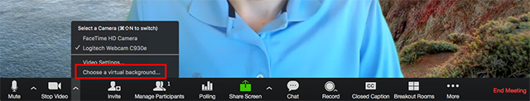
If prompted, click Download to download the package for virtual background without a green screen.
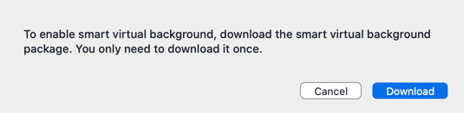

Troubleshooting
Try the following troubleshooting tips if you are experiencing issues with virtual background:
- If you do not have the virtual background tab, verify the meeting host to see if they’ve enabled virtual background. If the host answers yes, try signing out of the meeting and signing in again.
- Manually pick the background color to ensure the correct color is selected. This option is only available after you click an image.
- Ensure that the background is a solid color with minimal shadows. Also ensure the background is uniform in lighting.
- Ensure that your green screen color does not match your shirt or eye color.
If you continue to experience issues, contact Zoom technical support.

Participating in Breakout Rooms
To join a breakout room, sent as an invitation from the host, complete the following steps:
- Click Join.
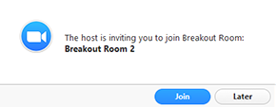
If you select Later, join later with a click from the Breakout Rooms selection on the meeting navigation controls.
Next, click Join Breakout Room.
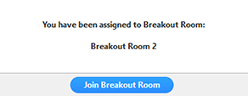
Participation in the breakout room is done with similar tools used in the general meeting. Here though you can also ask for help from the host. To ask for help, complete the following steps:
- Click Ask for Help in the meeting navigation controls.
The Invite Host confirmation window appears.
- Click Invite Host to confirm you want help.
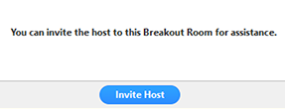

At the conclusion of the breakout session, complete the following steps to leave the breakout room:
- Click Leave Breakout Room in the meeting navigation controls.
- Select option to return to the main meeting immediately or in 60 seconds after the host ends the breakout session.

Before Leaving a Meeting

Saving In-Meeting Chat
If there is information you found helpful contained in the Chat during the meeting, complete the following steps to manually save the chat contents:
- Click Chat in the meeting navigation controls.
- Click the More drop-down menu.
- Click Save Chat.
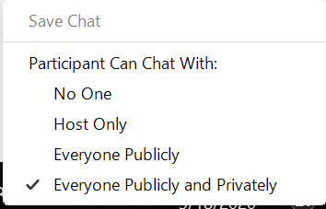
The chat saves to the default location of Documents folder > Zoom > Folder, with meeting name, date and time.

