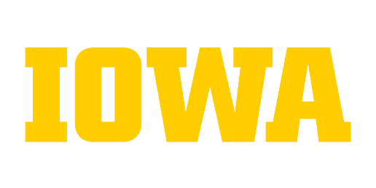
Sample Completed Documentation of Career Development
Career Advancement – Ima Hawk – HR Associate (PGA1)

Documentation of Career Development – Career Advancement

Complete Directions for Form available at: http://hr.uiowa.edu/career-development/form-instructions

Section 1 – Demographics (Employee and/or Supervisor)
Employee Name: Ima Hawk Current Classification/Job Code: HR Associate / PGA1
Department: Biology Supervisor: Ura Boss
Initiated by: Ura Boss Date Initiated: 11/6/2017

Section 2 - Scope/Responsibilities (Employee and/or Supervisor)
Please list the six most important activities that are performed. If the duty is entirely new since the last time the employee/position was classified, please indicate so. If an existing duty has changed, please describe the change. The new or expanded duties should be performed for an appropriate period of time that is sufficient enough to evaluate the employee’s performance and continuing success in the role. The period of time necessary for evaluation is at the discretion of the college/division. Examples of completed Documentation of Career Development Forms are found at http://hr.uiowa.edu/career-development/form-instructions.
Position Specific Duties | Is this a new duty? | Description of Change (i.e. new duties/skills, additional key areas of responsibility, expanded scope and/or advanced competency)
Serve as search administrator for the college by monitoring the EOD process and auditing/developing search justifications. |  | Expanded Scope - Previously assisted with searches but am now fully responsible for coordinating the search process.
Develop quarterly reports of leave usage for supervisor review; use department protocol for types of leave to exclude. For routine FMLA requests (pregnancy, surgery of defined duration, etc.), process all FMLA paperwork and approve requests. |  | Advanced Competency – As my knowledge has increased, my level of responsibility has led me to become more involved with generating reports, protocols and analysis. Previously I distributed reports and referred questions to my supervisor or the website.
Develop and distribute report used during the annual review to determine if all compliances are met. Schedule required trainings and promote participation. Maintain records and send appropriate reminders of non-compliance. |  | New Duty – Responsibilities shifted from another employee in the department. Previously I only distributed reports and updated records.
Initiate all HR transactions and maintain accurate and complete personnel records.
Track performance reviews by maintaining a schedule of due dates and sending reminders 1 month prior and 1 month after if delinquent. Provide forms as needed.
Provide policy and procedure information to supervisors and employees.

Section 3 – Supervisor Section

Assessment/Comments
Document if and how the employee has assumed each of the new, changed or expanded duties and the importance of these duties to unit operations.
Ima has assumed responsibility for all searches and has done 7 during the past months. Feedback from search committee chairs has been positive in that they appreciate her taking over the EOD process steps. Only 1 form has been returned from EOD for additional information which demonstrates Ima’s skill in this duty. By realigning responsibility for this duty with Ima, we have decreased the time researchers spent in the search process and have decreased the time to hire. With grants and contracts this is essential.
The tool Ima developed for supervisors to be aware of leave usage has been appreciated. It has made their discussion with staff timelier in addressing attendance issues. She has been timely in processing FMLA forms. She continues to expand her knowledge about union issues related to attendance and the various components of FMLA. Attendance concerns were an issue for several supervisors who now have the data to address issues. Ima has also freed up supervisor time previously spent on FMLA forms.
Ima has provided training opportunities that meet the busy schedule of our staff which has increased timely compliance. Her graphic display of non-compliance rates has brought supervisors to pay attention to this issue. She has been influential with those who are not timely in completing compliances with her pleasant but firm reminders. Compliance with research and safety training is essential in our unit and we have greatly improved our compliance with the least amount of effort due to Ima’s efforts.

Overall performance rating at last formal performance review
Date of Last Review: 6/8/2017
Did the employee receive a performance rating of “Successfully Meets Expectations” or higher on their most recent performance evaluation? Yes No

Section 4 – Employee and Supervisor Electronic Signature

I agree that this represents a true and accurate documentation of the work being performed.
Supervisor Employee

Date: 11/13/2017

©The University of Iowa 2011. All Rights Reserved. Last updated 3/2023

