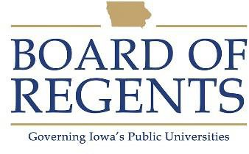
Clerk IV

GENERAL CLASS DESCRIPTION

Under general supervision, performs and coordinates specialized work of a quasi-technical nature requiring a knowledge of a specialized subject matter. Duties may involve the use of personal computers, computer terminals, and a variety of software and/or conventional office equipment.

CHARACTERISTIC DUTIES AND RESPONSIBILITIES

- Researches information, prepares, reviews and analyzes documents, such as reports, applications, records etc., applicable to a specialized subject area requiring independent informational search and a knowledge of the policies and procedures of both the assigned and related work areas.

- Creates and maintains a complex database that requires specialized subject matter knowledge. Analyzes the data to maintain the database and generate reports. Troubleshoots database problems for staff.

- Advises staff, faculty, and others requiring interpretation of policies and regulations of specific projects or programs in assigned work area.

- Coordinates intra unit and interunit operations and procedures and participates in regular staff meetings to discuss and assist in developing operational policies and procedures.

- Composes correspondence requiring judgment in the application of policies and procedures in both the assigned and related work areas.

KNOWLEDGES, SKILLS AND ABILITIES

- Knowledge of institutional and unit policies, processes, and forms.

- Knowledge of format and clerical procedures to arrange a variety of material from different sources in a coherent and logical manner.

- Knowledge of grammar, spelling, punctuation, and capitalization.

- Skill in utilizing computer software packages and online systems to develop unit-specific applications.

- Skill in operating office equipment.





- Ability to communicate effectively with staff, students, and the public.

- Ability to make decisions requiring interpretation and judgment.

- Ability to follow oral and written instructions and interpret institutional and other policies accurately.

- Ability to gather, analyze, and display data in appropriate format and keep accurate records.

- Ability to organize and prioritize multiple tasks.

MINIMUM ELIGIBILITY REQUIREMENTS

Any combination of progressively responsible related clerical office experience, related undergraduate education, and/or post high school clerical training that is the equivalent to four years of full-time employment.

The tasks listed under the heading of Characteristic Duties and Responsibilities are examples of the variety and general nature of duties performed by employees in positions allocated in the class. The list is descriptive only and should be used for no other purpose. It is not intended that any position include every duty listed, nor is it intended that related duties cannot be required.

Last Revised: December 13, 2010




