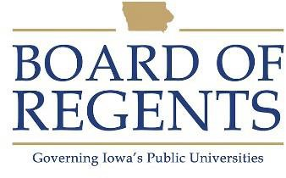
Secretary II

GENERAL CLASS DESCRIPTION

Under general supervision, performs secretarial work such as composing routine correspondence, maintaining records, and obtaining and providing factual information requiring a knowledge of the policies and procedures of both the assigned and related work areas. Duties involve the use of personal computers, computer terminals, and a variety of software and/or conventional office equipment. May provide functional supervision.

CHARACTERISTIC DUTIES AND RESPONSIBILITIES

- Reviews inquiries, provides information and otherwise represents assigned and related work areas referring inquiries to appropriate persons as required.

- Initiates and processes standard forms and documents such as personnel action forms, purchase orders, vouchers, and invoices.

- Maintains and updates records on personnel, budgetary and purchasing transactions, and verifies and reconciles departmental statements. Tracks and monitors expenditures, notifying management of status and/or concerns.

- Composes correspondence in response to routine inquiries within established guidelines.

- Assigns, coordinates and reviews the work of other secretarial/clerical personnel for conformance to established guidelines.

- Integrates information and may run routine queries to generate or produce reports.

- Organizes activities and/or events for department such as scheduling room, ordering food, sending invitations, preparing agenda, etc. according to pre-determined guidelines or standards.

KNOWLEDGES, SKILLS AND ABILITIES

- Knowledge of office routines and functions sufficient to refer visitors and telephone calls and to route correspondence by name and functional area.

- Knowledge of institutional and unit policies, processes and forms.

- Knowledge of proper format, grammar, spelling, punctuation, and capitalization.




- Skill in utilizing computer software and online systems.

- Skill in operating office equipment.

- Ability to communicate effectively with staff, students, and the public.

- Ability to follow oral and written instructions and apply institutional and policies accurately.

- Ability to collect data, keep records, and prepare reports.

- Ability to exercise functional supervision over employees.

- Ability to organize and prioritize multiple tasks.

MINIMUM ELIGIBILITY REQUIREMENTS

Any combination of related clerical office experience, related undergraduate education and/or post high school clerical training that is the equivalent to two years of full-time employment and includes the use of word processing.

The tasks listed under the heading of Characteristic Duties and Responsibilities are examples of the variety and general nature of duties performed by employees in positions allocated in the class. The list is descriptive only and should be used for no other purpose. It is not intended that any position include every duty listed, nor is it intended that related duties cannot be required.

Last Revised: June 20, 2017




