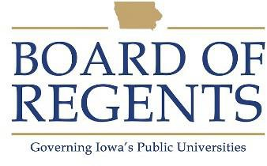
Clinical Technician II

GENERAL CLASS DESCRIPTION

Under general supervision, operates and maintains highly specialized medical equipment for use in performance of tests and studies related to the treatment of patients and the teaching of staff personnel. Provides functional supervision as required.

CHARACTERISTIC DUTIES AND RESPONSIBILITIES

Prepares machines, equipment and materials for patient testing, requiring knowledge of complex medical equipment and its usage.

Determines calibration factors and balances and calibrates equipment for tests.

Performs technical measurements using highly specialized medical equipment to determine changing conditions of a patient.

Records and maintains information obtained during equipment tests to facilitate interpretation of the data and meet established equipment review guidelines/protocols.

Performs maintenance of moderately complex medical equipment to ensure operational condition at all times; assists in repairing equipment as required.

Submits requests for major maintenance of central equipment systems and bedside equipment with unit supervisor.

Maintains and monitors inventories of expendable supplies for use with the systems and suggests orders of new units and replacement for out-of-date equipment.

Provides functional supervision and training to lower level clinical technicians and support staff members as required.

Prepares and maintains emergency accessory equipment.

Assembles emergency trays to be used for tests.

Instructs unit personnel in the operation and maintenance of complex medical equipment.

Escorts patients to examination rooms.

Assists with monitoring patients to help ensure their safety and well-being.





May assist with physical examination of patients and related treatment.

Assists higher-level staff in performance of their duties as assigned.

KNOWLEDGES, SKILLS AND ABILITIES

- Ability to communicate effectively with staff, students, patients, and the public.

- Ability to follow oral and written instructions.

- Ability to collect data and maintain accurate records.

- Ability to operate and perform routine maintenance on various types of highly specialized medical equipment.

- Ability to perform calibrations of equipment.

MINIMUM ELIGIBILITY REQUIREMENTS

Two years of health care experience involving direct patient care including use of specialized medical equipment at the level of a Clinical Technician I or equivalent, or a combination of related education and experience.

The tasks listed under the heading of Characteristic Duties and Responsibilities are examples of the variety and general nature of duties performed by employees in positions allocated in the class. The list is descriptive only and should be used for no other purpose. It is not intended that any position include every duty listed, nor is it intended that related duties cannot be required.

Last Revised: August 1, 2005




