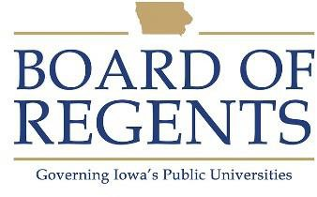
Phlebotomy Technician I

GENERAL CLASS DESCRIPTION

Under direct supervision, performs phlebotomy and a variety of tasks related to phlebotomy.

CHARACTERISTIC DUTIES AND RESPONSIBILITIES

Performs phlebotomy draws.

Completes redraws.

Labels specimens.

Performs computer data entry and other clerical tasks as required.

Orders, receives and distributes supplies.

Performs routine cleaning of phlebotomy and related equipment.

Responds to basic phlebotomy inquiries and otherwise represents assigned and related work areas.

KNOWLEDGES, SKILLS AND ABILITIES

- Ability to follow oral and written instructions.

- Ability to communicate effectively with others.

- Knowledge of care and use of laboratory equipment.

- Knowledge of principles of sanitation, health hazards, and the necessary precautionary measures.

- Knowledge of standard cleaning techniques and equipment and supplies required.

- Ability to collect patient data and maintain accurate records.

- Knowledge of keyboarding and computer data entry skills.

MINIMUM ELIGIBILITY REQUIREMENTS

High school graduation or equivalent.




The tasks listed under the heading of Characteristic Duties and Responsibilities are examples of the variety and general nature of duties performed by employees in positions allocated in the class. The list is descriptive only and should be used for no other purpose. It is not intended that any position include every duty listed, nor is it intended that related duties cannot be required.

Last Revised: April 1, 2008




