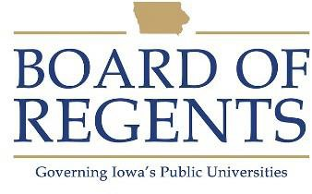
Phlebotomy Technician II

GENERAL CLASS DESCRIPTION

Under general supervision, performs phlebotomy and a variety functions related to phlebotomy. Provides functional supervision and training of Phlebotomy Technician I, wage staff and students as required.

CHARACTERISTIC DUTIES AND RESPONSIBILITIES

Performs all duties of a Phlebotomist I.

Performs routine and complex specimen procurement processes.

Instruct and train others in phlebotomy techniques.

Responds to or may direct responses to inquiries concerning phlebotomy policies and procedures.

Performs data entry and computer tasks related to order entry and phlebotomy.

Maintains phlebotomy area and equipment.

KNOWLEDGES, SKILLS AND ABILITIES

- Ability to follow oral and written instructions.

- Ability to communicate effectively with others.

- Ability to instruct and train employees.

- Knowledge of care and use of laboratory equipment.

- Knowledge of principles of sanitation, health hazards, and the necessary precautionary measures.

- Knowledge of standard lab cleaning techniques, equipment and supplies required.

- Knowledge of keyboarding and computer data entry skills

- Ability to use proper bending and lifting techniques.

- Ability to collect data and maintain accurate records.





MINIMUM ELIGIBILITY REQUIREMENTS

- High school graduation or equivalent, and

- Current certification as a Phlebotomist Technician by ACA (American Certification Agency), AMT (American Medical Technologists), ASCP (American Society for Clinical Pathology), NCA (National Center for Competency Testing), NCCT (National Credentialing Agency) or NHA (National Healthcareer Association), and

- Six months full-time experience performing phlebotomy work, or completion of a Phlebotomy training program.

The tasks listed under the heading of Characteristic Duties and Responsibilities are examples of the variety and general nature of duties performed by employees in positions allocated in the class. The list is descriptive only and should be used for no other purpose. It is not intended that any position include every duty listed, nor is it intended that related duties cannot be required.

Last Revised: October 1, 2019




