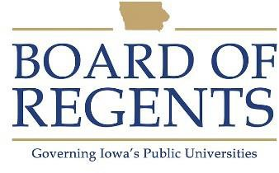
Mechanic’s Assistant

GENERAL CLASS DESCRIPTION

Under general supervision, performs routine maintenance, service tasks, and minor repair work on motor vehicles. Duties require some knowledge and skills in the use of power and hand tools related to motor vehicle service and repair.

CHARACTERISTIC DUTIES AND RESPONSIBILITIES

- Lubricates parts, checks and fills fluid levels, inspects lights, glass and tires.

- Repairs and changes tires, changes oil and filters, wiper blades, head-lights and adjusts brakes on vehicles.

- Performs minor repairs and replaces parts and components.

- Washes vehicle exteriors, cleans interiors, polishes and waxes motor vehicles and performs minor body trim repair.

- Fuels vehicles, and maintains shop equipment and work area.

- Responds to calls for emergency service, including snow removal.

- Drives vehicles into car washes, clean up bay, and parking lot.

- Picks-up or returns customers to their on-campus offices, and drives to pick-up parts from local vendors.

- Maintains records of vehicle maintenance, fueling, cleaning and repairs performed.

- May train and assign tasks to student workers.

- Orders and maintains parts and supplies, initiating purchase orders.

- Prepares vehicles for system operation and/or sale.

KNOWLEDGES, SKILLS AND ABILITIES

- Skill in operating and driving motor vehicles.

- Knowledge of general motor vehicle maintenance.

- Knowledge in the use of power and hand tools related to motor vehicle service and repair



- Ability to read, write and follow instructions.

- Ability to safely handle and use cleaning chemicals, fuels, and equipment.

- Ability to maintain accurate records.

- Ability to work under tight deadlines and prioritize tasks.

- Ability to lift, carry, and move parts weighing up to 75 pounds and to be on feet for prolonged periods of time.

- Ability to work in adverse conditions such as weather extremes, around fumes, noise, dust and dirt.

MINIMUM ELIGIBILITY REQUIREMENTS

- One year of experience servicing or repairing motor vehicles, or

- Any combination of related post high school education and work experience that totals one year.

- Valid state driver's license.

The tasks listed under the heading of Characteristic Duties and Responsibilities are examples of the variety and general nature of duties performed by employees in positions allocated in the class. The list is descriptive only and should be used for no other purpose. It is not intended that any position include every duty listed, nor is it intended that related duties cannot be required.

Last Revised: July 30, 2001




