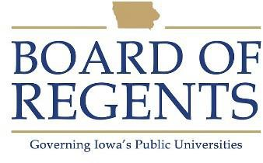
ERD Welder

GENERAL CLASS DESCRIPTION

Under general supervision, does work at the journeyman level using metal-cutting and joining processes including oxygen-acetylene torch, soft solder, silver solder, brazing, fusion arc welding, tungsten-inert gas welding, and metal-inert gas welding to fabricate or repair experimental equipment, construct high vacuum and cryogenic apparatus and weld defect-free joints in a wide variety of metals.

CHARACTERISTIC DUTIES AND RESPONSIBILITIES

- Builds experimental equipment in accordance with blueprints, sketches or verbal instructions. Designs and prepares the joints as appropriate for type of material and use.

- Welds structural steel and pipe, stainless steel, aluminum, magnesium, and titanium.

- Cuts steel shapes accurately using hand or automatic oxygen-acetylene torch.

KNOWLEDGES, SKILLS AND ABILITIES

- Ability to communicate orally and in writing.

- Ability to maintain effective working relationships with others.

- Knowledge of the principles, methods and techniques used in the trade.

- Ability to interpret and follow instructions and specifications such as blueprints, manuals, sketches and work orders.

- Ability to operate safely and care for tools, machines and equipment.

- Ability to perform a broad and varied range of welding tasks with precise attention to detail.

- Ability to lift or maneuver up to 100 pounds.

- Knowledge of occupational hazards and safety precautions associated with equipment assembly.





MINIMUM ELIGIBILITY REQUIREMENTS

Four years of experience in the trade, including apprenticeship.

The tasks listed under the heading of Characteristic Duties and Responsibilities are examples of the variety and general nature of duties performed by employees in positions allocated in the class. The list is descriptive only and should be used for no other purpose. It is not intended that any position include every duty listed, nor is it intended that related duties cannot be required.

Last Revised: October 1, 2009




