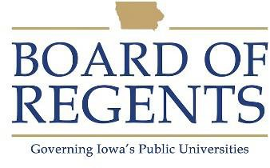
Baker I

GENERAL CLASS DESCRIPTION

Under direct supervision, produces all types of baked goods, using standardized recipes and performs other related preparation and sanitation duties as required.

CHARACTERISTIC DUTIES AND RESPONSIBILITIES

- Prepares dough and bakes bread, rolls, biscuits, muffins and similar items.

- Prepares and bakes cakes, cookies, cobblers, pies, puddings, doughnuts, and other desserts.

- Prepares icings, toppings, fillings and sauces for baked goods.

- Operates baking machines and equipment such as scales, dough mixers, molders, proof boxes, ovens, fryers and bread slicers.

- Cleans bakery and baking equipment and machinery.

- Notifies supervisor of food and supplies needed.

- Maintains maximum standards of sanitation and safety.

- Assists in training and assist directing the work of food service workers, students and other employees assigned to the bakery area.

- Performs other related duties and responsibilities as required or assigned.

KNOWLEDGES, SKILLS AND ABILITIES

- Knowledge of safety and sanitation standards for large scale bakery operation.

- Ability to read, write and follow instruction.

- Ability to perform physical tasks such as lifting (50 pounds), bending, stooping for prolonged periods.

- Ability to maintain effective working relationships with others.

- Knowledge of basic arithmetic skills, i.e., addition, subtraction, multiplication, division of whole and fractional numbers, count and decimal systems.

- Ability to convert standard unit recipes to desired quantity of product.





Ability to maintain simple records of quantities of ingredients used and volume of production.

Ability to provide on the job training in food preparation to lower level employees.

MINIMUM ELIGIBILITY REQUIREMENTS

Ability to read, write and follow instructions.

The tasks listed under the heading of Characteristic Duties and Responsibilities are examples of the variety and general nature of duties performed by employees in positions allocated in the class. The list is descriptive only and should be used for no other purpose. It is not intended that any position include every duty listed, nor is it intended that related duties cannot be required.

Last Revised: July 1, 1989




