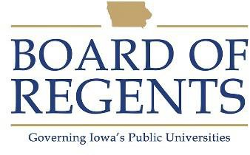
Baker II

GENERAL CLASS DESCRIPTION

Under general supervision, supervises and participates in the large-scale production of bakery goods and in the sanitation of baking equipment and facilities.

CHARACTERISTIC DUTIES AND RESPONSIBILITIES

- Supervises and participates in the preparation of doughs and in the baking of bread, rolls, muffins, biscuits and similar items.

- Supervises and bakes cakes, cookies, cobblers, pies, puddings, doughnuts, and other desserts.

- Supervises and prepares icings, toppings, fillings and sauces for baked goods.

- Prepares recipes for mixing of doughs.

- Estimates bakery needs and requisitions and maintains adequate supplies for baking operation.

- Trains personnel in the operation of baking machinery such as scales, dough mixers, bread molds, proof boxes, fryers and ovens.

- Maintains maximum standards of sanitation and safety.

- Performs other related duties and responsibilities as required or assigned.

- Recommends equipment repairs or improvements.

KNOWLEDGES, SKILLS AND ABILITIES

- Knowledge of safety and sanitation standards for large scale bakery operation.

- Ability to read, write and follow instruction.

- Ability to perform physical tasks such as lifting (50 pounds), bending, stooping for prolonged periods.

- Ability to maintain effective working relationships with others.

- Knowledge of basic arithmetic skills, i.e., addition, subtraction, multiplication, division of whole and fractional numbers, count and decimal systems.

- Ability to convert standard unit recipes to desired quantity of product.




Ability to maintain records of quantities of ingredients used and volume of production.

Knowledge of scratch and gourmet baking.

Ability to train, assign, delegate work to others.

Knowledge of methods and techniques used in large scale bakery operations.

Ability to understand and execute oral and written instructions.

Knowledge and care of food service equipment.

Ability to provide on the job training in food preparation to lower level employees.

MINIMUM ELIGIBILITY REQUIREMENTS

One year of experience as Baker I or outside experience comparable thereto.

The tasks listed under the heading of Characteristic Duties and Responsibilities are examples of the variety and general nature of duties performed by employees in positions allocated in the class. The list is descriptive only and should be used for no other purpose. It is not intended that any position include every duty listed, nor is it intended that related duties cannot be required.

Last Revised: July 1, 1989




