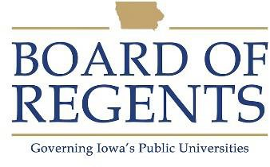
Food Service Coordinator II

GENERAL CLASS DESCRIPTION

Under general supervision, is responsible for multi-phases of food service in cafeterias, vending areas, dining rooms, banquet rooms, and patient food service systems. Trains and supervises personnel involved in food service, and some miscellaneous kitchen activities. Coordinates overall food center operations in absence of the unit supervisor.

CHARACTERISTIC DUTIES AND RESPONSIBILITIES

- Supervises Food Worker personnel in performance of food service tasks in cafeterias, dining rooms, banquet rooms, vending areas.

- Opens food service center; secures kitchen and dining areas at the close of daily serving period as shift may dictate.

- Assumes duties of unit supervisor during off-duty or absence periods; coordinates overall food center operations.

- Participates in evaluating performance of personnel and makes recommendations to unit supervisor.

- Arranges and assists in arranging for parties, conference luncheons, catering services, etc., and assist in preparation of dining areas and serving of food.

- Arranges for added regular and student help for special activities requiring food service and for student served meals.

- Supervises and participates in the work of kitchen and dining areas as required.

- Assists in service and dining areas as required.

KNOWLEDGES, SKILLS AND ABILITIES

- Knowledge of methods and practices of institutional food preparation and service.

- Knowledge of principles of food sanitation, health hazards, and the necessary precautionary measures.

- Ability to understand and execute oral and written instructions.

- Ability to maintain effective working relationships with others.

- Ability to perform physical tasks such as lifting (50 pounds), bending, stooping, standing for prolonged periods.




- Ability to set up and monitor a food serving line in accordance with menu.

- Ability to train, schedule and monitor work of student employees.

- Knowledge of effective communication skills in order to handle customer concerns, requests or complaints.

- Knowledge of basic arithmetic skills, i.e. addition, subtraction, multiplication.

- Ability to maintain records of quantities of ingredients used and volume of production.

- Knowledge of care of food service equipment.

MINIMUM ELIGIBILITY REQUIREMENTS

One year experience as Food Service Coordinator I or comparable experience in food distribution.

The tasks listed under the heading of Characteristic Duties and Responsibilities are examples of the variety and general nature of duties performed by employees in positions allocated in the class. The list is descriptive only and should be used for no other purpose. It is not intended that any position include every duty listed, nor is it intended that related duties cannot be required.

Last Revised: July 1, 1989




