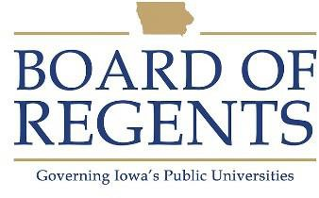
Kitchen Helper II

GENERAL CLASS DESCRIPTION

Under general supervision, assists in and is responsible for completion of work assignments of kitchen helpers in the food service facility.

CHARACTERISTIC DUTIES AND RESPONSIBILITIES

- Directs and assists in scheduling work arrangements of kitchen helpers to assure work areas are covered and assignments are completed. Assists with set up and clean up for special events.

- Checks and is responsible for cleanliness, orderliness, and maintenance of equipment and facilities.

- Assists in maintaining china, silverware and cleaning supplies inventory; suggest orders as needed.

- Trains kitchen helpers and assists with daily work routine as necessary.

- Performs other related duties and responsibilities as required.

KNOWLEDGES, SKILLS AND ABILITIES

- Ability to read, write and follow oral and written instructions.

- Ability to lift up to 50 pounds.

- Knowledge of operation and care of dishwashing machines.

- Ability to maintain a safe, clean work area.

- Ability to insure dishes, pans, glassware, and utensils are properly scraped or rinsed before placing in dishwashing machine.

- Ability to maintain effective working relationship with others.

- Ability to stand for long periods of time.

- Ability to plan, assign and direct work of others.

- Ability to count, add, subtract and convert to decimals.





- Knowledge of principles of sanitation, health hazards, and the necessary precautionary measures.

MINIMUM ELIGIBILITY REQUIREMENTS

One year experience as a Kitchen Helper I, or outside experience comparable thereto.

The tasks listed under the heading of Characteristic Duties and Responsibilities are examples of the variety and general nature of duties performed by employees in positions allocated in the class. The list is descriptive only and should be used for no other purpose. It is not intended that any position include every duty listed, nor is it intended that related duties cannot be required.

Last Revised: July 1, 1989




