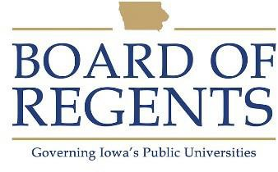
Sewing Machine Operator, Hospital

GENERAL CLASS DESCRIPTION

Under general supervision, designs, repairs and constructs clothing, linen and specialty items.

CHARACTERISTIC DUTIES AND RESPONSIBILITIES

- Reads and interprets drawings, specification, and work orders, and develop patterns for construction of specialized medical items (such as head and chin restraints, Timmerman sheets, dental dams) and draperies, linens and clothing.

- Operates various machines such as sewing machines, linen marker, serger, thermopatcher, name tag marker and applicator, hand iron and electric cutter.

- Measures patients for special body restraints and makes other field measurements, as necessary.

- Sorts linen to determine if items are to be discarded or repaired.

- Makes minor repairs, oils and cleans machines.

- Maintains records, estimates material and labor costs to manufacture items and controls inventory.

- Uses a variety of materials in the construction of items such as rubber, plastic, terry cloth, air foam padding, nylon, muslin, etc.

- Fits, alters, makes and issues uniforms for hospital personnel.

- Keeps working areas clean and orderly.

KNOWLEDGES, SKILLS AND ABILITIES

1. Ability to troubleshoot, adjust, clean and oil sewing machines and related equipment.

2. Ability to interpret oral and written instructions.

3. Ability to communicate orally with individuals from a variety of backgrounds.

4. Ability to mark material, determine where to cut, and how to fit, using measuring and other devices of the trade.

5. Ability to safely operate and maintain sewing tools and machines.

6. Ability to sit for long periods with continual movement of hands, arms and fingers.

7. Ability to maintain records of sewing projects and amounts of fabric and other supplies ordered and used.

8. Knowledge of principles of mathematics to calculate fabric and other supplies necessary for project.

9. Knowledge of techniques for altering and constructing uniforms, other garments, and hospital specialty items.

Knowledge of pattern making and ability to develop them, as necessary.

MINIMUM ELIGIBILITY REQUIREMENTS

One year tailoring or seamstress experience with personal sewing substituting based on three years of experience equaling one year of full-time paid experience.

The tasks listed under the heading of Characteristic Duties and Responsibilities are examples of the variety and general nature of duties performed by employees in positions allocated in the class. The list is descriptive only and should be used for no other purpose. It is not intended that any position include every duty listed, nor is it intended that related duties cannot be required.

Last Revised: June 1, 2026

