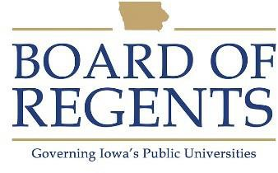
Facilities Coordinator

GENERAL CLASS DESCRIPTION

Under general supervision, is responsible for the operation of equipment and for directing and coordinating facilities to provide procurement and inventory control for a physically decentralized area. Provides functional supervision as required.

CHARACTERISTIC DUTIES AND RESPONSIBILITIES

- Supervises the ordering, receiving, storing, inventory, inspection and distribution of materials and supplies.

- Performs appraisals of the condition and cleanliness of grounds and facilities.

- Coordinates the maintenance and repair of facilities and equipment.

- Maintains and/or supervises the maintenance of records indicating receipt and disposition of all stock material and supplies.

- Maintains adequate inventory control system; conducts searches for misplaced or lost items.

- Performs a wide variety of housekeeping/custodial duties including cleaning, laundering and related functions inside and outside the building as required.

- Inspects and services equipment and building, performing minor repairs as necessary and reports major problems to the appropriate area.

- Answers telephone inquiries, making necessary and proper referrals of the calls, and maintains a call log.

- Prepares special and periodic reports for operation.

- Performs touring and chauffeuring duties as required.

- Provides training to other departmental staff members.

KNOWLEDGES, SKILLS AND ABILITIES

- Knowledge of facilities and industry standards in cleaning and maintenance of buildings.

- Knowledge of safety standards and safe work practices.

- Knowledge of institutional policies and procedures.




Knowledge of administrative activities to include preparation of specific and period reports, fiscal records and service changes.

Knowledge of measures to improve production/service methods, equipment performance, scheduling and quality control.

Knowledge of aseptic cleaning and maintenance techniques.

Knowledge of computer operations and windows software programs.

Ability to communicate effectively, both orally and in writing, with students, faculty, staff, vendors and the general public.

Ability to lead, coach, motivate, direct, train, and provide resources to staff members of the unit.

MINIMUM ELIGIBILITY REQUIREMENTS

- Four years of post high school work including experience involving public contact and storekeeping procedures.

- Possession of a current Iowa driver's license.

The tasks listed under the heading of Characteristic Duties and Responsibilities are examples of the variety and general nature of duties performed by employees in positions allocated in the class. The list is descriptive only and should be used for no other purpose. It is not intended that any position include every duty listed, nor is it intended that related duties cannot be required.

Last Revised: November 16, 2002




