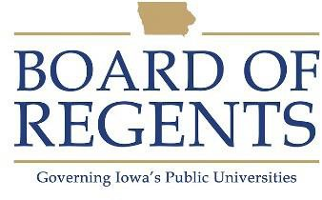
Bus Operator

GENERAL CLASS DESCRIPTION

Under general supervision, operates passenger carrying buses. Uses judgment to deliver safe and reliable public transit services.

CHARACTERISTIC DUTIES AND RESPONSIBILITIES

- Operates passenger vehicles in a variety of conditions.

- Assists riders to safely board and exit the vehicle.

- Assists riders with disabilities in compliance with agency policies and ADA regulations, including securing wheelchairs and other medical or mobility equipment.

- Provide customer service to riders, including relaying system information and answering questions in a professional and courteous manner.

- Perform vehicle inspections and checks to ensure vehicle is in safe operating condition for passenger carry.

- Report equipment malfunctions to appropriate personnel.

- Report delays, breakdowns, and accidents to dispatch and in written reports.

- Uses on-board vehicle equipment, including mobile data terminals, in compliance with agency policy.

- Maintains route schedules in a reasonable and safe manner.

- Assists in training activity of new drivers, including providing coaching.

KNOWLEDGES, SKILLS AND ABILITIES

- Knowledgeable of applicable local, state, and federal laws and regulations.

- Knowledgeable of campus and service area.

- Ability to operate assigned equipment in a safe manner.

- Ability to exercise good judgement and defensive driving techniques while driving.





Ability to communicate clearly with operators, dispatch, supervisors, and other agency personnel through written, verbal, and radio communication.

Ability to work and maintain professional composure in stressful situations.

Ability to understand and follow University and transit system policies and procedures.

MINIMUM ELIGIBILITY REQUIREMENTS

- Must possess a valid US Driver’s License.

- Must pass and maintain driving privileges in accordance with University Driving Policy.

- Possess, or ability to obtain and maintain a Class B Commercial Driver’s License with Passenger Endorsement, and Airbrakes restriction lifted.

This position is subject to drug and alcohol testing in compliance with FTA regulations.

The tasks listed under the heading of Characteristic Duties and Responsibilities are examples of the variety and general nature of duties performed by employees in positions allocated in the class. The list is descriptive only and should be used for no other purpose. It is not intended that any position include every duty listed, nor is it intended that related duties cannot be required.

Last Revised: June 1, 2024




