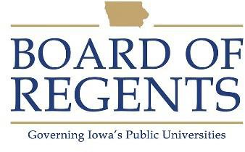
Laundry Production Worker

GENERAL CLASS DESCRIPTION

Under direct supervision, operates flatwork iron pressing machine, from air finishers and shirt finishers to finish and/or fold cloth materials such as sheets, pillow cases, aprons, operating room linens, towels, shirts, etc.

CHARACTERISTIC DUTIES AND RESPONSIBILITIES

- Takes material from basket and shakes out creases and positions semi-dry flatwork on a table for feeding into machine.

- Lays articles on feeder ribbons that convey it into machines. Smoothes and guides article by hand during ironing process to prevent folds and wrinkles.

- Folds flatwork and/or tumble work pieces discharged from machine and places in baskets on carts or on conveyor.

- Finishes shirts by operating four presses, such as the sleever, collar-cuff press and body presses as required.

- Finishes perma-press articles that are dried on hangers, placed on a conveyor and passed through a steam conditioner to remove any wrinkles and set finish.

KNOWLEDGES, SKILLS AND ABILITIES

- Ability to understand and follow oral and written instructions.

- Knowledge of hazards and safety precautions necessary in laundry work.

- Ability to perform manual labor.

- Ability to work out of doors under any type of weather conditions.

- Knowledge of proper bending and lifting techniques and ability to lift and carry 80 pounds.

- Knowledge of the safe use if chemical cleaning agents and possible hazards relating to environmental sanitation.





MINIMUM ELIGIBILITY REQUIREMENTS

Ability to understand and follow instructions.

The tasks listed under the heading of Characteristic Duties and Responsibilities are examples of the variety and general nature of duties performed by employees in positions allocated in the class. The list is descriptive only and should be used for no other purpose. It is not intended that any position include every duty listed, nor is it intended that related duties cannot be required.

Last Revised: October 1, 2009




